Contents

Bài 1: 1

1. Sơ đồ khối: 1

2. Bảng: 1

3. Các thực thể: 2

4. Nhập dữ liệu: 4

Bài 2: 7

1. Bảng: 7

2. Các thực thể: 7

# Bài 1:

1. Sơ đồ khối:

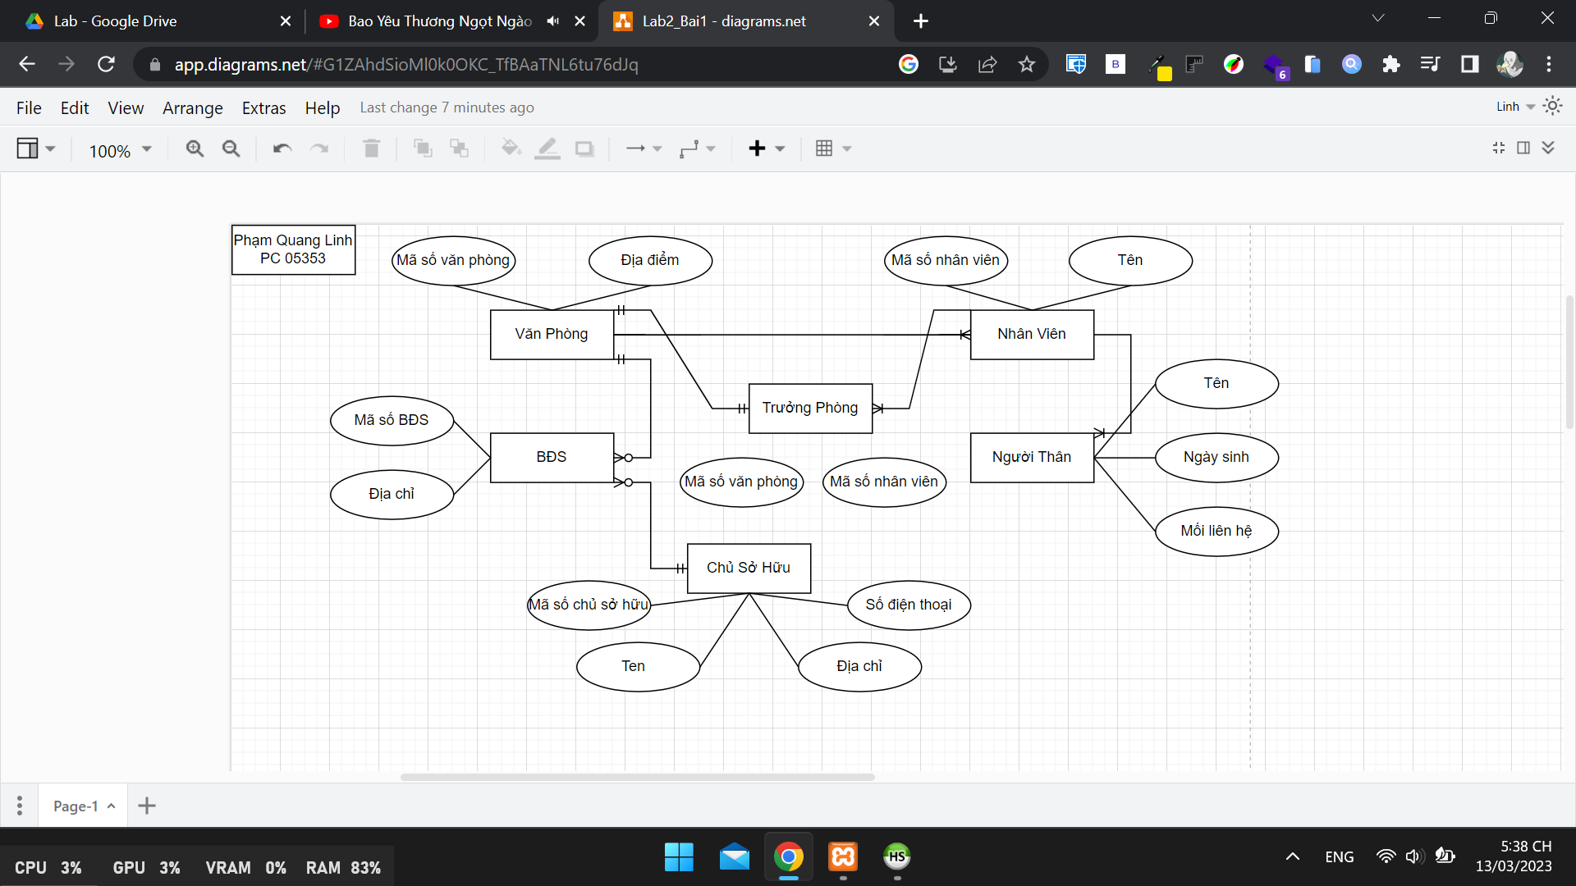

1. Bảng:

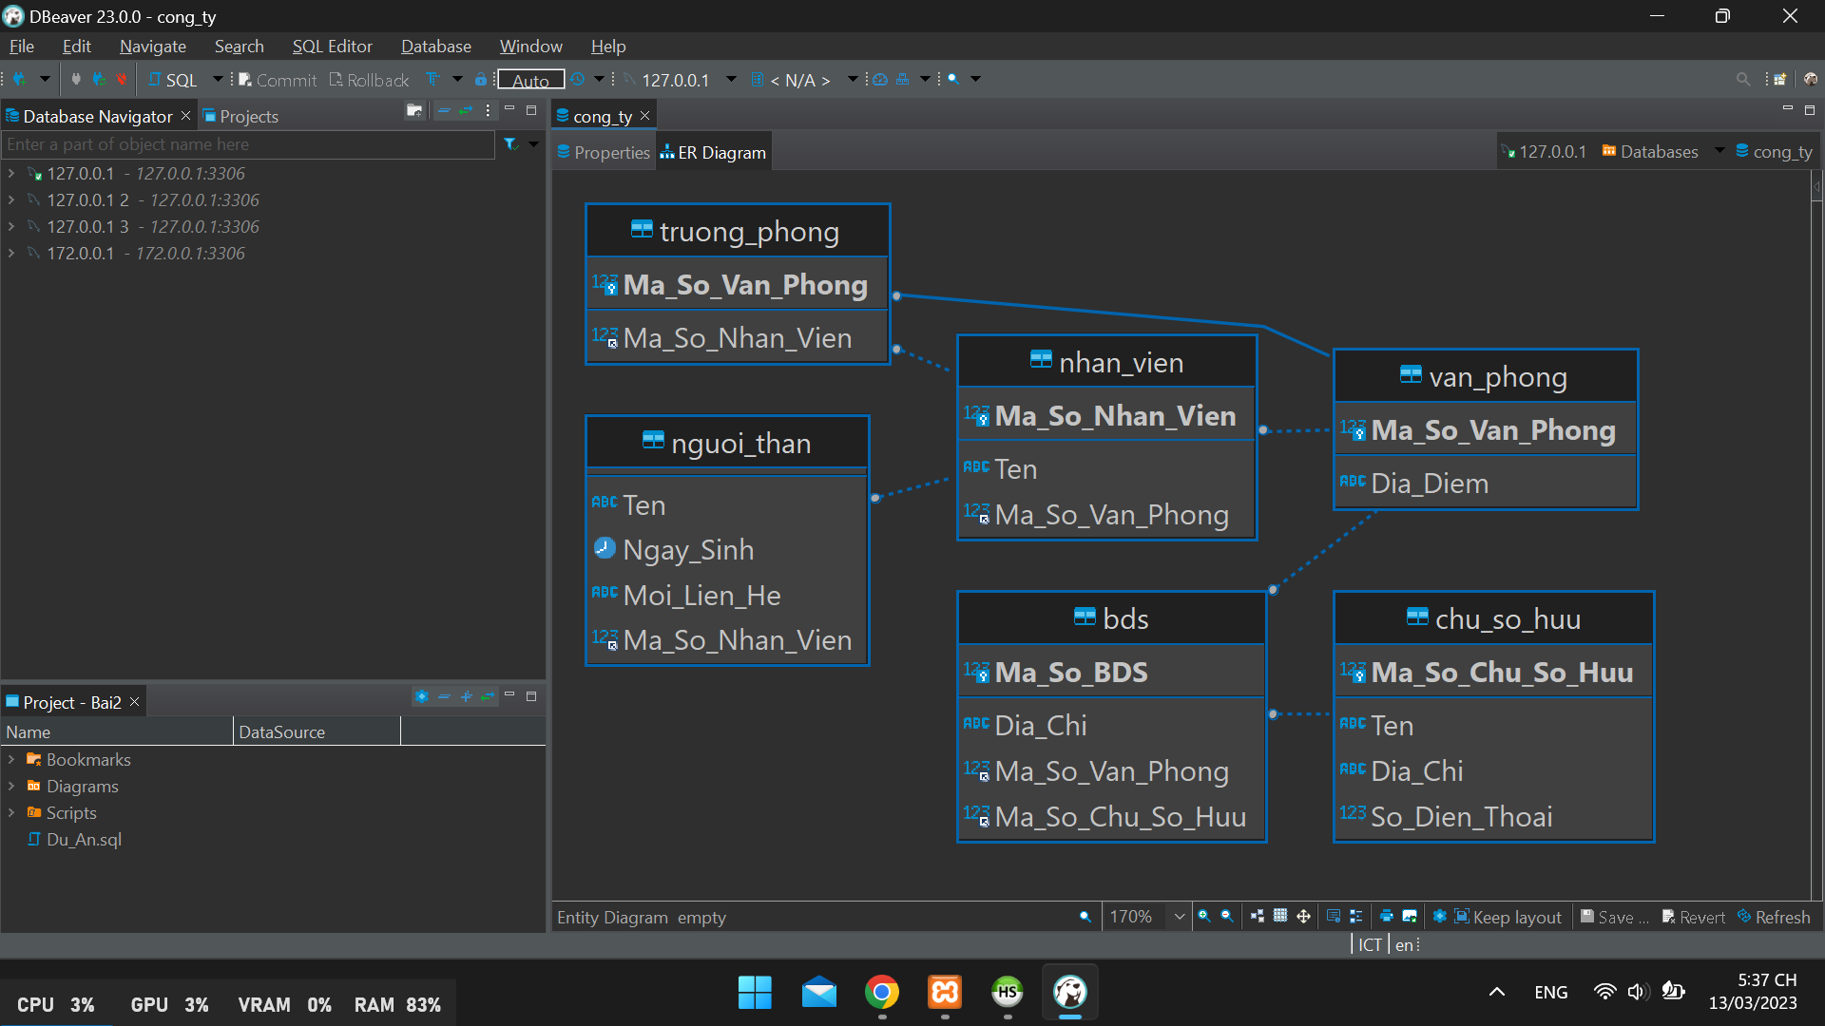

1. Các thực thể:

CREATE TABLE **IF** NOT EXISTS `van_phong` (

  `Ma_So_Van_Phong` int(11) NOT NULL,

  `Dia_Diem` varchar(50) NOT NULL *DEFAULT* '',

*PRIMARY KEY* (`Ma_So_Van_Phong`)

) ENGINE=InnoDB *DEFAULT* CHARSET=utf8mb4 *COLLATE*=utf8mb4_general_ci;

CREATE TABLE **IF** NOT EXISTS `nhan_vien` (

  `Ma_So_Nhan_Vien` int(11) NOT NULL,

  `Ten` varchar(50) NOT NULL *DEFAULT* '',

  `Ma_So_Van_Phong` int(11) NOT NULL,

*PRIMARY KEY* (`Ma_So_Nhan_Vien`),

  KEY `FK_nhan_vien_van_phong` (`Ma_So_Van_Phong`),

*CONSTRAINT* `FK_nhan_vien_van_phong` *FOREIGN KEY* (`Ma_So_Van_Phong`) *REFERENCES* `van_phong` (`Ma_So_Van_Phong`)

) ENGINE=InnoDB *DEFAULT* CHARSET=utf8mb4 *COLLATE*=utf8mb4_general_ci;

CREATE TABLE **IF** NOT EXISTS `chu_so_huu` (

  `Ma_So_Chu_So_Huu` int(11) NOT NULL,

  `Ten` varchar(50) NOT NULL *DEFAULT* '',

  `Dia_Chi` varchar(50) NOT NULL *DEFAULT* '',

  `So_Dien_Thoai` int(11) NOT NULL *DEFAULT* 0,

*PRIMARY KEY* (`Ma_So_Chu_So_Huu`)

) ENGINE=InnoDB *DEFAULT* CHARSET=utf8mb4 *COLLATE*=utf8mb4_general_ci;

CREATE TABLE **IF** NOT EXISTS `bds` (

  `Ma_So_BDS` int(11) NOT NULL,

  `Dia_Chi` varchar(50) NOT NULL *DEFAULT* '',

  `Ma_So_Van_Phong` int(11) NOT NULL,

  `Ma_So_Chu_So_Huu` int(11) NOT NULL,

*PRIMARY KEY* (`Ma_So_BDS`),

  KEY `FK_bds_van_phong` (`Ma_So_Van_Phong`),

  KEY `FK_bds_chu_so_huu` (`Ma_So_Chu_So_Huu`),

*CONSTRAINT* `FK_bds_chu_so_huu` *FOREIGN KEY* (`Ma_So_Chu_So_Huu`) *REFERENCES* `chu_so_huu` (`Ma_So_Chu_So_Huu`),

*CONSTRAINT* `FK_bds_van_phong` *FOREIGN KEY* (`Ma_So_Van_Phong`) *REFERENCES* `van_phong` (`Ma_So_Van_Phong`)

) ENGINE=InnoDB *DEFAULT* CHARSET=utf8mb4 *COLLATE*=utf8mb4_general_ci;

CREATE TABLE **IF** NOT EXISTS `nguoi_than` (

  `Ten` varchar(50) NOT NULL,

  `Ngay_Sinh` date NOT NULL,

  `Moi_Lien_He` varchar(50) NOT NULL *DEFAULT* '',

  `Ma_So_Nhan_Vien` int(11) NOT NULL,

  KEY `FK_nguoi_than_nhan_vien` (`Ma_So_Nhan_Vien`),

*CONSTRAINT* `FK_nguoi_than_nhan_vien` *FOREIGN KEY* (`Ma_So_Nhan_Vien`) *REFERENCES* `nhan_vien` (`Ma_So_Nhan_Vien`)

) ENGINE=InnoDB *DEFAULT* CHARSET=utf8mb4 *COLLATE*=utf8mb4_general_ci;

CREATE TABLE **IF** NOT EXISTS `truong_phong` (

  `Ma_So_Van_Phong` int(11) NOT NULL,

  `Ma_So_Nhan_Vien` int(11) NOT NULL,

*PRIMARY KEY* (`Ma_So_Van_Phong`),

  KEY `FK_truong_phong_nhan_vien` (`Ma_So_Nhan_Vien`),

*CONSTRAINT* `FK_truong_phong_nhan_vien` *FOREIGN KEY* (`Ma_So_Nhan_Vien`) *REFERENCES* `nhan_vien` (`Ma_So_Nhan_Vien`) *ON DELETE* NO ACTION ON UPDATE NO ACTION,

*CONSTRAINT* `FK_truong_phong_van_phong` *FOREIGN KEY* (`Ma_So_Van_Phong`) *REFERENCES* `van_phong` (`Ma_So_Van_Phong`) *ON DELETE* NO ACTION ON UPDATE NO ACTION

) ENGINE=InnoDB *DEFAULT* CHARSET=utf8mb4 *COLLATE*=utf8mb4_general_ci;

1. Nhập dữ liệu:

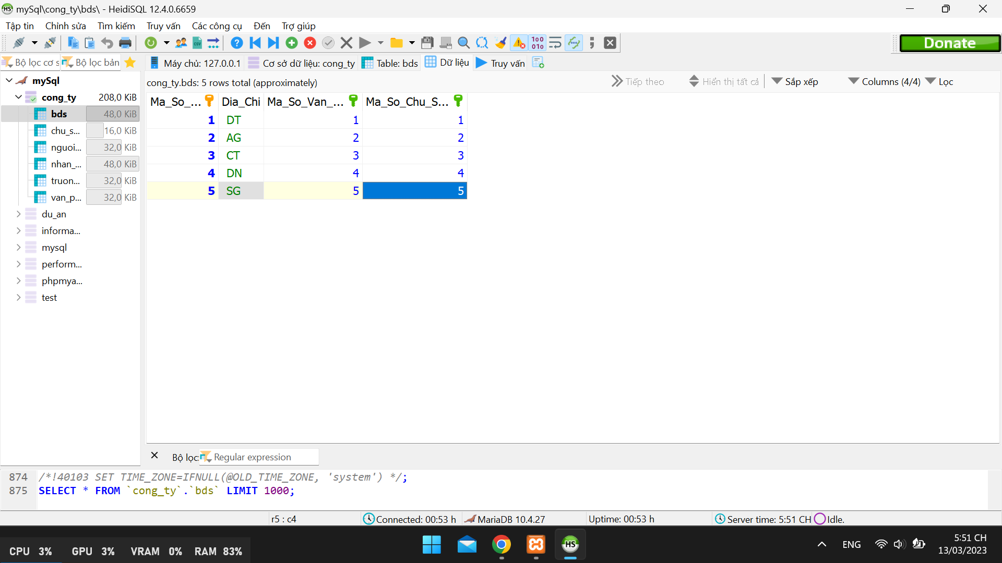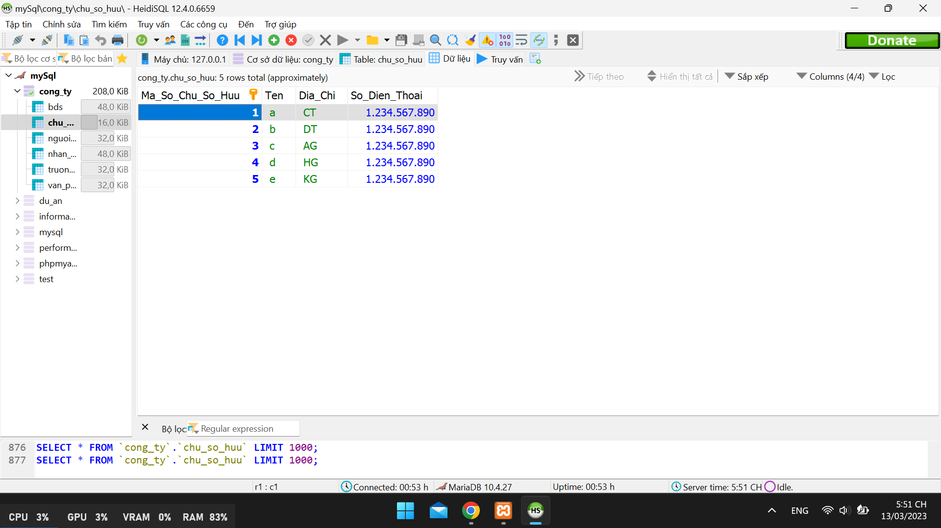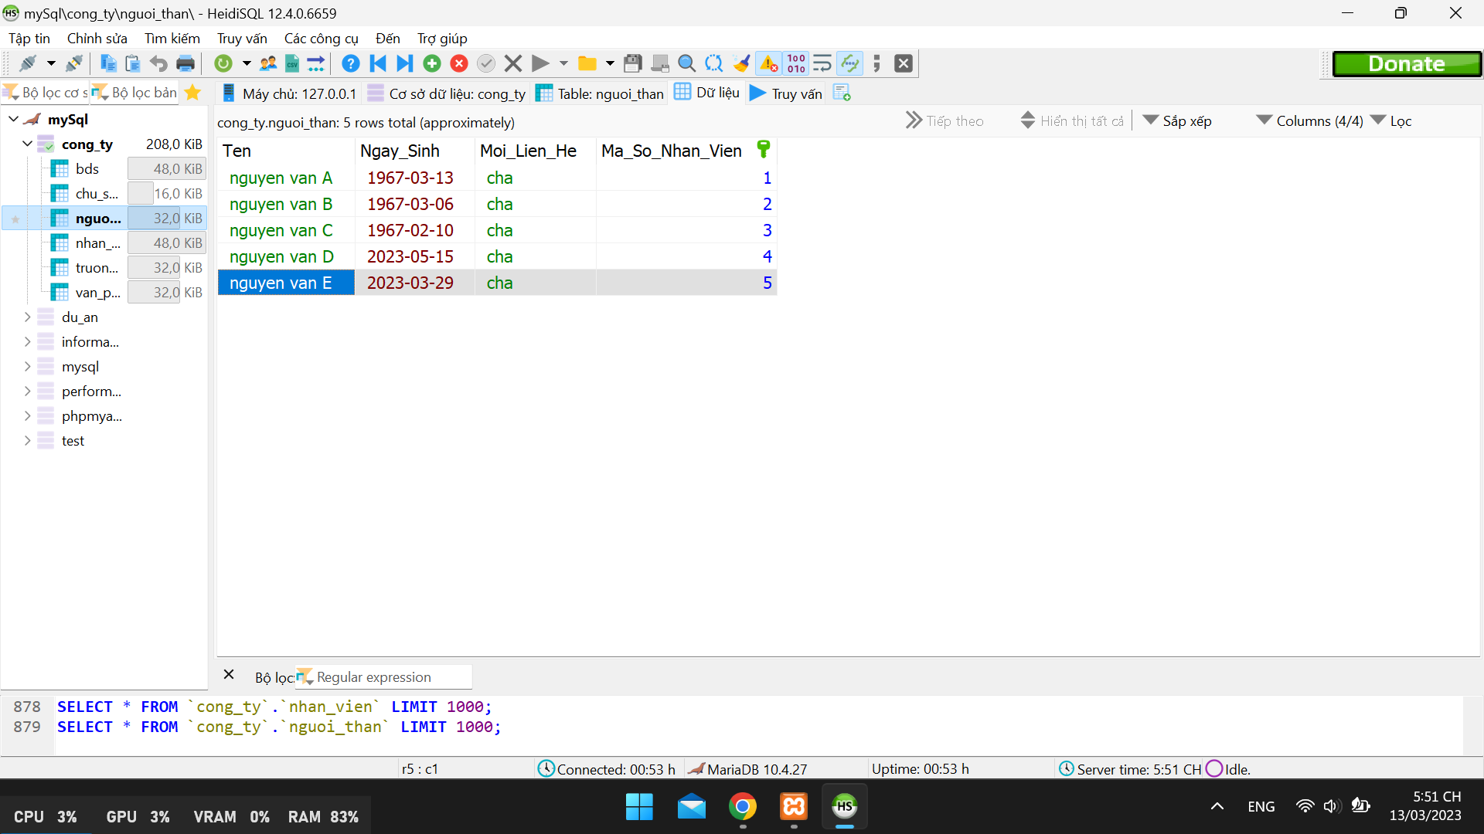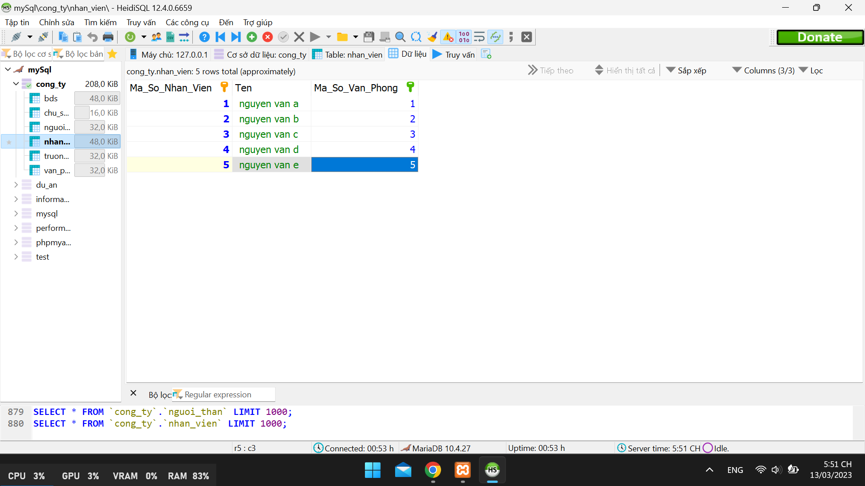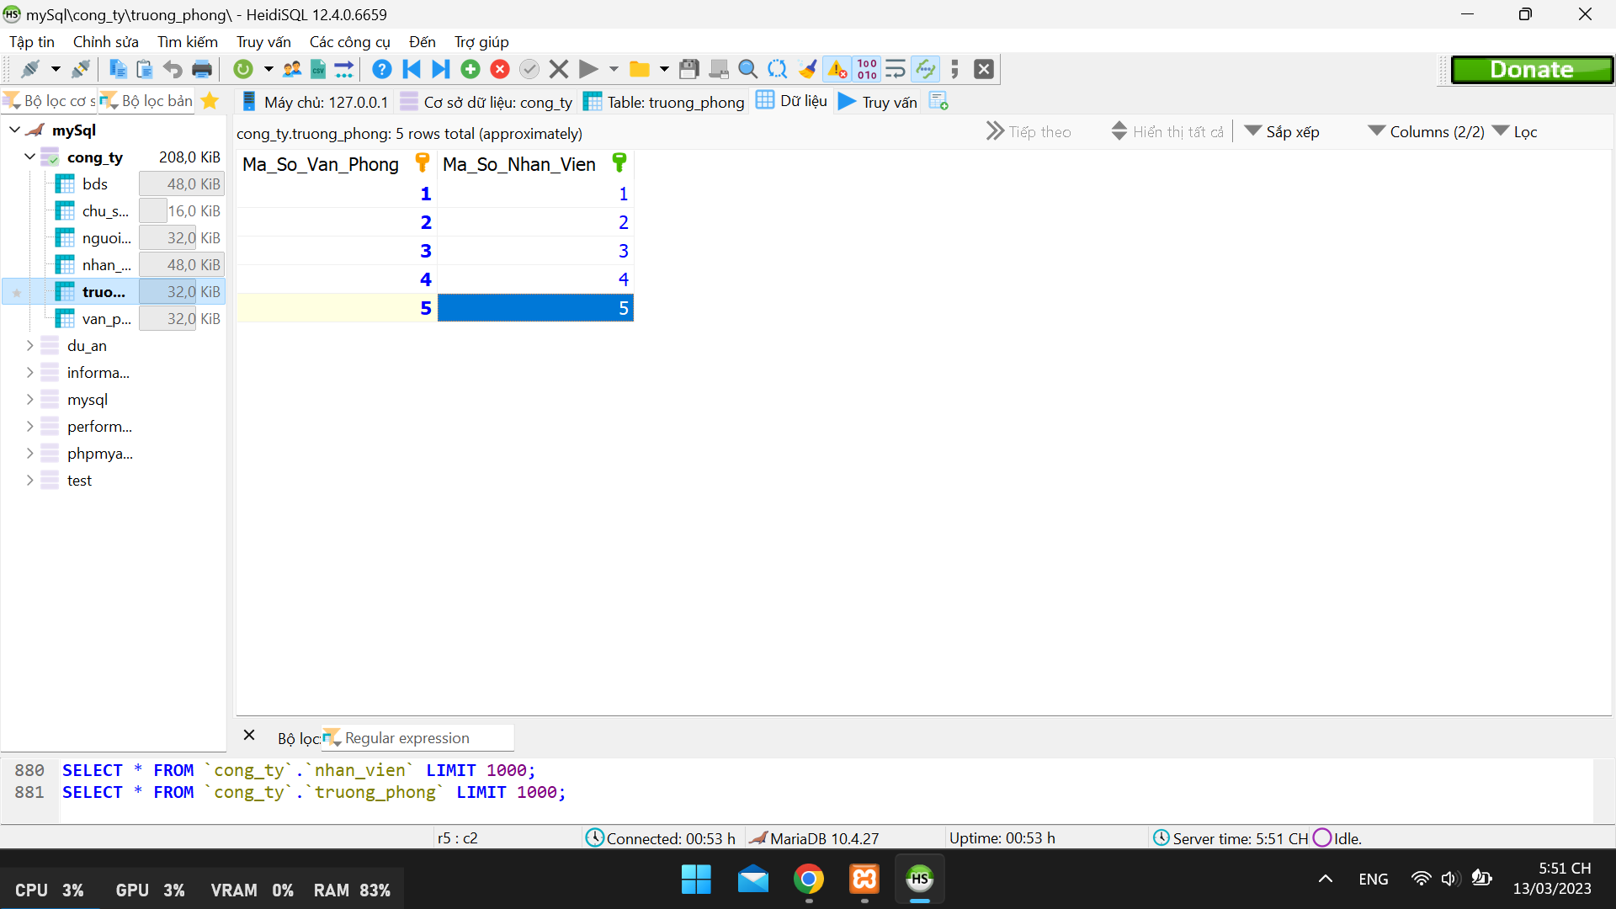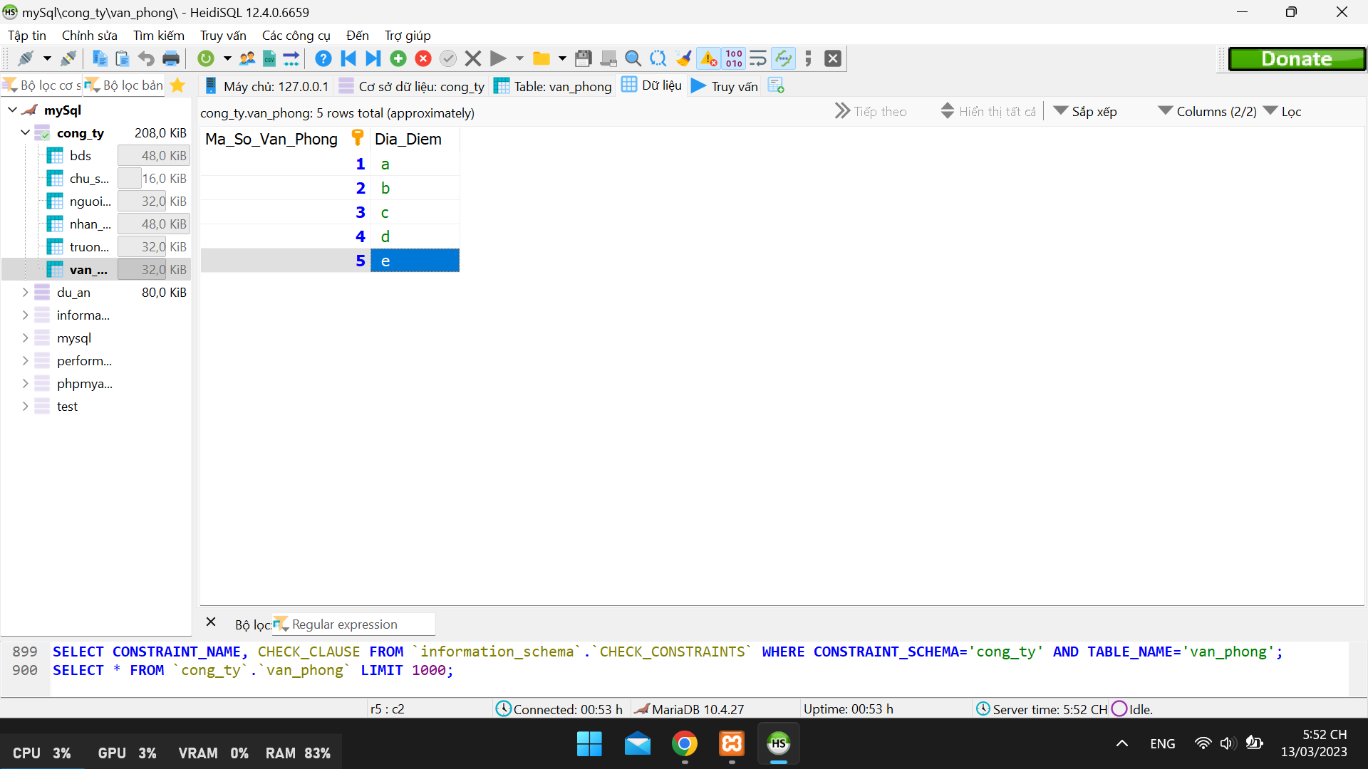

# Bài 2:

1. Bảng:

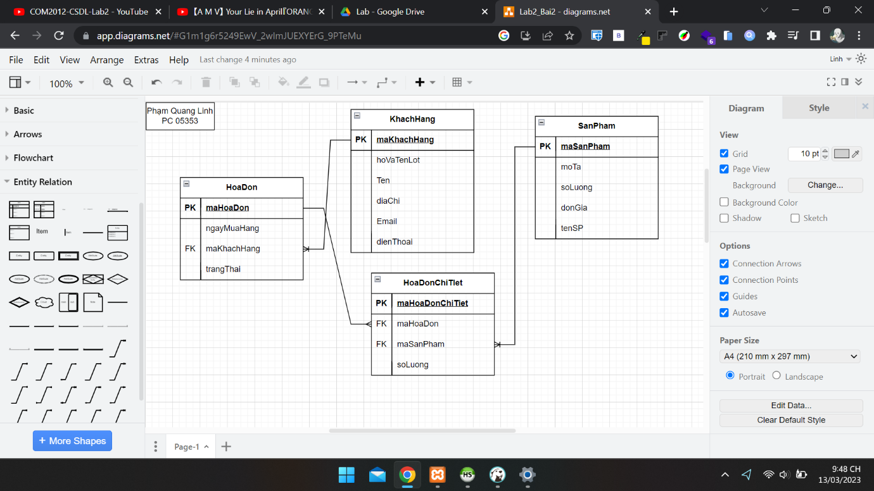

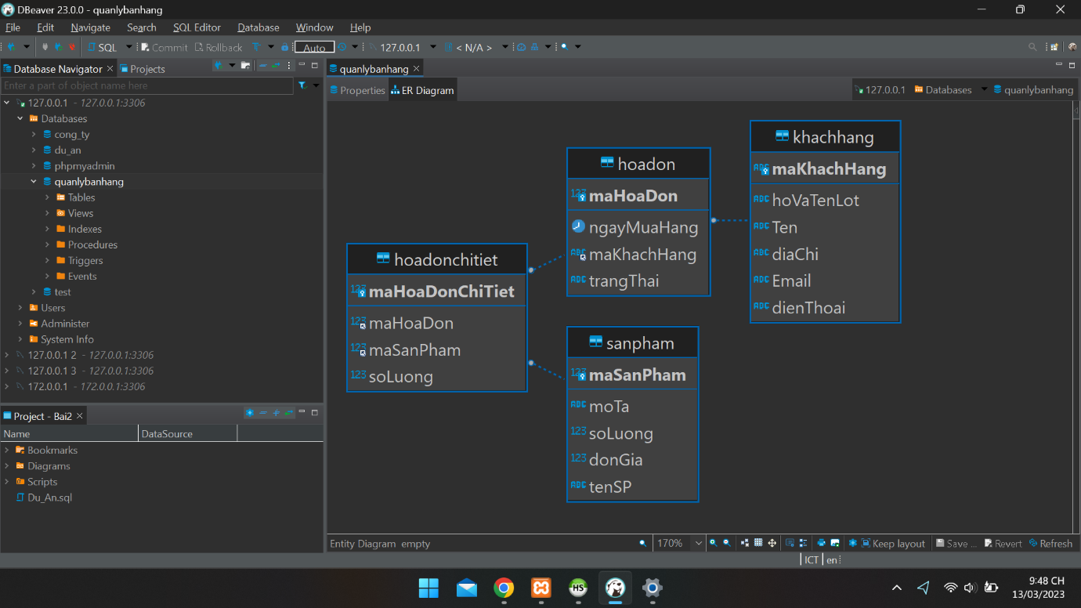

1. Các thực thể:

CREATE TABLE **IF** NOT EXISTS `khachhang` (

  `maKhachHang` varchar(5) NOT NULL *DEFAULT* '',

  `hoVaTenLot` varchar(50) NOT NULL *DEFAULT* '0',

  `Ten` varchar(50) NOT NULL *DEFAULT* '0',

  `diaChi` varchar(255) NOT NULL *DEFAULT* '',

  `Email` varchar(50) NOT NULL *DEFAULT* '',

  `dienThoai` varchar(13) NOT NULL *DEFAULT* '',

*PRIMARY KEY* (`maKhachHang`)

) ENGINE=InnoDB *DEFAULT* CHARSET=utf8mb4 *COLLATE*=utf8mb4_general_ci;

CREATE TABLE **IF** NOT EXISTS `sanpham` (

  `maSanPham` int(11) NOT NULL,

  `moTa` varchar(255) NOT NULL *DEFAULT* '',

  `soLuong` int(11) NOT NULL *DEFAULT* 0,

  `donGia` double NOT NULL *DEFAULT* 0,

  `tenSP` varchar(50) NOT NULL *DEFAULT* '0',

*PRIMARY KEY* (`maSanPham`)

) ENGINE=InnoDB *DEFAULT* CHARSET=utf8mb4 *COLLATE*=utf8mb4_general_ci;

CREATE TABLE **IF** NOT EXISTS `hoadon` (

  `maHoaDon` int(11) NOT NULL,

  `ngayMuaHang` date NOT NULL,

  `maKhachHang` varchar(5) NOT NULL *DEFAULT* '',

  `trangThai` varchar(50) NOT NULL *DEFAULT* '',

*PRIMARY KEY* (`maHoaDon`),

  KEY `maKhachHang` (`maKhachHang`),

*CONSTRAINT* `FK_hoadon_khachhang` *FOREIGN KEY* (`maKhachHang`) *REFERENCES* `khachhang` (`maKhachHang`)

) ENGINE=InnoDB *DEFAULT* CHARSET=utf8mb4 *COLLATE*=utf8mb4_general_ci;

CREATE TABLE **IF** NOT EXISTS `hoadonchitiet` (

  `maHoaDonChiTiet` int(11) NOT NULL,

  `maHoaDon` int(11) NOT NULL,

  `maSanPham` int(11) NOT NULL,

  `soLuong` int(11) NOT NULL,

*PRIMARY KEY* (`maHoaDonChiTiet`),

  KEY `maSanPham` (`maSanPham`),

  KEY `maHoaDon` (`maHoaDon`),

*CONSTRAINT* `FK_hoadonchitiet_hoadon` *FOREIGN KEY* (`maHoaDon`) *REFERENCES* `hoadon` (`maHoaDon`),

*CONSTRAINT* `FK_hoadonchitiet_sanpham` *FOREIGN KEY* (`maSanPham`) *REFERENCES* `sanpham` (`maSanPham`)

) ENGINE=InnoDB *DEFAULT* CHARSET=utf8mb4 *COLLATE*=utf8mb4_general_ci;