Contents

Bai 1: 1

Bai 2: 1

# Bai 1:

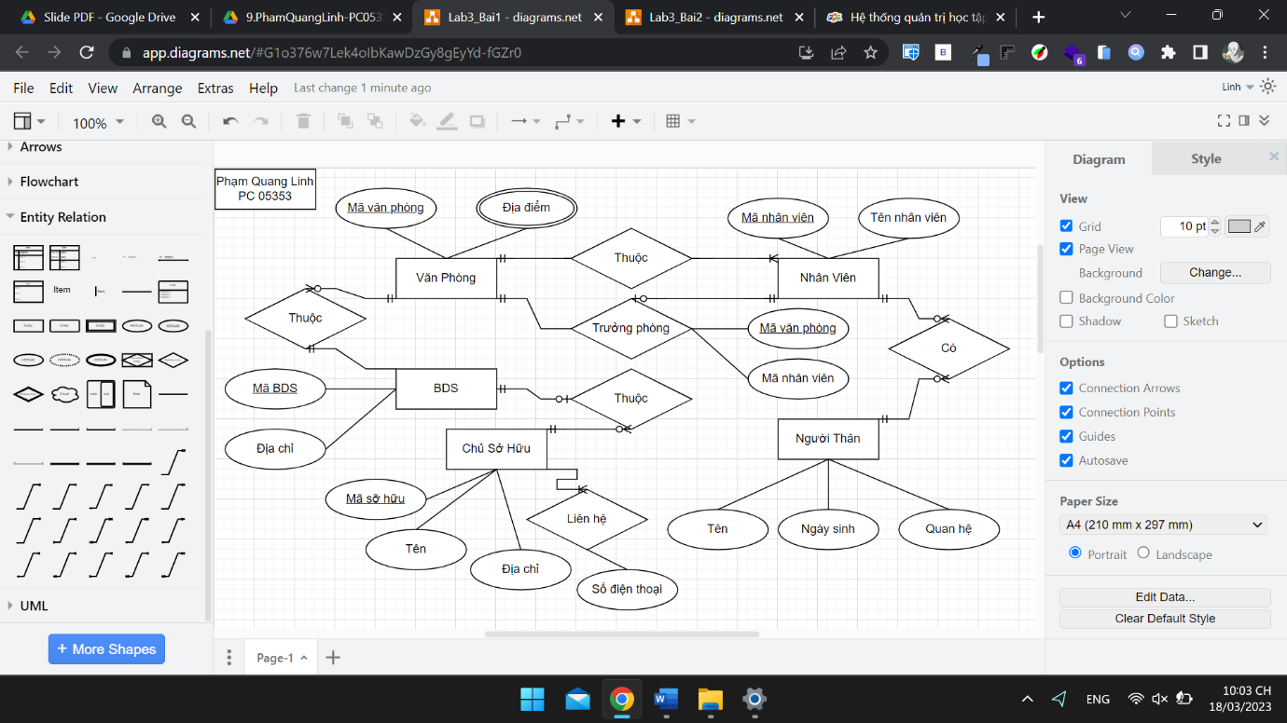

# Bai 2:

