Contents

Ban ghi: 2

hoadon 2

hoadonchitiet 3

khachhang 4

sanpham 5

Bai 1: 6

Bai 2: 6

# Ban ghi:

## hoadon

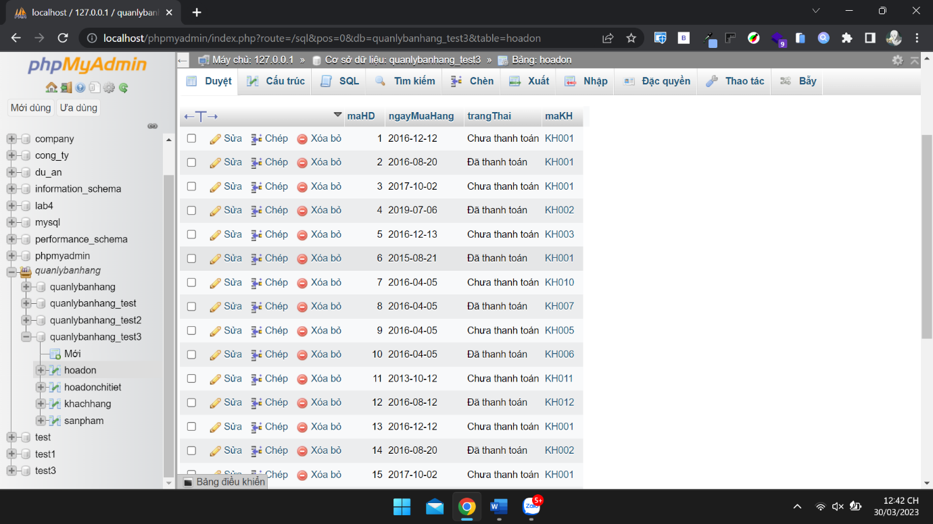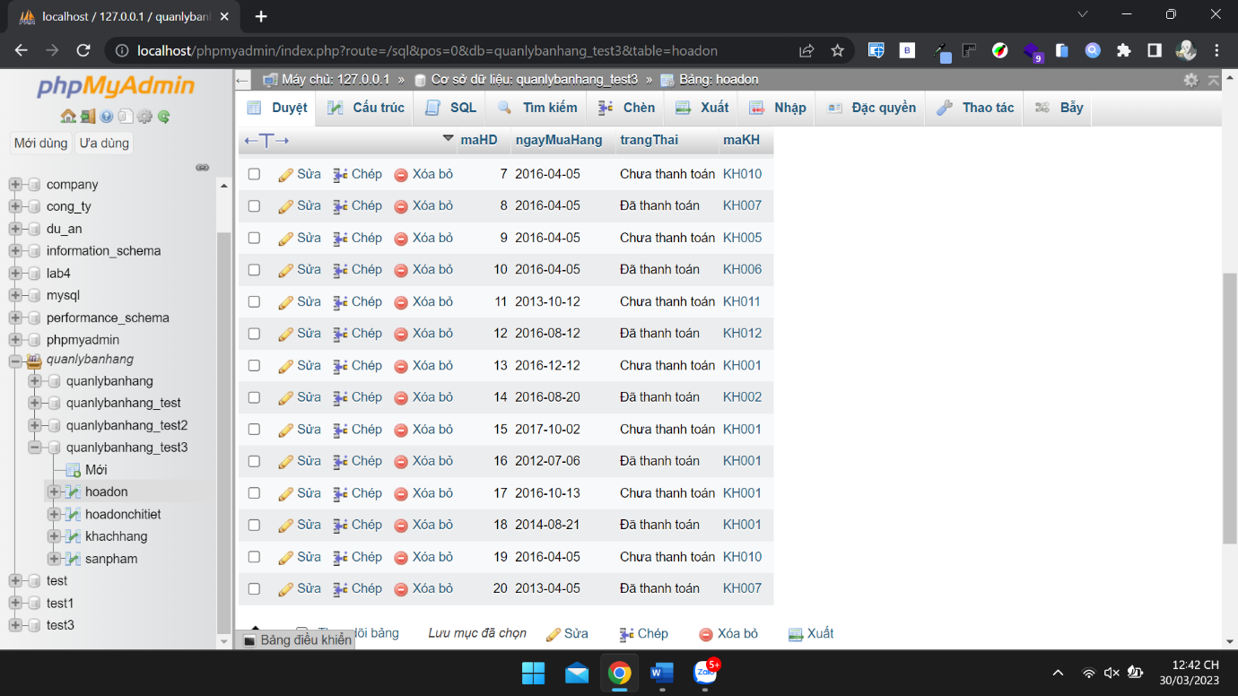

## hoadonchitiet

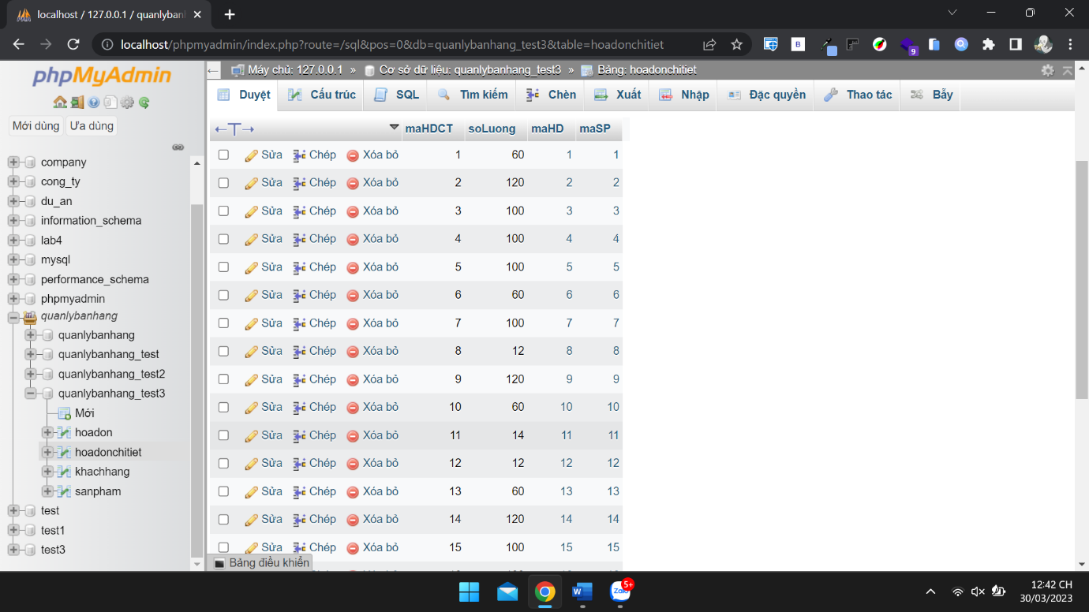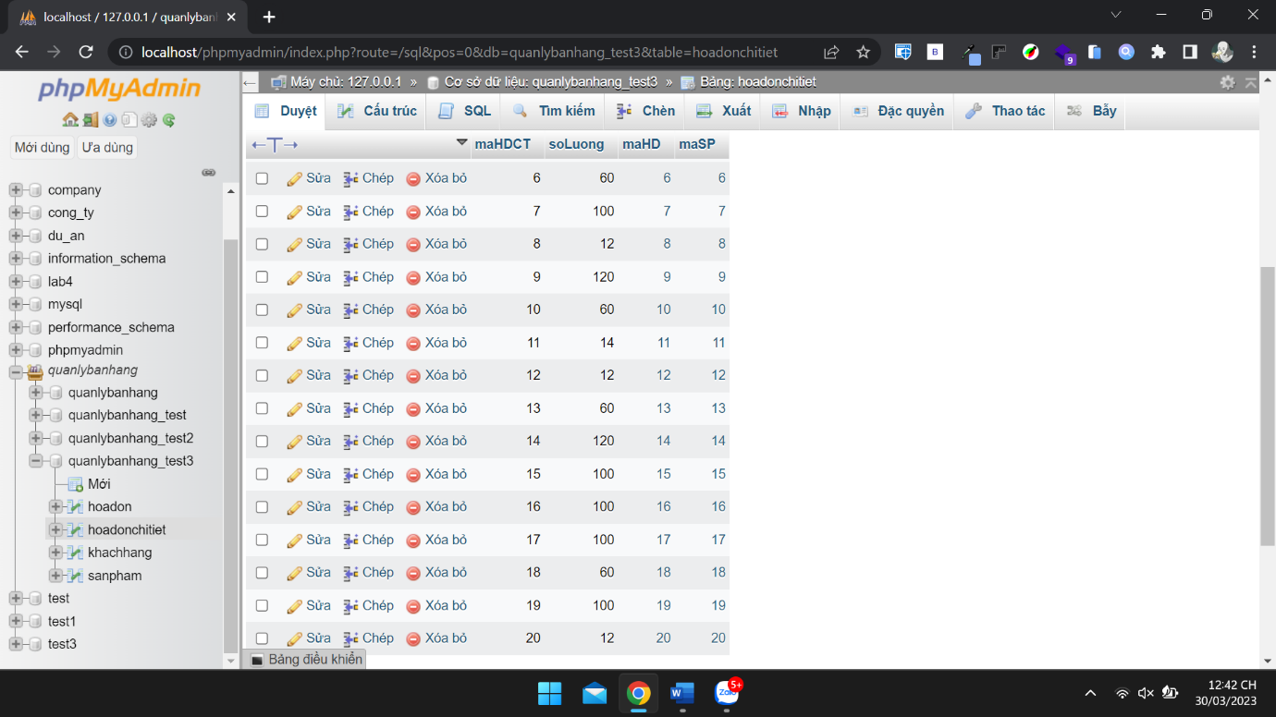

## khachhang

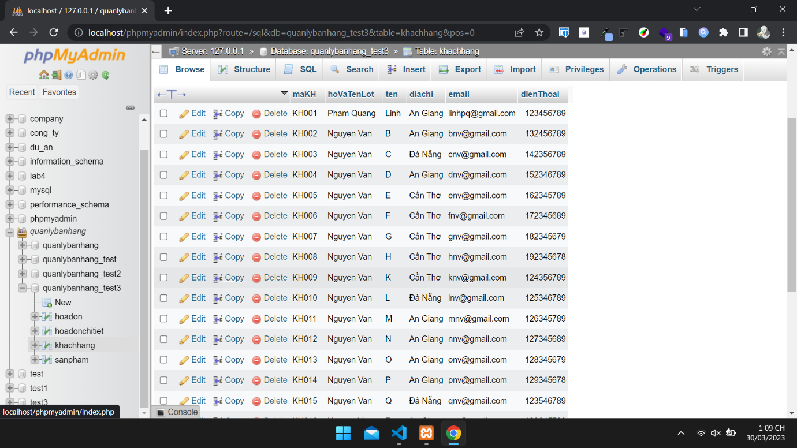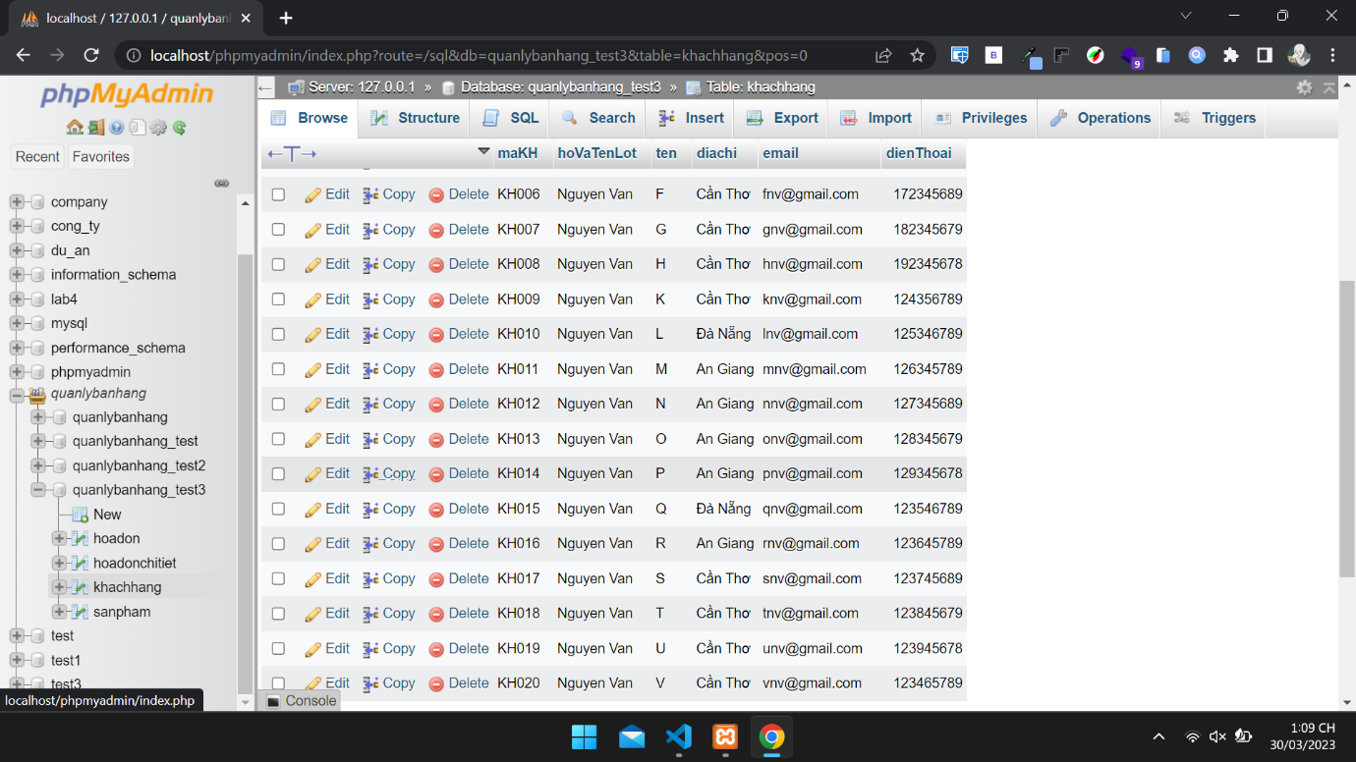

## sanpham

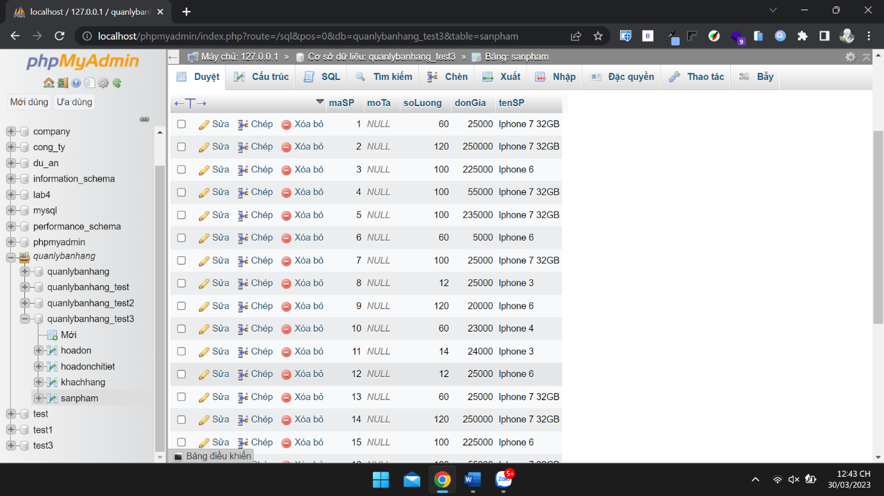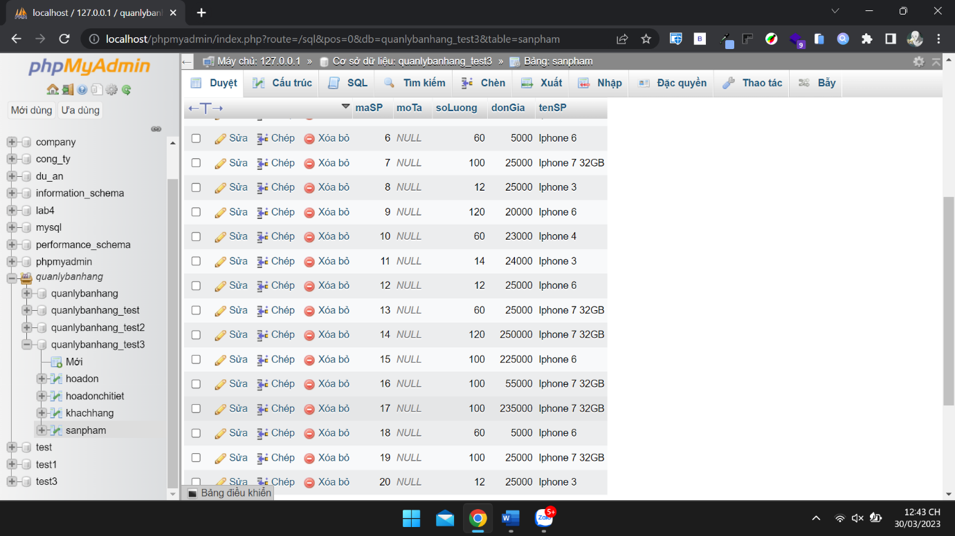

# Bai 1:

*-- a*

SELECT * FROM khachhang;

*-- b*

SELECT maKH, CONCAT(hoVaTenLot, ' ', ten) AS 'Ho va ten', email, dienThoai

FROM khachhang LIMIT 10;

*-- c*

SELECT maSP, tenSP, donGia * soLuong AS 'Tong tien ton kho'

FROM sanpham;

*-- d*

SELECT maKH, CONCAT(hoVaTenLot, ' ', ten) AS 'Ho va ten', diaChi

FROM khachhang WHERE ten LIKE 'H%';

*-- e*

SELECT * FROM khachhang

WHERE diaChi = 'Đà Nẵng';

*-- f*

SELECT * FROM sanpham

WHERE soLuong >= 100 AND soLuong <= 500;

*-- g*

SELECT * FROM hoadon

WHERE trangThai = 'Chưa thanh toán' AND ngayMuaHang LIKE '2016%';

*-- h*

SELECT * FROM hoadon

WHERE maKH IN ('KH001', 'KH003', 'KH006');

# Bai 2:

*-- a*

SELECT COUNT(maKH) AS 'So luong khach hang'

FROM khachhang;

*-- b*

SELECT MAX(donGia) AS 'Don gia lon nhat'

FROM sanpham;

*-- c*

SELECT MIN(soLuong) AS 'So luong thap nhat'

FROM sanpham;

*-- d*

SELECT SUM(soLuong) AS 'Tong so luong san pham'

FROM sanpham;

*-- e*

SELECT COUNT(maHD) AS 'So hoa don chua thanh toan'

FROM hoadon

WHERE ngayMuaHang LIKE '2016-12%' AND trangThai = 'Chưa thanh toán';

*-- f*

SELECT maHD, soLuong FROM hoadonchitiet;

*-- g*

SELECT maHD, soLuong

FROM hoadonchitiet

WHERE soLuong >= 5;

*-- h*

SELECT maHD, ngayMuaHang, maKH

FROM hoadon

GROUP BY ngayMuaHang DESC;