Bai 1:

1: 

2: 

Bai 2:

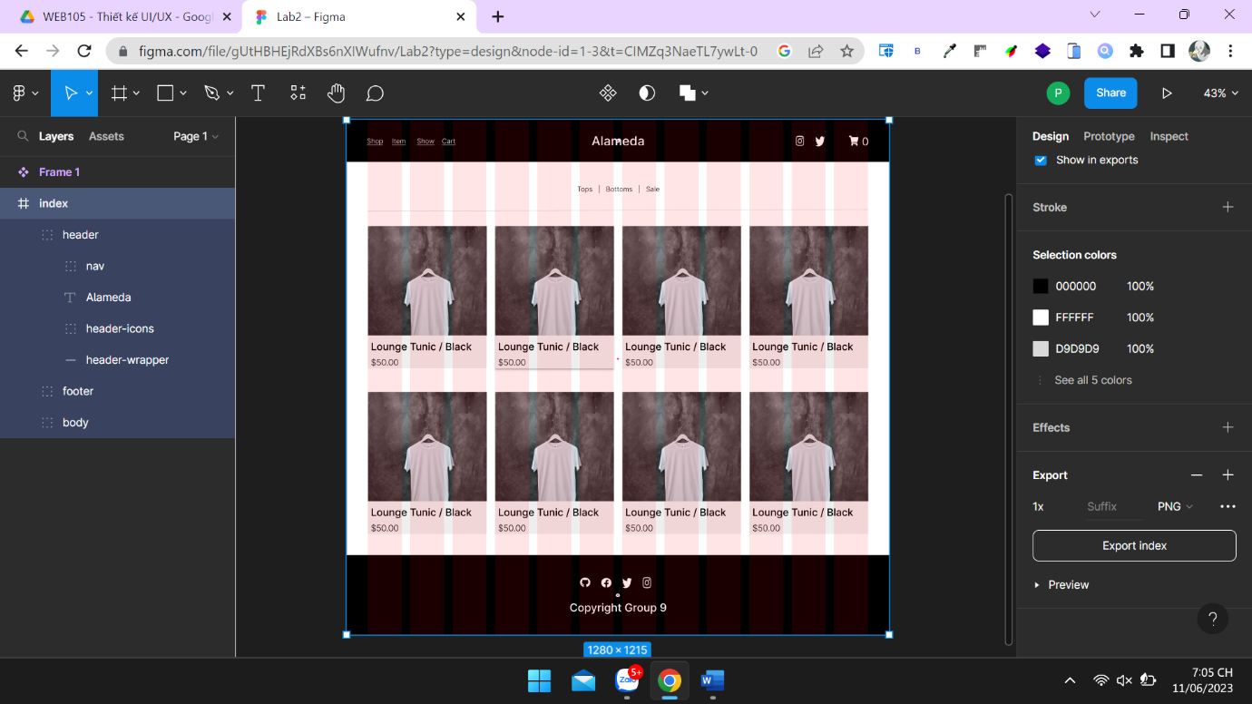

Bai 3: https://www.figma.com/file/zuZX3GaoTXsUSrHbZrE7aO/Lab3-Bai3?type=design&node-id=1-94&t=CIMZq3NaeTL7ywLt-0

Bai 4: https://www.figma.com/proto/Rc1oZ8flUtOVx1JKFj4JVU/Lab3-Bai4?type=design&node-id=1-2&scaling=min-zoom&page-id=0%3A1