README

1. In this MP, I designed the mp4 security module, when booting with this kernel, user can assign security attribute to files to enforce access control as they want.

2. My module can successfully compile and works good when rebooting.
I also tested the kernel with test.perm and test.perm.unload. They results are corrent.

(1) . The original file.txt is like this:

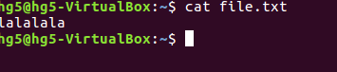

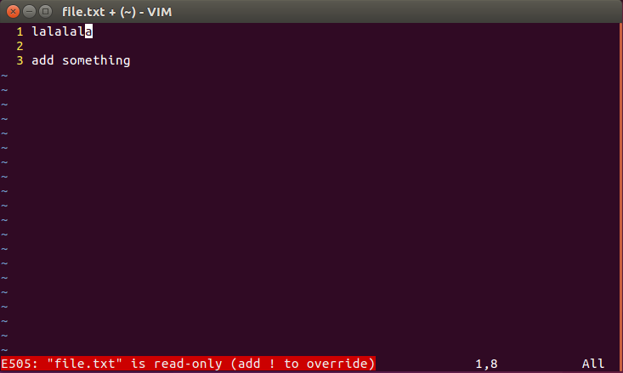
(2). After enforcing the test.perm. I tried to edit the file, but I failed because the access control (read-only)

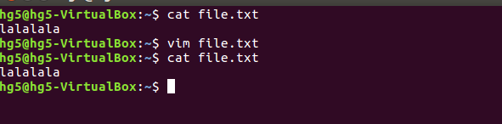
(3). I cannot change the file for access control.

(4). After “source test.perm.unload” I can edit the file now.
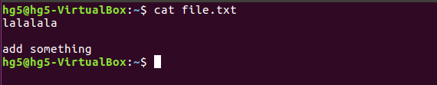

3. For the least privilege policy. I use strace on /usr/bin/passwd. I got all the permission denied file accesses. And then, apply our security policies on these files to grant acccesses.

The least privilege should be:

sudo setfattr -n security.mp4 -v target /usr/bin/passwd
sudo setfattr -n security.mp4 -v read-only /etc/shadow
sudo setfattr -n security.mp4 -v read-write /etc/.pwd.lock

