Product Detail

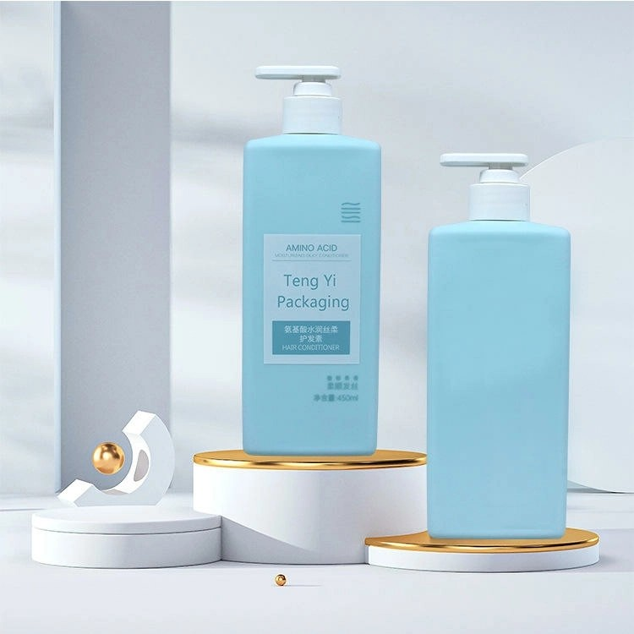

# Blue Square Bottle

**Material:** PC

**Capacity:** 20ml

**Price: $0.4**

**Product Description:**  
The bottle is made of opaque blue plastic, which protects light-sensitive materials. The pump also features a quick and easy-to-use twist lock to dispense no unnecessary soap. All dispensing pumps include a transparent cover and ship to you in a locked position. Turn the pump head 90° counterclockwise to unlock.