Course – 2020 Mar 27

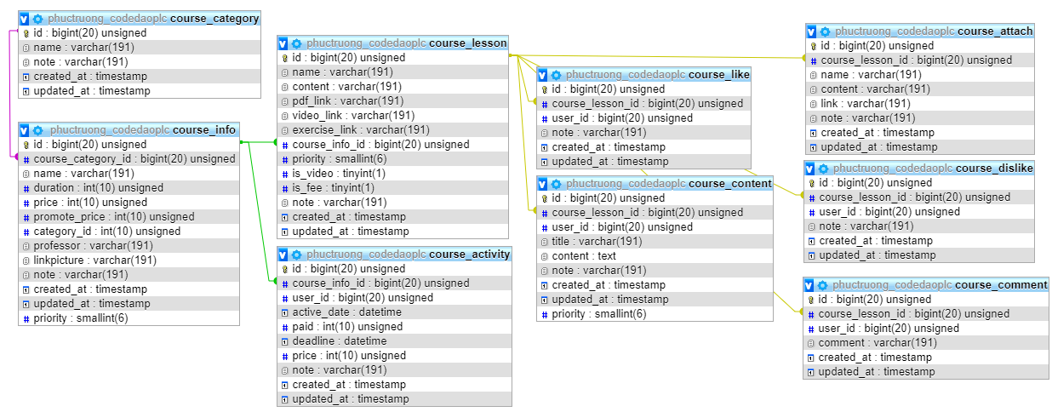

Software share

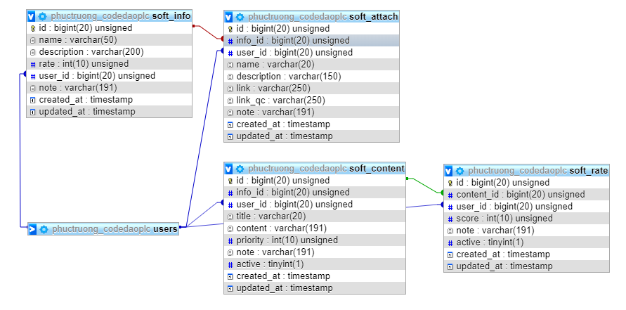

News

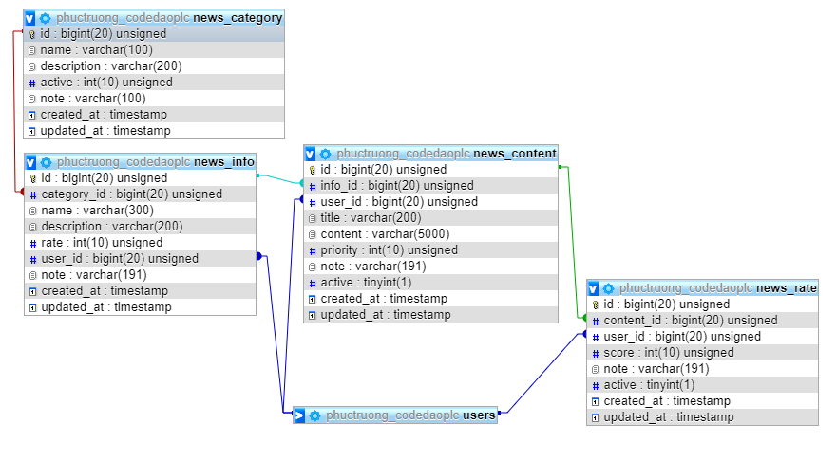

User:

Role

1: member confirm

2: add content

3: admin

4: supper_admin

Link: <https://laravel-news.com/use-laravel-geoip-to-determine-users-geographical-location>

