ARGISENSE
Firmware Overview
Low-power methane, pressure, RS485, and 4-20 mA output firmware proposal
Target board | argisense_u575rg / STM32U575RGT6
Firmware base | Zephyr 4.4.0 application repository
Primary outputs | RS485 / Modbus RTU and 4-20 mA current loop
Document source | docs/firmware-overview.md

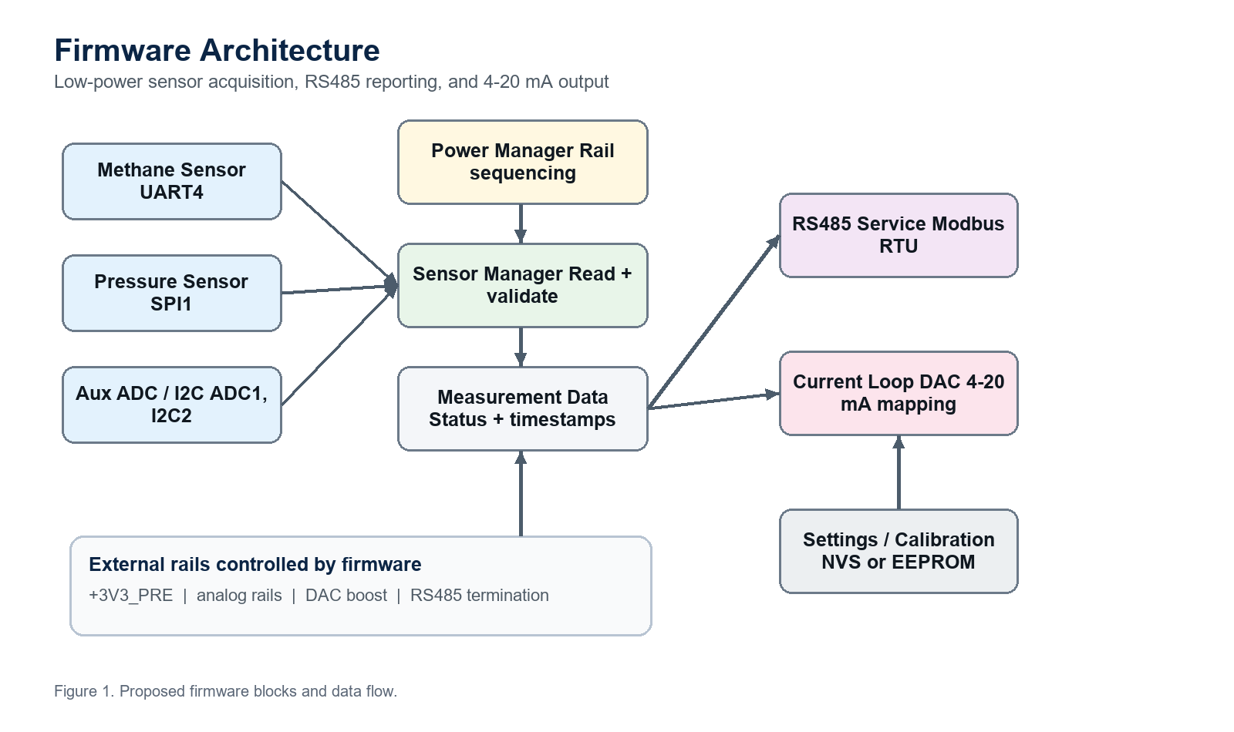
Figure 1. Proposed firmware block diagram and data flow.

Overview
This document describes the proposed firmware architecture for the ArgiSense
low-power sensor board based on STM32U575RGT6 and Zephyr 4.4.0.
The firmware reads methane gas and pressure sensors, publishes measurements over
RS485, and drives a 4-20 mA analog output through the external DAC/current-output
circuit. The design is power-first: external sensor and analog rails are off by
default and are enabled only during measurement or output update windows.

Firmware Goals
- Periodically measure methane gas concentration.
- Periodically measure pressure.
- Optionally read auxiliary environmental data if populated on the board.
- Export live values and status over RS485.
- Drive a 4-20 mA output mapped from a selected process value.
- Keep high-current rails off whenever the board is idle.
- Preserve a clean path for calibration, diagnostics, and future OTA/storage.

Current Board Interfaces
The custom board DTS currently exposes these hardware interfaces:
Function | Zephyr device | MCU pins | Schematic role
Debug console | usart1 | PA9, PA10 | Console/debug UART
RS485 | usart2 | PA2, PA3, PA1 DE | Half-duplex RS485 port
Methane sensor | uart4 | PC10, PC11 | Methane sensor UART
DAC and EEPROM bus | i2c1 | PB8, PB9 | GP8302 DAC and EEPROM
Analog/helper bus | i2c2 | PB10, PB14 | Analog supply monitor and HTU21D
Pressure sensor | spi1 | PA5, PA6, PA7, PA4 CS | Pressure sensor SPI
Thermistor/ADC | adc1 | PC0 / ADC1_IN1 | Analog temperature or board sensing

The board-specific GPIOs are exposed through /zephyr,user:
Property | Purpose | Default firmware state
pre-power-gpios | Enables +3V3_PRE sensor rail | Off
analog-power-gpios | Enables analog positive/negative rail section | Off
dac-power-gpios | Enables DAC/4-20 mA boost supply | Off
dac-alarm-gpios | Reads DAC alarm/status pin | Input
rs485-termination-gpios | Enables optional 120 ohm termination | Off
pressure-ps-gpios | Selects pressure sensor protocol/mode | Configurable
pressure-cs-gpios | Pressure sensor SPI chip select | Inactive

Proposed Runtime Model
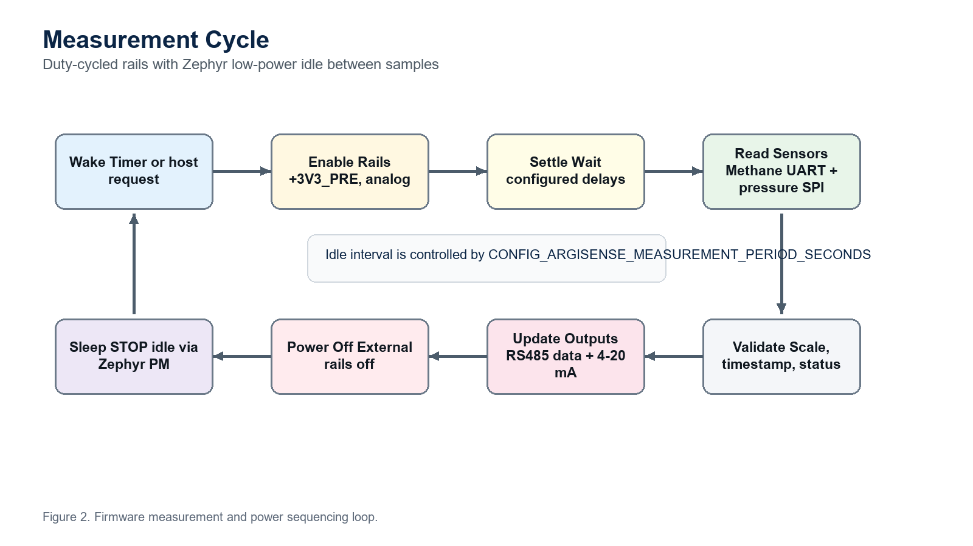
Figure 2. Measurement and rail power sequencing cycle.
The firmware should run as a small event-driven application with one primary
measurement loop and optional communication work items.
Recommended thread/work split:
Component | Responsibility | Suggested context
Power manager | Controls external rails and settle delays | Main thread or service module
Sensor manager | Coordinates methane, pressure, and auxiliary reads | Main measurement loop
Methane driver | UART protocol parser for methane module | Work queue or blocking read with timeout
Pressure driver | SPI transactions and compensation | Main measurement loop
DAC driver | Converts engineering value to 4-20 mA command | Measurement loop or output service
RS485 service | Modbus RTU or framed protocol slave | Dedicated thread or UART async callbacks
Data model | Holds latest measurements, status flags, timestamps | Shared module with locking

The initial implementation can stay simple and run from main.c. Once sensor
drivers grow, split the application into these files:
app/src/main.c
app/src/power_manager.c
app/src/power_manager.h
app/src/sensor_manager.c
app/src/sensor_manager.h
app/src/methane_sensor.c
app/src/methane_sensor.h
app/src/pressure_sensor.c
app/src/pressure_sensor.h
app/src/current_loop_dac.c
app/src/current_loop_dac.h
app/src/rs485_service.c
app/src/rs485_service.h
app/src/measurement_data.c
app/src/measurement_data.h

Measurement Cycle
The proposed measurement sequence is:
- Wake from Zephyr idle.
- Keep RS485 termination disabled unless configured by the host.
- Enable +3V3_PRE.
- Wait CONFIG_ARGISENSE_PRE_RAIL_SETTLE_MS.
- Configure pressure PS mode.
- Enable analog rails.
- Wait CONFIG_ARGISENSE_ANALOG_RAIL_SETTLE_MS.
- Read pressure over SPI.
- Read methane sensor over UART.
- Read optional ADC or I2C environmental values.
- Validate and timestamp all readings.
- Update the internal data model.
- Update the 4-20 mA DAC if enabled.
- Turn off DAC power when the current loop does not need continuous output.
- Turn off analog rails.
- Turn off +3V3_PRE.
- Sleep until the next measurement period.
Current Kconfig duty-cycle controls:
CONFIG_ARGISENSE_MEASUREMENT_PERIOD_SECONDS
CONFIG_ARGISENSE_PRE_RAIL_SETTLE_MS
CONFIG_ARGISENSE_ANALOG_RAIL_SETTLE_MS
CONFIG_ARGISENSE_MEASUREMENT_WINDOW_MS
CONFIG_ARGISENSE_PRESSURE_PS_ACTIVE
CONFIG_ARGISENSE_DAC_POWER_DURING_MEASUREMENT

Methane Sensor Handling
The methane sensor is connected to uart4.
Recommended behavior:
- Default to the sensor module's required baud rate. The current DTS default is
9600 baud.
- Add a frame parser specific to the selected methane module.
- Use a read timeout so the measurement loop cannot hang.
- Track these fields in the data model:
- methane concentration
- methane unit
- sensor status
- warm-up state
- last successful read timestamp
- communication error counter
The methane sensor should be treated as invalid during warm-up or after a UART
timeout. The RS485 status map and 4-20 mA fault behavior must expose this state.

Pressure Sensor Handling
The pressure sensor is connected to spi1 with GPIO chip select on PA4.
Recommended behavior:
- Use SPI mode unless the selected pressure sensor datasheet requires I2C.
- Keep pressure-ps-gpios deterministic before enabling transactions.
- Add sensor-specific compensation in the pressure driver.
- Track these fields:
- raw pressure sample
- compensated pressure
- pressure unit
- sensor temperature if available
- sensor status
- CRC or data-valid flag if supported by the sensor
Pressure sensor chip select should stay inactive while the sensor rail is off.

4-20 mA DAC Output
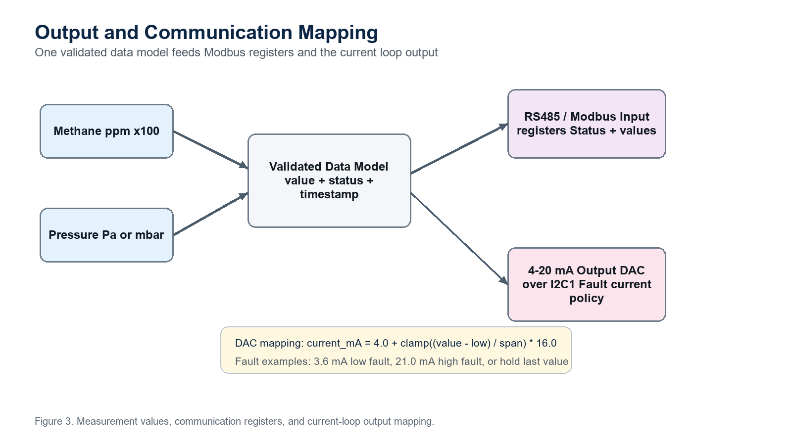
Figure 3. Output scaling to Modbus registers and 4-20 mA current loop.
The DAC/current-output device is on i2c1. The schematic uses a GP8302-family
current DAC circuit with a 0-25 mA capable output stage.
Recommended behavior:
- Keep dac-power-gpios off by default.
- Power the DAC only when output must be refreshed, unless the product
requirement says the 4-20 mA loop must remain continuously driven.
- Map one selected process value to current:
span = clamp((value - range_low) / (range_high - range_low), 0.0, 1.0)
current_mA = 4.0 + (span * 16.0)

- Convert current_mA to the DAC register value using the final DAC resolution
and calibration constants from the DAC datasheet.
- Support fault current policy:
- 3.6 mA for sensor fault or under-range
- 21.0 mA for over-range or configured alarm
- hold-last-value for short transient faults, if required
Recommended Kconfig or settings fields:
output_source = methane | pressure
output_range_low
output_range_high
fault_current_mode = low | high | hold
dac_update_period_seconds

RS485 Communication
The RS485 interface is connected to usart2 with hardware DE on PA1.
Recommended protocol: Modbus RTU slave.
Reasons:
- Common for industrial sensors.
- Easy to test with existing RS485 tools.
- Natural fit for measured values, status words, calibration, and output
configuration.
Default electrical and UART setup:
Setting | Proposed value
Interface | RS485 half-duplex
UART | usart2
Baud rate | 115200 for bring-up, configurable later
Data format | 8N1
DE control | STM32 USART hardware DE
Termination | Disabled by default, host configurable

Proposed register map:
Register | Type | Description
0x0000 | Input | Device status bitfield
0x0001 | Input | Firmware version major/minor
0x0002 | Input | Uptime low word
0x0003 | Input | Uptime high word
0x0010 | Input | Methane value, scaled integer
0x0011 | Input | Methane status
0x0020 | Input | Pressure value, scaled integer
0x0021 | Input | Pressure status
0x0030 | Input | DAC current command in microamps
0x0031 | Input | DAC/alarm status
0x0100 | Holding | Modbus slave address
0x0101 | Holding | RS485 baud preset
0x0110 | Holding | Measurement period seconds
0x0120 | Holding | DAC output source
0x0121 | Holding | DAC range low
0x0122 | Holding | DAC range high
0x0123 | Holding | Fault current mode
0x0200 | Coil | Force measurement
0x0201 | Coil | Enable RS485 termination
0x0202 | Coil | Enable continuous DAC power

All multi-register values should use a documented endianness. For bring-up,
prefer signed 32-bit scaled integers split into two 16-bit registers.

Data Model
Use one central measurement data structure so RS485 and DAC output read from the
same validated state.
Example fields:
struct argisense_measurement {
int32_t methane_ppm_x100;
int32_t pressure_pa;
int32_t board_temp_mc;
uint32_t status_flags;
uint32_t uptime_ms;
int32_t dac_current_ua;
};

Recommended status flags:
BIT(0) methane_valid
BIT(1) pressure_valid
BIT(2) dac_valid
BIT(3) methane_warmup
BIT(4) methane_comm_error
BIT(5) pressure_comm_error
BIT(6) dac_alarm
BIT(7) rail_fault
BIT(8) calibration_missing

Power Strategy
The board should keep only the MCU and always-on support circuitry alive during
idle.
Idle state:
- +3V3_PRE off.
- Analog rails off.
- DAC boost off unless continuous 4-20 mA output is required.
- RS485 termination off unless the installation requires this node to terminate
the bus.
- Pressure CS inactive.
- Zephyr PM allowed to enter STM32U575 STOP idle states.
Measurement state:
- Enable sensor rails.
- Wait for rails to settle.
- Read sensors.
- Update output and communication data.
- Return rails to off state.
Product decision to confirm: whether the 4-20 mA loop must remain driven while
the MCU sleeps. If yes, the DAC power strategy must change from duty-cycled to
continuous or latched-output mode.

Fault Handling
Minimum recommended fault handling:
- If a sensor read fails, keep the last valid value and mark the corresponding
status bit invalid.
- If the same sensor fails for N consecutive cycles, drive the DAC to configured
fault current.
- If DAC alarm is asserted, expose it over RS485 immediately.
- If rail GPIO setup fails at boot, stop the measurement loop and report a fatal
error over console.
- If RS485 receives unsupported commands, respond with a protocol error rather
than silently ignoring them.

Calibration and Persistent Settings
The schematic includes I2C storage support, so firmware should eventually store:
- Methane offset and span calibration.
- Pressure offset and span calibration.
- DAC current trim at 4 mA and 20 mA.
- RS485 address and baud rate.
- Output source and range.
- Measurement period.
- Fault-current policy.
Recommended storage approach:
- Use Zephyr settings/NVS for generic firmware settings.
- Add an EEPROM backend only if the product must store settings outside MCU
internal flash.
- Keep a settings version and CRC so invalid calibration can be detected.

Suggested Implementation Phases
Phase 1 - Board bring-up:
- Keep the current power manager.
- Add GPIO self-test logs for each rail.
- Add I2C scan for i2c1 and i2c2.
- Add simple UART receive test for methane sensor.
- Add pressure SPI device ID read.
Phase 2 - Sensor acquisition:
- Implement methane UART protocol driver.
- Implement pressure sensor driver.
- Add measurement data model and status flags.
- Replace the placeholder measurement window with real sensor reads.
Phase 3 - Outputs:
- Implement GP8302 current DAC driver.
- Add 4-20 mA scaling and fault current policy.
- Add RS485 Modbus RTU slave register map.
Phase 4 - Product behavior:
- Add calibration storage.
- Add configurable measurement period.
- Add watchdog strategy.
- Add low-power validation on real hardware.
- Add hardware-in-loop tests for sensor read, RS485, and DAC output.

Open Hardware Items
These details should be confirmed before final firmware lock:
- Exact methane sensor module and UART protocol.
- Exact pressure sensor part number, SPI mode, and PS polarity.
- GP8302 I2C address, resolution, and alarm polarity.
- Whether 4-20 mA output must be continuously driven while sleeping.
- Whether RS485 default baud should be 9600, 19200, or 115200.
- Whether RS485 termination should be controlled by firmware or fixed by
installer configuration.

