**Partition-route-table**

Khi dien thoai duoc login agent, thi cor cua agent se quyet dinh quyen tren ip-phone do chu ko phai cor cua station

Dial – ARS – Partition_route_table – route_pattern – trunk

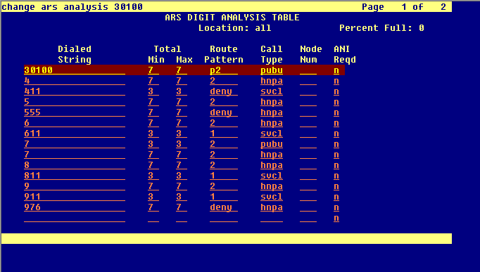

P2: route index, su dung p2, cuoc goi se di theo dong 2(route-index), nhung PGN nao se di theo route-partern tuong ung

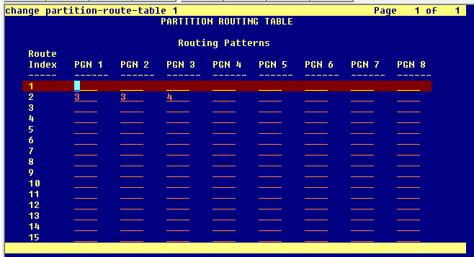

Moi agent co 1 cor, moi cor co 1 time-of-day-char

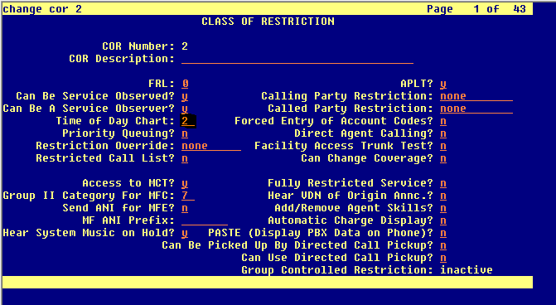

Moi time-of-day-chart se quy dinh thoi gian route cuoc goi den partition-route-table nao

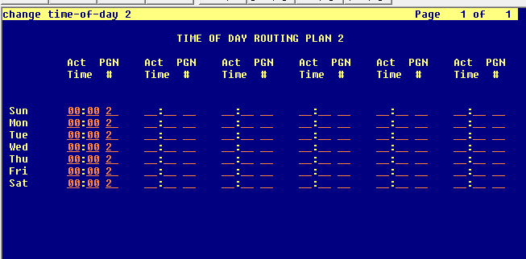

Partition-route-table se route den route partern nao -> trunk

