面包
蛋糕

面包
免揉法式面包

材料:
水 375 g
酵母 5 g
中筋面粉 350 g
盐 5 g

做法：
- 酵母放水里搅拌一下，静置5分钟
- 面粉和盐搅拌一下。加酵母水混合至没有干粉。发酵。
- 等面团涨到两倍大，手指沾点水把面团迭一下赶出气泡。
- 面板上撒干粉，把面团倒出来整形成圆面饼。
- 切成八份，每份揉成圆球醒15分钟
- 取一圆球，擀成长方形，按破气泡，卷起成长园型，放烤盘。
- 整形完毕再醒 30 分钟，烤箱预热440°
- 每个长圆型上划几刀，刷黄油或橄榄油。
- 烤15 分钟。
甜口荷兰松饼
全脂牛奶半杯 118克 中筋面粉半杯 61克 盐 1/4 茶匙 2克
鸡蛋 2 个 无盐黄油 15-20克（1Tbl） 干奶粉一大勺

除黄油外食材混合在一起。 铸铁锅融化黄油，倒入混合液，放入烤箱 425°烤20 分钟。

Good Old Fashioned Pancakes

Ingredients
1 1/2 cups all-purpose flour
3 1/2 teaspoons baking powder
1 teaspoon salt
1 tablespoon white sugar
1 1/4 cups milk
1 egg
3 tablespoons butter, melted

Directions
- In a large bowl, sift together the flour, baking powder, salt and sugar. Make a well in the center and pour in the milk, egg and melted butter; mix until smooth.
- Heat a lightly oiled griddle or frying pan over medium high heat. Pour or scoop the batter onto the griddle, using approximately 1/4 cup for each pancake. Brown on both sides and serve hot.

蛋糕

巧克力慕斯蛋糕 （6 寸）
https://www.youtube.com/watch?v=KMsZMQcrgsI
蛋糕底： 饼干黄油底 或者 戚风蛋糕底
慕斯:
蛋黄 4pcs 糖 35g
牛奶 60g 黑巧克力 240g
Heavy Cream 360g 朗姆酒 10g
吉利丁片2pcs = 4g
Steps:
- Measure all ingredients ahead of time
- On low heat, pour egg yolk, sugar and Rum in. Stir until all melted and start to thicken. Move away from heat.
- Pour in all chocolate and stir until melted and form a smooth liquid.
- Pour in hot milk and stir well.
- Put gelatin sheet in cold water to soften, squeeze out extra water and put in the chocolate mixture. Stir and mix well.
- In a separate bowl, beat heavy cream 50% and smooth and fluffy.
- Scoop some whipped heavy cream into chocolate mixture. Mix well. Then pour all in the whipped cream and mix well.
- Pour into mousse ring on top of the cake bottom. Shake to smooth the top. Leave some space between the mousse ring and the cake bottom so the mousse can sip into outside of the cake bottom to form a smooth side.
- Fridge at least 5 hours.

巧克力奶油： 黑巧克力 30g heavy cream 30g heavy cream 90g
Steps:
1. Mix 30g heavy cream and dark chocolate, in double boiler melt chocolate. Put in fridge for 20 minutes to cool down.
2, Mix in 90g heavy cream.
- Beat until firm. Decorate.

视频中用的蛋糕片参考：https://youtu.be/zDUb4jE4vkk

黑巧克力奶油蛋糕 （6 寸）
https://bbs.wenxuecity.com/cake/1759448.html
- 蛋黄液：
Egg Yolk 3pcs Dark cocoa powder 18g （3tbsp）
Hot oil 38g (3tbsp) Milk 65g
cake flour 55g 1/3cup

- Heat oil in microwave for 45 seconds. Pour in Dark cocoa power and mix well.
- Mix in milk
- Sift in cake flour and mix till no dry flour can be seen
- Mix one egg yolk a time

- 蛋白霜
Egg white 3 pcs sugar 55g 1/4cup
corn starch 1tbsp Lemon juice 1tsp 5g

- Add lemon juice to egg white, beat
- Add sugar in three batches, beat high speed
- Add corn starch, beat till firm
- Fold in 1).
- Put a pan with water in oven preheat to 280F
- Put cake liquid in a 6” cake pan, shake to remove big bubbles. 280F 1 hour
- Put cake upside down to cool down.
- Slice into three even layers

- 巧克力奶油 （6寸蛋糕减半使用）
Chocolate Ganache
Dark chocolate 140g
Milk Or heavy Cream 60g 1/2 cup

Melt chocolate in milk/heavy cream and put in fridge to cool down.

heavy whipping cream 473ml 2cup sugar 25g 2tbsp
加入放凉的Chocolate Ganache，一起打发成巧克力奶油。

6寸巧克力脏脏云朵蛋糕

https://bbs.wenxuecity.com/cake/1762199.html 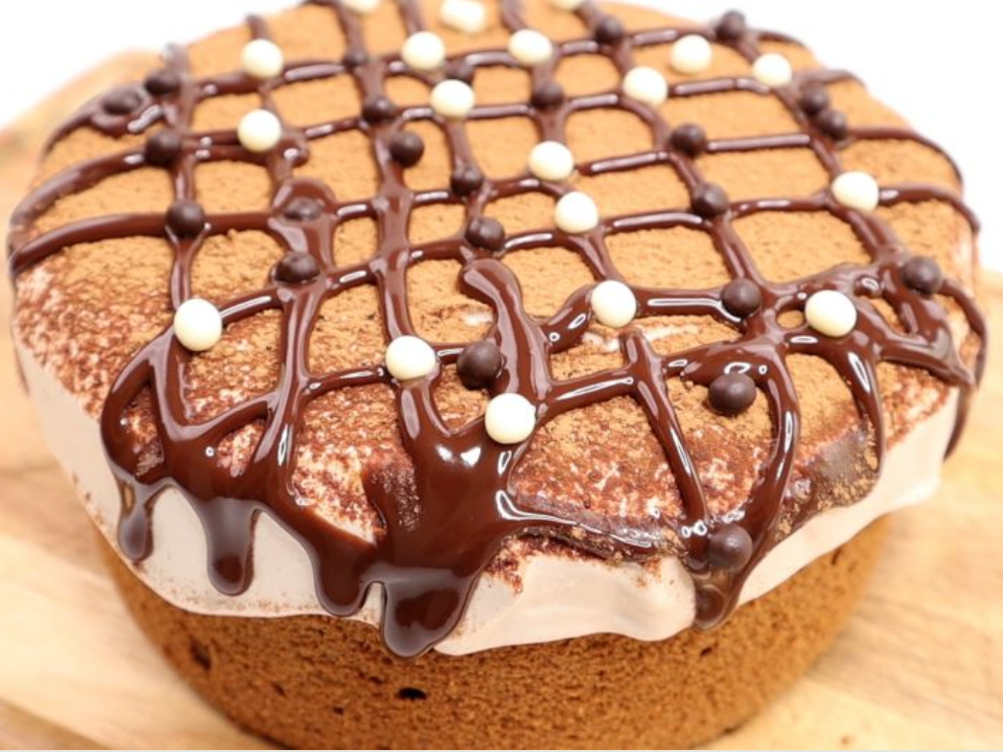

巧克力云朵蛋糕：3 pcs 鸡蛋；50g 牛奶; 40g色拉油; 50g低筋面粉; 10g可可粉; 2g浓缩咖啡粉; 50g白砂糖

Steps

面粉， 可可粉过筛， 色拉油加热到80F（不超过90F）， 倒入干粉中， 搅拌均匀。 加入牛奶， 搅拌均匀

蛋黄加入1 中，搅拌均匀

蛋白，糖， 干性打发

翻拌混合2， 3

倒入6寸摸具， 350F 45 分钟

巧克力甘纳许: 50g 巧克力豆; 50g淡奶油

Steps

heavy cream microwaved 30sec.

Pour in chocolate chips, cover for 5 minutes. Stir till smooth.

Refrigrate 5-10 minutes to thicken it

巧克力奶油：200g 淡奶油；15g 白砂糖；30g 甘纳许

This might be too much for this cake. Can reduce 30-50%
Steps
- Put 30g Ganache in heavy cream, beat till like yogurt
- Take the middle part of the cake out, put in some of the 1, put back the cake part.
- Put the rest of 1 on top and smooth out.
- Top with coco powder
- Use the rest of Ganache to decorate the top.

巴斯克焦糖香流心芝士蛋糕

400g 1.67cups Unsalted Cream Cheese

200g 0.84cup Heavy whipping cream
80g 1/3cup Sugar

5drops or more Vanilla Essence
3eggs 57g/each

1.5tbsp 13g Corn starch

活底模具，铺上烘焙纸

室温软化的无盐奶油奶酪，加糖和蛋液, vanilla extract，搅匀

加入heavy cream, 搅匀

Corn Starch过筛, 搅匀

面糊最后过筛一次更细腻(optional)

450F 25 min

冷藏5小时以上

戚风蛋糕卷
Eggs Yolks: 5  Veg Oil: 48g  Milk: 90g  Flour: 55g – 60g (60g if no other dry ingredient)  (optional)Coco Powder: 10g  (optional)Greentea powder: 5g | Eggs Whites: 5  Cream of Tarta  Sugar: 55g

330F

13”x9” - 14min

10”x12” – 18min

撒葱花肉松在表面烤。

凉到室温，铺Mannaise,肉松， 卷紧定型。室温放凉。

Tirumisu

Whipping cream 400g

Mascarpone 225g

Sugar 58g

Rum 15ml

Gelatin 1 pack （7克）

Lady fingers

Coffee 200ml

Rum 15ml

Cocoa powder

中速打发 WhippingCream 至浓稠， 加入Mascarpone cheese。 打匀

加糖， Rumors， 打匀

Gelatin 凉水搅匀， 用温水化开， 不要有疙瘩。

将化开的Gelatin 加入2 中

速溶咖啡200ml， 加入15ml Rum

手指饼干在5中略浸一下， 放入6“方形蛋糕摸具， 底部是可以脱模的。

铺好第一层， 加入一半的4料抹匀

重复6-7

放冰箱冷藏5+小时

脱模， 表面撒可可粉做装饰

https://www.youtube.com/watch?v=Kzkqn1flIMI

6寸咸奶油戚风蛋糕
蛋糕体
玉米油 40克 （加热）  可可粉 15克  牛奶 50克  低筋面粉 45 克  蛋黄 4 个 | 糖 35克  蛋清 4 个  塔塔粉
311F 40分钟 （ 280F 20分钟， 300F10 分钟 311 10-20 分钟）
两个六寸蛋糕模， 2/3， 1/3. 分成三片

焦糖酱
白糖 100 克
水 26克 淡奶油 100克（加热） 黄油 26克 盐 2克
熬制冒大泡，变焦糖颜色。加入温的淡奶油， 搅拌， 加入黄油， 盐。 搅拌丝滑倒入容器冷藏过夜。

焦糖咸奶油
焦糖酱 100 克， 淡奶油 320 克， 盐 2 克

焦糖果仁
糖 20 克， 水 克，黄油 5 克 果仁 80克
加热至融化， 加入黄油， 果仁， 慢慢炒至焦糖色， 离火继续炒至浓稠， 摊开放在拷盘上凉凉。

薄脆
黑巧克力 50 克
玉米cereral 50克 焦糖果仁 30 克
黑巧加热至融化， 倒入玉米脆片， 搅匀。 加入碾碎的果仁搅匀凉凉

布丁
蛋黄 1 糖 8克 牛奶 80 克 淡奶油 80 克， 香草精 几滴 吉利丁 3克
所有食材除吉利丁外混合加热至冒泡， 加入吉利丁片。搅匀至融化。 倒入六寸摸具冷藏过夜或冷冻2小时定型

西餐
Kyle’s One90 Brisket Chili
Beef Brisket/Roast 2lb 抹胡椒盐腌一晚。 除血水。
高压锅加
Coke/Dr Pepper 4 oz
Onion .5
Bell Peppers 1
Tomato Sauce 2 cups
Worcestershire 2 TBSP
Vinegar 2 TBSP
Ketchup .5 cup
Creole Mustard .5 cup
Paprika 2 TBSP
Chili Powder 4 TBSP ( reduce. This is too spicy)
Garlic Powder 1 TBSP
Cumin 1 TBSP
Cayenne 1 TBSP
Honey 1 TBSP
Salt/Pepper to taste
Corn Starch As needed

炖至烂

instant pot mexican shredded beef
★★★★★

5 from 47 reviews

Author: Amy @ The Blond Cook Total Time: 1 hour 50 minutes Yield: 6 servings
INGREDIENTS
1 cup beef broth
1 teaspoon kosher salt
1 teaspoon freshly cracked black pepper
1 tablespoon ground cumin
2 teaspoons chili powder
1 teaspoon garlic powder
1 teaspoon onion powder
1 teaspoon paprika
1 teaspoon dried oregano
1 teaspoon crushed red pepper flakes
2 tablespoons olive oil
1 (2-1/2 to 3-pound) boneless chuck roast
1 cup prepared salsa
INSTRUCTIONS
Pour beef broth in a small bowl. Add salt, pepper, cumin, chili powder, garlic powder, onion powder, paprika, oregano and crushed red pepper flakes. Whisk to combine and set aside.
Pour oil into your Instant Pot and set to saute. When oil is heated, sear roast on all sides until browned. Turn off Instant Pot.
Pour beef broth mixture and salsa over roast.
Place the lid on pressure cooker and lock. Steam release knob should be set on “sealing”. Cook on manual setting (high pressure) for 70 minutes. Allow pressure to release naturally.
Remove beef from pressure cooker and shred with 2 forks, discarding any fat. Allow fat to rise in liquid and skim off fat. Return beef to liquid mixture.
NOTES
I used an Instant Pot LUX80 8 quart in this recipe.
Cook time includes time it takes for pot to come to pressure and natural release time.

Air Fryer Roasted Butternut Squash & Kale Salad with Balsamic-Maple Dressing
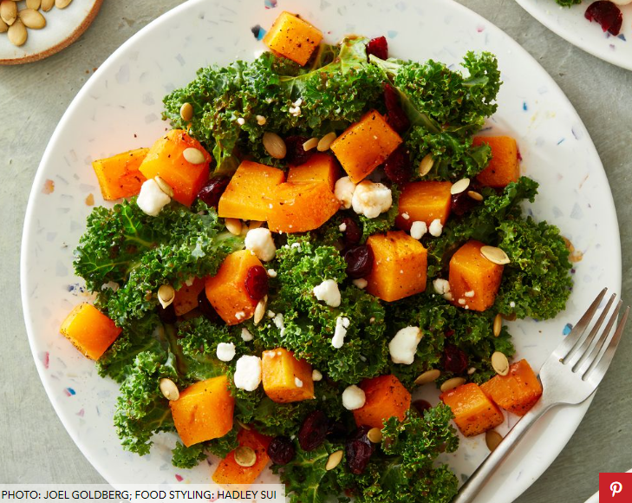
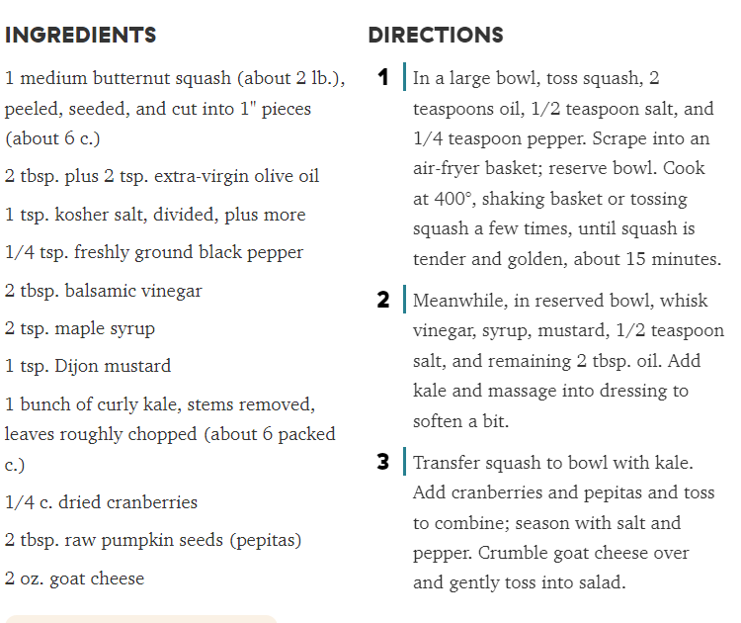

Avocado Tomato Salad

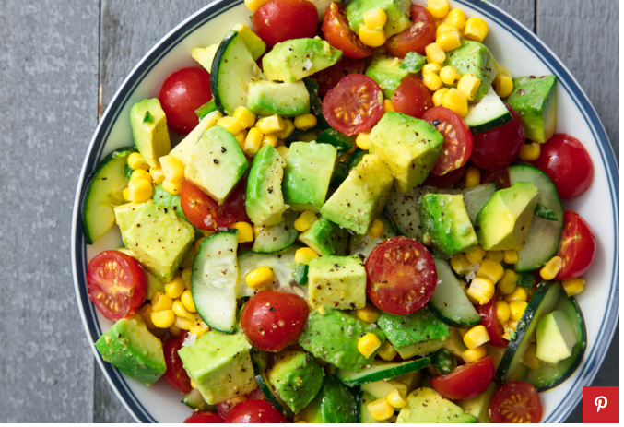
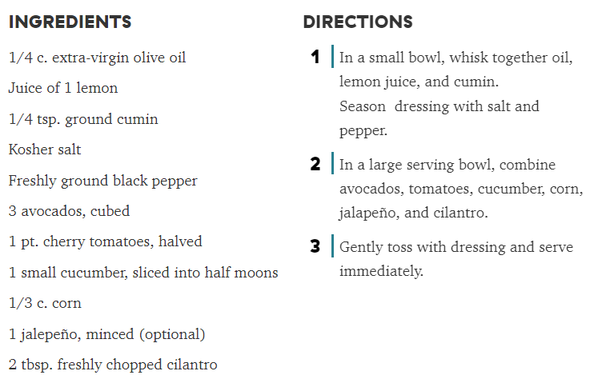

Southwestern Chopped Salad

