now, have a look at the signals

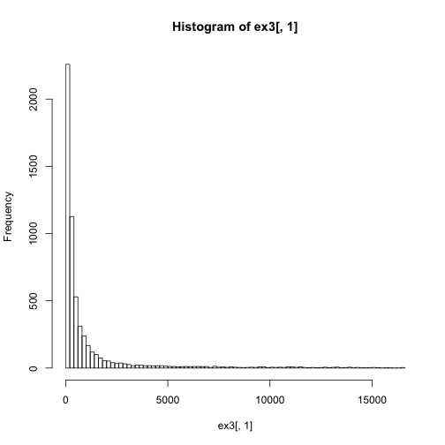

outfilename = paste(myGSE, "_log2CV.csv", sep='')

write.csv(myarray, outfilename, row.names=F)

hist(ex3[,1], br=100)

ex4 = log2(ex3)



hist(ex4[,3])

ex4[ex4<0] = NA

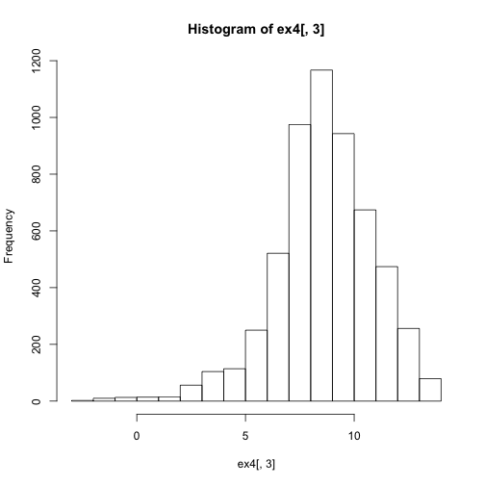

hist(test$myCV, br=100)

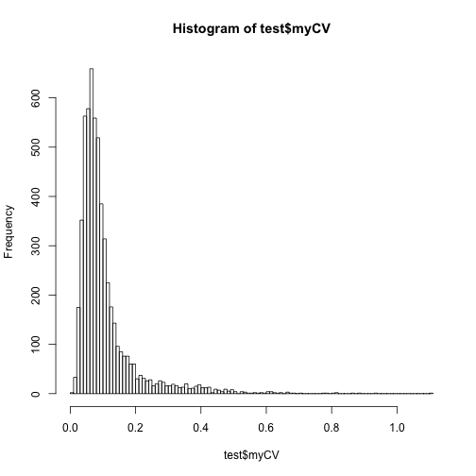

hist(test$myStddev, br=100)

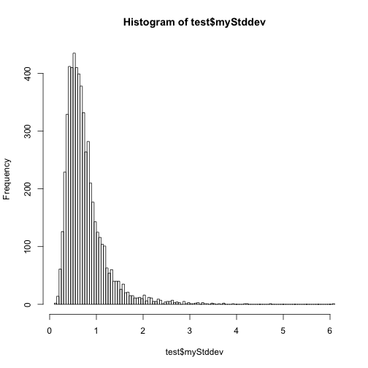

hist(test$myMean, br=100)

