The FACSCalibur can detect 4000 events/second and measure up to 6 different characteristics/parameters at the same time and analyze them. It exploits these characteristic interactions to generate useful signals. It is comprised of three main systems:

- Fluidics system – transports particles (cells) in a stream to the laser beam for interrogation. Any particle or cell from 0.2-150 micrometers in size is suitable for analysis.
- Optics bench/system – consists of lasers to illuminate the particles in the sample stream and optical filters to direct the resulting light signals to the appropriate detectors. When particles pass through the laser they scatter light to produce the following signals:

- Non-Fluorescent signals
  - Forward scatter (FSC) - related to cell size and is detected along the axis of incident light in the forward direction,
  - Side scatter (SSC) – related to cell granularity / internal complexity and is detected at 90° to the incident light.

  - Fluorescent signals
  - Fluorescent light – is a measure of the relative fluorescence of the particles in your sample.
  - It is proportional to the number of fluorometric groups (i.e. conjugated antibodies) that are present on each particle. Also detected at 90° to the incident light – measured by FL 1-4 detectors.

  - Electronics system – The scattered and fluorescent light is picked up by the detectors which produce electronic signals proportional to the optical signals striking them, which can then be processed by the computer.

Using the characteristics of size and granularity alone, the FACSCalibur is capable of resolving hundreds of events within a mixed population into a profile relating to size, shape and internal complexity (Fig.1). Particles/cells in the same FSC-SSC group can be further distinguished according to the antigens/chemical groups present on their surface – leading to further selection.

Altogether, these three characteristics can be exploited to target, separate, class or identify mixed and homogenous populations of particles/cells.
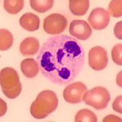
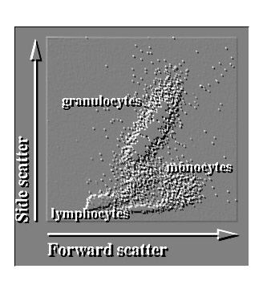
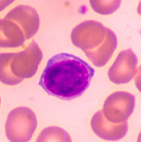
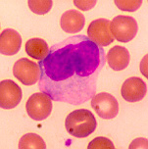
Fig. 1 This shows a simple scatter/dot plot representing the relationship between FSC and SSC characteristics in a mixed population of white blood cells: 1. Granulocytes (e.g. Eosinophils and Neutrophils - these have light staining granules of various sizes. The nucleus is frequently multi-lobed with lobes connected by thin strands of nuclear material, and 2. Agranulocytes (e.g. Lymphocytes and Monocytes – These are agranular cells with very clear cytoplasm and large nucleus, i.e. notice that the nucleus almost fills the cell leaving a very thin rim of cytoplasm. The nucleus is ruggedly spherical in lymphocytes and most often "U" or kidney bean shaped in monocytes.

I) Turning on and preparing the cytometer.

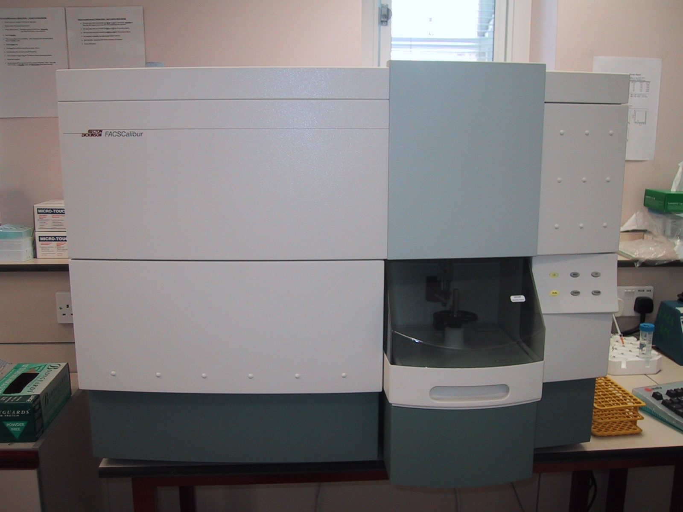
“On” Switch
“Run” speed, i.e. Lo, Med and Hi.
Run
Standby
Prime
Fluidic system
Optical bench
Electronics system

- Make sure the fluidics pressure switch is on “tank change” (towards the back - the system must initially be in a depressurized state).
- Make sure the computer is turned off before turning on the cytometer – otherwise the computer will not initialise the cytometer when the computer is turned on.
- Turn on the cytometer (green button - the right hand side)
- Turn on the fuidics system (under the cytometer – green button – top right)
- Pressurize the cytometer (pull the switch forward to “pressurise”)
- Remove dH₂O tube from the SIP
- Leave SIP support arm to one side and press the Prime button (this will turn red whilst active). This helps to remove any bubbles in the system.
- Repeat this twice more.
- Place tube of FACS flow onto SIP (and close the support arm), run on LOW (this warms up the laser). The LOW button should turn green, if it turns amber – prime again. If it is still on amber follow the cleaning protocol.

The sample injection port (SIP) holds the sample in place and allows the sample to be drawn upwards towards the laser. Interrogation of a single cell suspension is achieved by hydrodynamic focusing (differential pressure of the sample and sheath fluid) whilst on the Low run setting (see figure 1).

Sheath
Sheath
Sample
Hydrodynamic focusing
Figure 1. Sample flow – FACS Calibur

CAUTION: When placing your sample on the SIP, it is safer for the cytometer to be in Standby mode, other than Run, otherwise there is a danger your sample will be aspirated and removed to the waste reservoir.

II) Creating an optimisation template:
- Turn on the computer and open CellQuest.
- Open a new document and maximise
(for ease of working, use a two page document - go to File>Document size and highlight two pages)
- Draw a dot plot of forward scatter (FCS – x axis) vs side scatter (SSC – y axis).
- When the dot plot is drawn, the Dot Plot window appears. From this choose the plot source as Acquisition to Analysis.
- The Dot Plot menu also gives you the option to chose how much of the data is shown at any one time, i.e. # of Events (when optimising instrument it is handy to show a low number so you can see the population moving and so positioning the population becomes easier), and to do Multicolour Gating (this is helpful to visually distinguish regions of interest).

We now need to distinguish the fluorescence on our cells.

- Draw histograms for each of your fluorochrometric labels (i.e. FL1, FITC; FL2, PE and; FL3, PerCP). Again remember to change the plot source from Acquisition to Acquisition to Analysis.
- Onto each of the histograms place a marker from the 1st log decade to the last log decade (to differentiate between positive and negative events for the fluorochrome-labelled sample).
Hint: After placing the marker onto the first histogram, it is easier to copy and paste this one onto the remaining ones. Make sure the marker is selected, then go to Edit > Copy and select the destination plot and Paste the marker onto the new histogram.
- Select a marker and then select Stats > Histogram stats. A statistics box will now be shown.
- Select Edit stats from the Stats menu. Change the selection from live stats to cumulative.
- Repeat for the second and third histogram – the edit step does not need repetition as previous editing is replicated in all.
- Draw dot plots for “FL1 vs FL2” and “FL2 vs FL3” (remembering Acquisition to Analysis mode).
- Draw a Quadrant Marker into each of these dot plots so that the bottom left quadrant is marking the 1st log decade. This positioning is arbitrary but placing unlabelled cells in this 1st quadrant should allow for all positive events to be on scale (again, copy the 1st quadrant marker into the others).
- Again select the quadrant and go to Stats > Quadrant stats.
- Select Edit stats from the Stats menu. This allows you to uncheck anything we don’t need to show in the stats box. Also change the selection from live stats to cumulative.
- Repeat for the second dot plot. Again, any editing is already replicated.

We now have the optimisation template showing forward scatter (FSC) against side scatter (SSC) dot plots, a histogram for each fluorochrome, dot plots representing the “FL1 vs FL2” and “FL2 vs FL3” relationships (which will allow us to set compensation) and statistics for each plot. We can now save this template and use this again if we were to run another three colour experiment.

III) Optimising data acquisition:
- Connect the computer to the cytometer via the Acquire menu. The cytometer menu becomes active and an Acquisition Control box appears. (When the Run button is pressed on the cytometer, the sample is drawn up but data is not acquired until the Acquire button on the Acquisition Control box is pressed)
- From the Cytometer menu select Threshold, Compensation, Detector/Amps and Status so all of these windows appear.
- The threshold is usually set on a default value of 52 on the FSC parameter. This will only display data that has a forward scatter light value in channel 52 or above. Any value lower than this will be rejected (i.e. debris). This is fine and so the Threshold menu can be closed.
- Run an unlabelled sample
- Observe the FSC and SCC dot plot (lin/linear). Using the Detectors and Amps, adjust the FSC voltage to center the cells on your FSC/SSC dot plot. (The voltage for FSC is in increments of 10 i.e. E00 multiplies the signal by 10⁰ or 1, E01-10¹ or 10, E02-10² or 100, E03-10³ or 1000. E-1 multpiplies the signal by 10⁻¹ or 0.1 and this setting reduces the signal of large events). Use the Amp gain to adjust the cells to the center of the plot. Next, adjust the SSC by first using the voltage, then the Amp gain to center the cells by clicking on the arrow keys.

Note: The center bar may be used to move quickly through the range of voltages, or the arrows will move by tens if the option key is held down when they are used.

Be sure the FSC and SSC are in linear, while the fluorescence parameters should be in log. Logarithmic amplification increases the resolution of weak signals and increases the dynamic range of the measurements so that both weak and strong signals can be displayed on the same scale.

- All cells have an autofluorescence and therefore we need to optimize the cytometer so that this autofluorescence will be seen as unlabelled (Fig2).
- Using the Detectors and Amps, you will position your negative control in the 10¹ decade of your histogram, or in the 10¹ decades of your dot plot (the lower left-hand corner) in the same way the voltage was adjusted for the FSC and SSC.

We now need to set compensation.

Compensation:

Color Fluorochrome Detector Filter__

Green FITC FL1 530/30nm
Yellow/Orange PE FL2 585/42nm
Dark red PerCP etc FL3 670nm LP
Red APC FL4 661/16nm

Note: When using two or more fluorochromes we need to set the Compensation. This is because there may be spectral overlap of one fluorochrome into the detector intended to measure the fluorescence of the second fluorochrome and vice versa. In other words, when compensation is not set, cells labelled with only PE can be detected not only In the orange (PE) detector but also in the green (FITC) and red (tandem or PerCP) channels. When compensation is properly set, cells labelled with only PE record the same fluorescence as unlabelled cells when observed in the green (FITC) and red (PerCP) channels.

- Run the singly labelled FL1 sample (i.e. FITC).
- The cells will appear in the double positive quadrant on the FL1 vs FL2 dot plot (upper right).
- Using the compensation control window move the FL1-labelled cells so they appear only in the FL1-positive quadrant i.e. lower right. To do this, use the FL2-FL1% button (this subtracts the amount of unwanted signal from the FL1 detector). It is good practice to have the Y geometric mean of the FL1-positive population the same as the Y geometric mean of the FL1-negative population – i.e. so the populations lies at the intersection of the “dashed” axes. FL1 labelled cells should now appear the same as unlabelled cells when viewed on the FL2 and FL3 histograms.

FL1
FL2
Fig.2

- Repeat for FL2-only (i.e. PE) labelled cells (this needs to be subtracted from both the FL1 and FL3 detectors as the FL2-label is detected in both as well as FL2 so use FL1-FL2% and FL3- FL2%). Here, make sure that the x-geometric means are equal (Fig. 3).

FL1
FL2
Fig.3

- Repeat for FL3-only (PerCP) labelled cells. FL3 labels may be detected by the FL2 detector so use FL2-FL3% compensation. Again, make sure the x-geometric means are equal (Fig. 4).
- FL3 labels don’t need to be compensated for FL1-detectors, and FL1 labels don’t need compensation for FL3 detectors, as their emission spectra are far enough away from each other. If FITC is being picked up in FL3, and vice versa, then the detector is too sensitive and its voltage needs to be lowered.

FL1
FL2
Fig.3

- Run a mixed tube. You should not see any cells appearing in double-positive quadrants of the dot plots.

We can now save the instrument settings (Cytometer>Instrument settings> Save - choose desired folder). This is what needs to be carried out before the experiment if more than one fluorochrome is used. If the same cells with the same Ab staining are used with exactly the same protocol then these instrument settings can be loaded up for subsequent experiments – but I would still advise checking settings beforehand.

If only one label is used, skip this Compensation step.

Acquisition parameters
We need to set up acquisition parameters for when we run an experiment (i.e. we tell the computer exactly what information to accept and store)

- Choose Acquisition and Storage from the Acquire menu – the Acquisition and Storage window appears
- Data from the cytometer is processed through the Acquisition Gate first (i.e. this tells the computer which data sets to accept when we run the sample). It is advisable to Accept All at this point as any data not collected here cannot be retrieved!
- Next we can choose either Event Count or Time from the Collection Criteria pop up menu (this allows us to choose x number of events or events over time, and data is acquired until this count is reached). Leave the defaults 10000 and All.
- Leave the default All in the Storage Gate pop up menu. (Data storage is defined here. All events or data within a particular gate can be stored in a data file).
- Leave the default 1024 for Resolution
- Click okay in the Acquisition and Storage window.

Parameter Description
File storage and parameter labels are defined in the Parameter Description window

- Choose Parameter Description from the Acquire menu. The Parameter Description window appears
- Click the Folder button. Navigate to the correct folder to save your file into.
- Click the Select *NAME* button at the bottom of the dialog box.
- Click the File button. The File Name Editor appears. Type in your filename
- Click OK.

Labelling samples and parameters. There are different ways to label samples (i.e. tubes) and their associated parameters in CellQuest. One way is to type names into the Sample/Patient ID windows and use the pop up menus for P1-9 in the Parameter Description window. The other way is to create a reagent panel.
- Choose Edit Panels from the Acquire menu. The Edit Panels dialog box appears.
- Click the Add button above the panels list. The new panel will be added to the bottom of the list with the default name New Panel. Enter a new panel name.
- Click the icon to the left of the panel name to select it.
- Click the Add button above the Tubes list. A new tube is added. Enter a name for the new tube.
- Click the icon to the left of the tube name to select it.
- Select labels for the parameters by clicking on the arrow in the labels list next to the parameters field or just type in your own parameter.
- Label the parameters as follows:

P1 – Forward Scatter
P2 - Side Scatter
P3 – FITC/FL1
P4 – PE/FL2
P5 – PerCP/FL3

- Click Add above the Tubes list to add another tube to the panel. Type a name for the tube and define the parameter labels

Note: If you are measuring the same parameters for all of our tubes in this experiment, we can highlight the first tube and click Duplicate above the Tubes list. This will copy all the parameters that we have listed for the first tube onto the second tube. Name the second tube. Repeat this for all five tubes – e.g. Unlabelled, FITC, PE, PerCP and Mixed.

- Click OK. The panel is defined – we have named the tubes and labelled these for all parameters measured in the experiment.
- To implement these changes for the experiment, click the Panel checkbox in the Parameter Description window.
- Choose the reagent panel that you have just created in the panel pop up menu.

Note: Make sure the first tube in the panel is displayed in the window. Leave the Parameter Description window open so you can view the parameter labels and ensure you are running the correct tube.

Acquisition of data
- Open up your template document (make sure the plots are on acquisition to analysis)
- Choose Counters from the Acquire menu.
- Install your first/control/unlabelled tube on the SIP and place cytometer on Run mode.
- Click Acquire and verify that acquisition is successful.
- Deselect the Setup check box in the Acquisition Control window.
- Click Acquire again to run and save your sample– the system beeps upon completion of the acquisition (once the predetermined total number of events has been detected).
- With the system still running, replace the control tube with your FITC tube. Repeat.
- Once all the samples have been acquired, select the Setup checkbox and switch the cytometer to Standby mode. Save template.
- Proceed with the shutdown procedure.

Analysis of data

Flow cytometric data can be displayed on either a linear or a logarithmic scale.

Logarithmic scale

The use of a logarithmic scale is necessary in the events where distributions are skewed to the right. The Log mode normalises the distribution - log-transformation.

The use of a logarithmic scale is also required when there is a broad range of fluorescence as this can then be compressed; again this is true of most biological distributions.

Linear scale

Linear scaling is used when there is not such a broad range of signals, e.g. in QC assays (using beads), DNA analysis and calcium flux measurement.
Data from a single data channel (i.e. FSC, SSC, FL1, etc) is displayed as a histogram in which the x axis is divided into 1024 channels. If the data is in a linear scale, the channel number and the linear value for that channel will be easily obtained.

On a logarithmic scale, the x axis is still divided into 1024 channels, but it is now displayed as a 4-log decade scale. For log transformed data, we can choose either channel numbers or linear values. We can relate the two as each log decade takes up a quarter of the available channels.

i.e.

1st Log = channels 0 to 255 = linear values 1 to 10;
2nd log = channels 256-511 = linear values 10-100
3rd log = channels 512-767 = linear values 100-1000
4th log = channels 768-1023 = linear values 1000-10000.

The linear value for a particular channel number, N, may be calculated as so,

N = anti-log (channel number/256).

Quantification
To quantify flow cytometric data we need to look at the measures of the distribution of a population. The measures of central tendency are:

  - the mode
  - the mean
  - the median
To compare absolute fluorescence values, it is best to use linear values as these can be directly compared, i.e., a cell with a linear value of 100 is 10 times brighter than a cell with a linear value of 10. This cannot be done with channel number - a cell in channel 512 is still 10 times as bright as one in channel 256- we have to talk about 'channel shifts', i.e., a shift in fluorescence intensity of 256 channels.
Logic and consistency are the keys to successful data analysis in flow cytometry, and realising that at best flow cytometry is only semi-quantitative. It is excellent for relative comparisons but more problematic when asking for absolute quantitative data. If you have any queries or questions, we are always available for advice!

If you have any questions regarding data analysis, please contact:

Tomas Adejumo, t.adejumo@ucl.ac.uk, 02076796719
Zoe Ward, z.ward@ucl.ac.uk, 0207-679-6719

Appendix

PMT detection

Please note that the available PMT’s on the FACSCalibur have a finite range for detection and must be considered when choosing appropriate labels for your experiment.

