1. Which of the following is **NOT** a property of the yeast strain used for the functional assay?
2. It lacks a functional MSH2 gene
3. It requires tryptophan to grow
4. It requires histidine to grow
5. **It contains the pSH44 plasmid carrying a mutant URA3 gene**
6. None of the above
7. The potent drug, 5-FOA is used for complementation assay because
8. the URA3 gene combines with it to produce a color change
9. **it can be converted into a toxic form (5-FU) by an enzyme coded for by the URA3 gene**
10. it is able to make transformed yeast cells grow
11. it does all of the above
12. Which of the following statements are true about the pRS413 plasmid?
    1. May contain WT or Mutant allele of MSH2 gene
    2. It contains His3 gene that rescues the yeast strain from His dependence
    3. It contains antibiotic resistance gene that allows for selection of plasmid-containing bacteria during cloning
    4. Only A and B are true
    5. **All of the above are true**
13. The biological name for the yeast utilized in the second phase of your project is
14. Candida Albicans
15. **Saccharomyces cerevisiae**
16. Zygosaccharomyces
17. Escherisia coli
18. Cryptococcus neoformans
19. Where is the gene responsible for producing MSH2 located in the yeast cell used

for your transformation and complementation experiments?

1. Yeast genome
2. Yeast membrane
3. **pRS413 plasmid**
4. pSH44 plasmid
5. Culture plate
6. In Genetic Nomenclature *his*-means:

a. we are dealing with a protein, specifically an enzyme synthesizing lysine

**b. we are looking at a recessive *His* allele, in yeast requiring histidine**

**supplementation in media**

c. it is a dominant gene allele

d. wild type gene coding for a Lysine synthesizing enzyme

1. To confirm successful transformation of yeast with our plasmids we did which of the following:

**a. we plated transformants on SD-his-trp plates (lacks histidine & tryptophan)**

b. used a strain of yeast commonly dependent on agarose

c. we used negative selection with 5-FOA to confirm the MSH2 gene was present

d. we transferred the yeast onto the YPD plate to select transformants

e. we plated transformants on SD-his-trp plates that only have histidine and tryptophan

1. Mutation in which one of the domains of the MSH2 may result in a non-functional protein:

a. the protein binding domain

b. the DNA binding domain

c. the ATPase domain

**d. all of the above**

1. Open Reading Frame (ORF) for a gene represents

a**. complete set of expressed sequences (exons)**

b. Complete set of intervening sequences (introns)

c. Combined set of introns and exons

d. Complete set of amino acids

e. Product of the gene replication

1. Which of these internet links is best suited for obtaining a complete nucleotide sequence (both introns and exons) for the human MSH2 gene:

a. Google

b. Wikipedia

c. Biology Workbench

d. Yahoo

**e. Pubmed**

1. Based on your knowledge of the cell cycle and MSH2 function, which part of the cell cycle is this protein active in?

**a. S phase**

b. M phase

c. G1 phase

d. G2 phase

1. In PAGE analysis we used a certain reagent to help us give the protein charge and denature them, the name of the reagent is:

a. Ethidium Bromide

b. B-mercaptoethanol

**c. sodium dodecyl sulfate**

d. dithiotreitiol

1. To **transform** yeast means to:

a. Convert one strain of yeast into another

**b. Introduce into the yeast cell a foreign DNA sequence, which can be inherited and expressed**

c. Add an antibiotic to the growth media to allow for survival of one strain of yeast

d. Insert a gene into a specific yeast strain that can only be copied but NOT expressed

1. Hallmarks of a cancer cell include all of the following **EXCEPT**:

a. ability to go through cell cycle check points without proper DNA repair

b. ability to avoid apoptosis (cell death)

c. ability to promote formation of new blood vessels

**d. ability to differentiate into a specialized cell**

e. ability to invade local surrounding tissues and metastasize

1. Major source of restriction enzymes are...:

a. liver cells

b. pancreatic cells

**c. bacterial cells**

d. B cells

e. yeast cells

1. Which of the following should **NOT** be included in an abstract of a paper?

a. hypothesis

**b. acknowledgements**

c. summary of methods

d. summary of results

e. conclusions

1. When a yeast cell has homologous pairs of chromosomes it is said to be
2. Haploid
3. Autologous
4. Heterologous
5. **Diploid**
6. Mutated
7. The strands of DNA are held together by which of the following?

a. interstrand cross-links

b. van der waals interactions between neighboring bases on the same strand

**c. hydrogen bonds between the bases of anti-parallel strands**

d. covalent bonds

e. all of the above

1. You have a 20 X solution of coomassie blue in your laboratory. You need to stain protein on several PAGE gels so you need to prepare 250 mL of 1X coomassie blue solution. How much of the 20X solution should you add to water to make your 1x solution?

**a. 12.5 mL**

b. 12.5 uL

c. 25 mL

d. 10 uL

e. 250 mL

20. Polymerase chain reaction (PCR) is:

a. a way in which cells can increase the amount of mRNA

b. a means of amplifying the amount of DNA in a cell

**c. a means of amplifying a specific segment of DNA in the lab**

d. a nuclear reaction that leads to mutations in microsatellite DNA

1. A mutation that results in the formation of a stop codon and subsequent premature termination of protein synthesis is a:
   1. Missense mutation
   2. Frameshift mutation
   3. Silent mutation
   4. **Nonsense mutation**

22. Yeast constitutes a great model organism for molecular studies because:

1. They are simple prokaryotic organisms with a lot of similarities to human cells
2. Even though their genome is not fully sequenced we know it is small and

simple

1. **they can exist in a haploid or diploid form, are simple to manipulate, and**
2. **recapitulate all key cellular processes observed in a eukaryotic cell**
3. they multiply by budding or direct division
4. In PCR which of the following ingredients allows us to control WHICH fragment of DNA is being amplified?
   1. Template DNA
   2. Taq polymerase
   3. Primers
   4. Buffer with MgCl2
   5. **A and C are true**
5. What is the difference between agarose gel and polyacrylamide gel?
6. agarose gel is made from agarose while polyacrylamide is a mix of acrylamide and bisacrylamide
7. you can melt the agarose gel (and pour it again) but not polyacrylamide
8. agarose gel is run horizontally, polyacrylamide is run vertically
9. we used agarose gel to separate DNA and polyacrylamide to separate protein
10. **all of the above are true**
11. Which of the followings statements about cell cycle are true?
    1. progress through stages of cell cycle is regulated by proteins called cyclins and cyclin-dependent kinases (Cdk)
    2. S phase is the only stage at which DNA is being synthesized in the cell
    3. Cell has to go through all the stages of cell cycle in a specific order: G1-S-G2-M
    4. M phase of the cell cycle includes Mitosis (division of the nucleus) and Cytokinesis (division of the cytoplasm)
    5. **All of the above are true**
12. Major gene defect associated with HNPCC which was the focus of our project was:
    1. nonsense mutation of mismatch repair system
    2. suppression of tumor genes
    3. activation of mismatch repair genes
    4. **missense mutation in the MSH2**
13. Repetitive (microsatellite) DNA regions are usually more unstable and prone to mutations because:
    1. **DNA polymerase tends to slip and insert the wrong nucleotide base as it makes the new DNA strand in this region**
    2. RNA polymerase cannot function properly in this region of DNA
    3. They are not a part of the coding sequence in a gene
    4. They are not a part of a normal chromosome
14. During final stages of western blotting, which reagent was used to visualize the bands on the nitrocellulose membrane?
    1. Ethidium bromide
    2. Sodium Dodecylsulphate (SDS)
    3. B-mercaptoethanol
    4. Enhanced chemiluminescence (ECL)

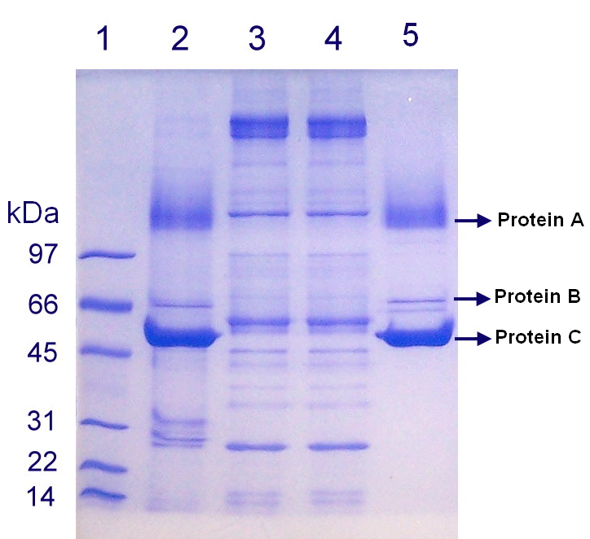**Looking at the figure below, please determine if the following statements are true (T) or false (F):**

**Figure 1.** Image of gel electrophoresis.

1. **T F Protein A** is larger in size than **Protein C**.
2. **T**  **F** There is less of **Protein C** than **Protein B**.
3. **T**  **F** **Lane 3** visible on this gel contains the protein standard.
4. **T** **F** Approximate size of **Protein C** is no less than 45 kDa.
5. **T F** Lane **2** contains more **Protein C** than lane **5**.
6. **T F** kDa next to the standard lane stands for number of amino acids.
7. Gene categories important for cancer development include:

a. proto-oncogenes which normally act to promote cell death

b. tumor suppressor genes which when damaged are not able to regulate cell growth

c. genome stability genes which are responsible for repairing DNA damage

d. A and B are true

**e. B and C are true**

1. In studying the role of MSH2 in HNPCC, we were using *E. coli* bacteria because:
   1. E. coli lacks the MSH2 gene and therefore are a good test organisms
   2. **When E. coli grows and divides it also rapidly replicates the plasmid to produce multiple copies of the pMSH2 for molecular studies**
   3. Bacteria like E. coli are easy to work with in the laboratory
   4. Understanding the role of MSH2 in E. coli will help us better understand the role of MSH2 in HNPCC
   5. When E. coli grows it expresses large amounts of MSH2 protein which can be used for analysis
2. Which of the following statements is true about different plates we used:

a. SD-his-trp plate was used to select for successful yeast transformants

b. we used SD-his-trp plate to determine whether *msh2* allele is functional

c. we used FOA plate to see if functionality of the MMR can be restored by WT msh2 allele found on the yeast chromosome

d. A and C are true

**e. none of the above are true**

1. In eukaryotes, MSH2 binds with either MSH3 or MSH6 to form:

**a. MutS or Mut Heterodimers**

b. MSH Homodimers

c. PMS1 Heterodimer

d. MutS Homodimer

1. Organize the following protocols completed during this semester in order in which they were performed in class:

**Protocols:**

|  |  |
| --- | --- |
| **A**. Yeast transformation  **B**. PCR amplification  **C**. plasmid isolation  **D**. FOA Complementation assay  **E**. Protein extraction from yeast | **F**. Restriction analyses  **G**. Selection of transformants  **H**. DNA gel electrophoresis  **I**. Protein gel electrophoresis |

1. **C, B, F, H, A, G, D, E, I**
2. H, G, A, B, D, E, C, I, F
3. A, B, C, D, E, F, G, H, I
4. I, F, D, C, A, G, H, E, B
5. During which biological event is base substitution mutation most likely to occur in the cell?

a. Transformation

b. Bulk sequence deletion

c. PCR

**d. Replication**

e. Translation

1. SDS-PAGE is a technique used to:

a. quantify the relative amount of proteins present in a sample

b. can be used as a step in western blotting

c. separate proteins based on their size

d. Only A and C are true

**e.** **All of the above are true**

1. Based on the plate in **Figure 2** we can say that:
2. MMR is restored by the Empty Vector containing yeast
3. URA3 is not expressed in the yeast containing WT MSH2
4. **5-FOA was converted to 5-FU in WT MSH2 containing yeast**
5. None of the above are true

**FOA plate**

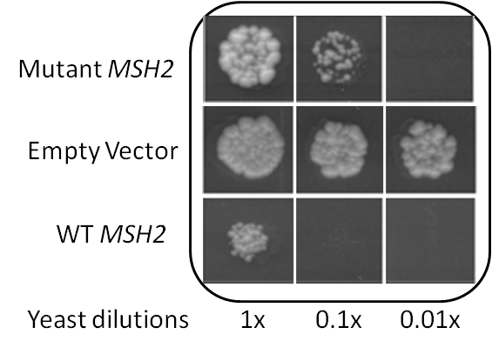

**Figure 2.** Picture reveals results of the 5-FOA complementation assay. 5-FOA plate was spotted with yeast transformed with plasmids containing either Wild Type MSH2, Mutant MSH2 or with an empty plasmid and incubated for 72 hrs at 30°C.

1. Based on the **Figure 2** we can also deduce that:

a. Mutant MSH2 was able to completely restore MMR functionality

b. Since we are able to see some yeast colonies in areas spotted with yeast containing WT *MSH2* plasmid, WT *MSH2* is mutated as well

c. Mutant MSH2 was NOT able to restore functionality of MMR in yeast

**d. Mutant MSH2 was able to ONLY PARTIALLY restore the MMR functionality**

1. Based on **Figure 3** we can say that:
2. Enzyme restriction worked
3. Mutant *MSH2* contains an extra restriction site
4. Mutant *MSH2* sequence differs from WT *MSH2*
5. Only A and B are true
6. All of the above are true

**Figure 3**. Image represents 2 % agarose gel electrophoresis of DNA samples following enzyme restriction analysis with BstYI enzyme.



**Figure 4.** Linear Enzyme Restriction Map

**Table 1. Total Number of Hits per Enzyme and Specific Sequence Recognized by each Enzyme:**

|  |  |  |
| --- | --- | --- |
| Enzyme name | Number of cuts | Restriction sequence |
| AciI | 15 | C'CG_C |
| AluI | 6 | AG'CT |
| AvaI | 4 | G'GwC_C |
| CviKI-1 | 19 | rG'Cy |
| HinfI | 3 | G'AnT_C |
| Hpy188I | 8 | TC_n'GA |
| MaeIII | 6 | 'GTnAC_ |
| MspA1I | 1 | CmG'CkG |
| NciI | 7 | CC's_GG |
| NotI | 1 | GC'GGCC_GC |
| PmlI | 1 | CAC'GTG |
| PspOMI | 2 | G'GGCC_C |
| SetI | 14 | _AssT' |

1. Using information from **Figure 4** and **Table 1** Identify the enzyme that cuts in **6** places and **creates blunt ends**:
2. CviKl-1
3. Ncil
4. **Alul**
5. Pmll
6. Acil
7. Based on **Figure 4** and **Table 1** Identify the enzyme that generates **sticky ends**, cuts the sequence in **3** different locations:
8. MaeIII
9. **HinfI**
10. MspA1I
11. NotI
12. AciI

**EXAMINE the sequence below and answer questions:**



**Figure 5. …..**

1. The above **Figure 5** shows:
2. An ORF – a result of SIXFRAME analysis
3. A linear enzyme restriction map
4. an alignment of amino acids
5. **an alignment of nucleotides**
6. codon sequence
7. Based on the **Figure 5** provided above we can say the following about the mutation:
8. Mutation converts T to A
9. This is a missense mutation
10. **This is a base pair substitution**
11. This is a silent mutation
12. This is a frameshift mutation

WT PQDASTKKLSECLKRIGDELDSNMELQRMIAAVDTDSPREVFFRVAADMF

Mutant PQDASTKKLSECLKRIGDELDSNMELQRMIAAVDTDSPREVFFRVAADMF

**************************************************

WT SDGNFNWGRVVALFYFASKLVLKALCTKVPELIRTIMGWTLDFLRERLLG

Mutant SDGNFNWGRVVALFYFASKLVLKALCTMVPELIRTIMGWTLDFLRERLLG

*************************** **********************

WT WIQDQGGWVRLLKPPHPHHRALTTAPAPPSLPPATPLGPWAFWSRSQWCP

Mutant WIQDQGGWVRLLKPPHPHHRALTTAPAPPSLPPATPLGPWAFWSRSQWCP

**************************************************

**Figure 6. Clustlaw alignment of a mutant and WT VIP sequences**:

1. Based on the alignment in the **Figure 6** we can say that the following mutation is:
2. Mutation converts M to K
3. This is a point mutation
4. This is a nonsense mutation
5. **This is a missense mutation**
6. A and D are true
7. Based on the mutation in **Figure 6** we can say that the protein activity …
8. is increased
9. is reduced
10. **cannot be determined**
11. is unaffected
12. is completely abolished
13. Before we did FOA and Western Blot analysis we measured the OD. Which of the following statements are true about the OD measurement:
    1. **We measured OD in order to approximate the amount of yeast cells (our starting material)**
    2. We measured OD on the plasmid DNA to see how much DNA to load on the gel
    3. We measured OD using the total protein extract from the yeast
    4. OD measurement was done using a thermocycler
14. During western blotting protocol we used antibodies. Which of the following statements are true about Antibodies?
    1. Primary antibody is usually conjugated to an enzyme
    2. Primary antibody recognizes an epitope on a specific target protein
    3. Primary antibody we used recognizes hemagglutinin epitope
    4. **B and C are true**
    5. All of the above are true
15. Which of the following statements about yeast transformation are true?
    1. PLATE solution contains special reagents that help yeast cells grow on the selection plate
    2. We heat shocked the yeast by boiling them for 40 minutes
    3. **Carrier DNA used in this protocol assists in the uptake of our plasmid DNA**
    4. We incubated the carrier DNA at 42°C for 5 min to denature it.
16. Which best describe the role of cyclin D, pRb, and E2F pathway?   
    A. G1/S check point  
    B. G2/M check point  
    C. Cancer prevention  
    D. Angiogensis.
17. Which is NOT a hallmark of cancer?
18. Genome instability and mutation.
19. Sustaining proliferative signaling.
20. Resistance to antibiotics
21. Metastasis
22. Which cancer can occur in higher rate in African Americans?
    1. Malignant prostate cancer.
    2. FAP.
    3. HNPCC
    4. Leukemia
23. In principle, anti-CTLA4 mAb can activate immune system to destroy cancer cells. True or False