Bio 125 Final Examination – Part II

I agree to abide by the standards of academic integrity for the Spelman campus community. By this electronic signature, I confirm that I have neither given nor received assistance on this examination, and the answers on this exam are my own work written in my own words. I agree not to share or discuss any part of this examination with any other person prior to receiving a grade for my performance.

Instructions: Type Your Name in the Box

Instructions:
You will have one (1) hour to work on this portion of the midterm examination. At the end of the hour, you must submit your work as a file attachment through WebCT Assignments. Failure to properly upload your completed document will result in receiving zero (0) points for this section of the exam.

- Experimental Design. Read the abstract below and then answer the questions that follow.

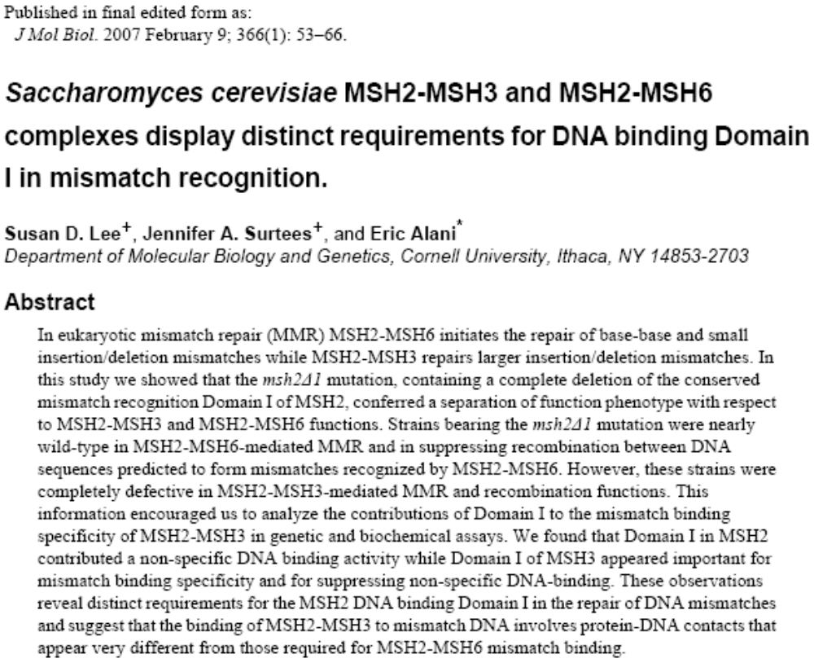

1a. (10 pts.) The authors of this article are studying the function of Domain I, a region of the MSH2 gene product, in mismatch repair. In the space below, state their research question.

1b. (7 pts.) How did the investigators use a mutant strains in their experimental approach to study the role of Domain I in MSH2-MSH3 and MSH2-MSH6 functions? Explain.

1c. (7 pts.) Based on the results described in this study, what is the role of Domain I in MSH2-MSH3 and MSH2-MSH6 functions? Explain.

1d. (3 pts.) In what organism did these investigators conduct their experiments?

1e. (3 pts.) When was this article published? What is the name of the journal in which it was published?

- Sequence Analysis. For this portion of the exam, you will need to log onto your WorkBench account in order to conduct sequence analysis.

A Spelman student is studying genes involved in MMR in order to understand how the structure of the gene product affects function. She obtains the nucleotide sequences for the MMR1 gene from mouse and yeast so that she can compare them. Use the gene sequences shown below to answer the questions that follow.

Mouse MMR1 (319 nucl.):
1 GGGAGGTAAA TCAACATATA TTCGACAAAC TGGGGTGATA GTACTCATGG CCCAAATTGG
61 GTGTTTTGTG CCATGTGAGT CAGCAGAAGT GTCCATTGTG GACTGCATCT TAGCCCGAGT
121 AGGGGCTGGT GACAGTCAAT TGAAAGGAGT CTCCACGTTC ATGGCTGAAA TGTTGGAAAC
181 TGCTTCTATC CTCAGGTCTG CAACCAAAGA TTCATTAATA ATCATAGATG AATTGGGAAG
241 AGGAACTTCT ACCTACGATG GATTTGGGTT AGCATGGGCT ATATCAGAAT ACATTGCAAC
301 AAAGATTGGT GCTTTTTAA

Yeast MMR1 (350 nucl.):
1 GTTGGTGTGA TTTCTTTAAT GGCCCAAATT GGTTGTTTCG TACCTTGTGA AGAAGCTGAA
61 ATAGCCATAG TAGATGCAAT TCTTTGCAGG GTCGGGGCAG GAGATTCCCA ATTGAAAGGT
121 GTTTCCACAT TTATGGTTGA AATATTGGAA ACTGCTTCTA TACTAAAGAA TGCGAGTAAG
181 AATTCTTTGA TTATTGTAGA TGAACTAGGG CGTGGTACTA GTACATATGA TGGTTTTGGT
241 CTAGCTTGGG CAATTGCTGA ACATATCGCA AGTAAGATTG GATGATTCGC TTTGTTTGCA
301 ACTCACTTTC ATGAATTGAC AGAATTGTCT GAAAAATTGC CCAATGTCAA

2a. (10 pts.) Determining Gene Products – To start, the Spelman student must determine the amino acid sequence of each gene. Help her out by using the proper Workbench tool(s) to determine the correct ORF for each gene. Show the correct amino acid sequence in the box below.

Mouse MMR1 ORF (3 pts.):
(1 pt.) The mouse MMR1 gene product is _____ amino acids long.

(1 pt.) The mouse MMR1 gene product contains _____ cysteine (C) residues.

(3 pts.) Yeast MMR1 ORF:

(1 pt.) The yeast MMR1 gene product is _____ amino acids long.

(1 pt.) The yeast MMR1 gene product contains _____ cysteine (C, cys) residues.

2b. Sequence Analysis (10 pts.) – Next, the Spelman student must compare the two gene products. Help her out by using the proper Workbench tool(s) to compare the amino acid sequences of mouse and yeast MMR1. Show the proper alignment in the box below - be sure to indicate mouse and yeast sequences.

Extra credit (10 pts.)

- (5 pts.) Examine the comparison, paying careful attention to the cys (C) residues in the two sequences. Based on your sequence analysis, which of the cys residues in the mouse MMR1 gene product do you think are most important for the structure and function of the protein? Explain your answer.

- (5 pts.) How would you test your hypothesis about the importance of a specific cys residue to the structure and function of the protein? Briefly describe the experimental strategy you would employ.

