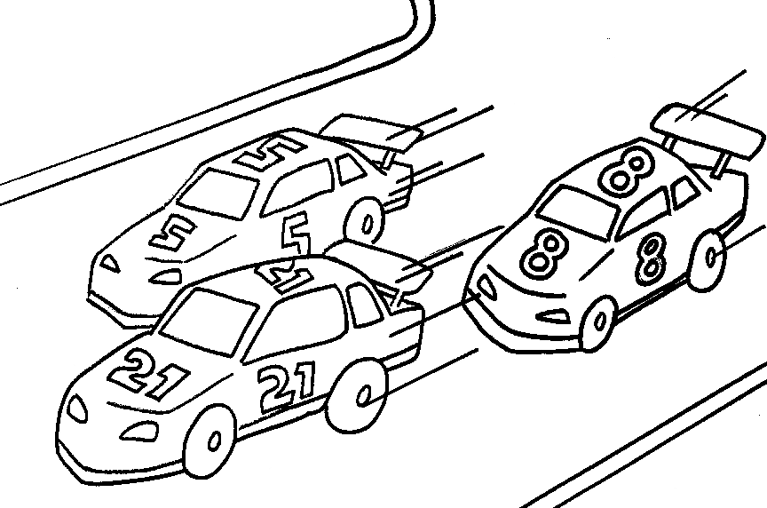

|  |  |  |  |  |  |  |  |  |  |
| --- | --- | --- | --- | --- | --- | --- | --- | --- | --- |
| **X** | **P** | **L** | **A** | **Y** | **Y** | **W** | **A** | **S** | **H** |
| **D** | **M** | **S** | **A** | **I** | **D** | **X** | **H** | **I** | **M** |
| **A** | **N** | **M** | **W** | **H** | **E** | **N** | **S** | **H** | **E** |
| **Y** | **T** | **H** | **E** | **N** | **L** | **W** | **E** | **M** | **E** |
| **I** | **F** | **O** | **R** | **L** | **H** | **I** | **V** | **E** | **E** |
| **S** | **B** | **Y** | **A** | **O** | **I** | **T** | **R** | **W** | **L** |
| **T** | **H** | **E** | **Y** | **F** | **S** | **E** | **A** | **I** | **I** |
| **S** | **A** | **Y** | **O** | **U** | **H** | **E** | **L** | **T** | **K** |
| **E** | **R** | **A** | **Y** | **W** | **H** | **A** | **D** | **H** | **E** |
| **E** | **E** | **H** | **A** | **S** | **C** | **O** | **M** | **E** | **N** |