Supplementary Information

Epithelial-Mesenchymal Status Renders Differential Responses to Cisplatin in Ovarian Cancer

Qing Hao Miow, Tuan Zea Tan, Jieru Ye, Jieying Amelia Lau, Takako Yokomizo, Jean-Paul Thiery, Seiichi Mori

Table of Contents:

Supplementary Text

- Cisplatin-induced p53 pathway activation
- Flow cytometric analyses of selected cell lines
- Influence of histology and TP53 mutational status

Supplementary Materials and Methods

- TP53 mutation status
- Validation of transcriptomic responses by quantitative RT-PCR
- Western blot analysis for p53 downstream genes induction
- Flow cytometric analysis
- Measurement of NF-ĸB p65 DNA binding activity

Supplementary Figures

Suppl. Fig. 1. Quantitative RT-PCR validation of differential transcriptional responses following cisplatin treatment.
Suppl. Fig. 2. Selective transactivation of p53 downstream genes in ovarian cancer cell lines with wild-type TP53 at the protein level.
Suppl. Fig. 3. Relationship between EMT status and molecular subtyping in the cell line panel.
Suppl. Fig. 4. Cell cycle profiles of epithelial- and mesenchymal-like ovarian cancer cell lines following cisplatin treatment.
Suppl. Fig. 5. Differential changes in NF-κB activities in epithelial- or mesenchymal-like cells following cisplatin treatment.
Suppl. Fig. 6. Differential cisplatin-induced responses in epithelial- and mesenchymal-like ovarian cancer cells with serous histology or mutant TP53.
Suppl. Fig. 7. Overall survival of epithelial- or mesenchymal-like ovarian tumours following cisplatin/carboplatin single treatment, or cisplatin/carboplatin and paclitaxel combination treatment.

Supplementary Text

Cisplatin-induced p53 pathway activation
The tumour suppressor p53 is involved in transcriptional regulation of cell cycle arrest and apoptosis elicited by DNA damage, including the formation of DNA-cisplatin adducts.¹⁻⁶ Multiple p53 mutant proteins can inhibit the transactivating function of wild-type p53, typically through their dominant-negative effect.⁷⁻¹⁰ Using Sanger sequencing analyses, the TP53 protein coding region was found to be mutated in 30 (65.2%) of the 46 cell lines, with only 16 (34.8%) cell lines retaining the wild-type TP53. Taking advantage of this mutational status information for each ovarian cancer cell line, we examined whether p53 downstream genes were transactivated by cisplatin treatment. Using a gene set curated from a previous study,¹¹ which included CDKN1A, MDM2, BAX and GADD45A, a single sample gene set enrichment analysis (ss-GSEA) was undertaken, and showed that the cell lines with wild-type TP53 indeed exhibited a higher activation of p53 downstream genes in the enrichment score (ES) as compared with those harbouring the TP53 mutation (Figure 1B; Mann Whitney U-test, p = 0.0359). These microarray profiling results were validated not only by quantitative RT-PCR (qRT-PCR) with the same RNA used for microarray assays (Suppl. Figures 1A, 1B and 1C) but also with protein expression via western blotting in an independent experiment (Suppl. Figure 2). The ability to detect differential transcriptomic changes induced by cisplatin between wild-type and mutant TP53 cancer cells validated the experimental approach of the current study.

Flow cytometric analyses of selected cell lines
To determine the phenotypic consequence of a transcriptomic change in the cell, we performed cell cycle analyses on four epithelial-like (OVCA 429, M41, JHOS-3 and OAW-42) and four mesenchymal-like (HeyA8, A2780, IGROV-1 and OVCAR-10) cell lines using flow cytometry. For this study, we chose the cell lines with a cell-cycle gene expression pattern “typical” of epithelial-like or mesenchymal-like cells (Figure 2A and Suppl. Figure 4). Therefore, four cell lines with epithelial status exhibited enrichment of G1/S- and S-phase genes, whereas those with a mesenchymal-like status showed a predominantly down-regulated expression in all cell cycle genes examined (Suppl. Figure 4). Consistent with the transcriptomic analysis, S-phase arrest was indeed observed in three of the four epithelial-like cell lines upon cisplatin treatment; one cell line (OVCA 429) showed G2/M arrest instead (Suppl. Figure 4). G2/M-phase arrest was observed in all four cisplatin-treated mesenchymal-like cell lines; this was contrary to the transcriptomic analysis, where G2/M-phase genes were down-regulated. Hence, the transcriptomic pattern for cell cycle phase genes does not wholly mirror the pattern of cell cycle arrest. Nevertheless, results from our BrdU incorporation and Caspase-3/7 release assays clearly indicate that epithelial-like cells are more prone to proliferation arrest regardless of the phase at which cell cycle arrest occurred, but not to apoptosis at a given dosage of cisplatin. These results imply that the process of apoptosis is impaired in epithelial-like cells (Figure 3C).

Influence of histology and TP53 mutational status
Most of the high-grade serous ovarian cancers possess a TP53 mutation¹² and this aspect was not fully captured in the cell line panel used in this study. In fact, the panel is of a mixed histology as well as having a mixed TP53 status (Suppl. Table 1). To ascertain the effect of not distinguishing, either serous from other histologies or mutant TP53 from wild-type samples, we repeated the analyses on 1) cell lines derived from ovarian cancers with serous histology (n = 20) and 2) cell lines with mutant TP53 (n = 30). Although the differences were reduced due to the limited number of the cell lines, a similar trend could still be observed regardless of histotype or TP53 status. In both settings, cisplatin treatment led to statistically significant enrichment of NF-κB-related pathways in epithelial-like cell lines (Suppl. Figure 6B). Similarly, as shown by the MTS, BrdU incorporation and Caspase-3/7 release assays, epithelial-like cell lines showed tendency toward resistance to cisplatin as well as toward susceptibility to undergo proliferation arrest, albeit these results were not statistically significant (Suppl. Figures 6C and 6D). We also confirmed no association of serous histology or TP53 mutational status with EMT status (Suppl. Table 6; Fisher’s exact tests; p = 0.78 and 0.76, respectively). Thus, the differential transcriptomic responses to cisplatin treatment were mainly dependent upon the epithelial and mesenchymal phenotypes and to a lesser extent on the histotype or TP53 status.
We noted that TP53 was found to be mutated in only 13 (65%) of our 20 serous ovarian cancer cell lines, unlike the >96% of high-grade serous in vivo tumors reported previously;¹² this discrepant frequency may be caused by a bias in the panel. Although we concede that a cell line is not a perfect replica of in vivo tumors, it is important to emphasize that at least some features in epithelial-like cells, such as NF-ĸB activation and platinum resistance, which was initially observed in the cell line panel, were able to be validated in clinical samples in the current study (Figures 2 and 4).

Supplementary Materials and Methods

TP53 mutation status
The mutational status of TP53 was examined by nucleotide sequencing of TP53 cDNA amplified from each ovarian cancer cell line used in this study. One microgram of total RNA from each of the sham-treated cell lines was converted into cDNA using the Omniscript RT Kit (Qiagen, Düsseldorf, Germany) with random-hexamer primers, according to the manufacturer’s recommendations (Promega, Fitchburg, WI). PCR amplification was performed by KOD-Plus (Toyobo; Osaka, Japan) with the forward primer F1 (5'-GAC ACG CTT CCC TGG ATT-3') and the reverse primer R1 (5'-AGG GTT CAA AGA CCC AAA AC-3') as follows: 1 cycle of 94°C for 3 min; then 35 cycles of 98°C for 30 sec, 59°C for 30 sec and 68°C for 2 min. The amplicon was purified using PCR Purification Kit (Qiagen) and directly sequenced with the following sequencing primers: F1 (above), F2 (5'-TTT TGC CAA CTG GCC AAG-3'), R2 (5'-GGT GGG AGG CTG TCA G-3'), and R3 (5'-GAG TCT TCC AGT GTG ATG ATG G-3'). NM_000546 was used as reference of the TP53 cDNA sequence.

Validation of transcriptomic responses by quantitative RT-PCR
To validate the differential transcriptomic changes in TP53 downstream genes, cell cycle-phase genes and NF-κB downstream genes, quantitative RT-PCR was performed on cell lines as listed in Suppl. Table 7. Note that the same RNA was used as that in the expression microarrays. cDNA was synthesized from 300 ng of total RNA using SuperScript® III First-Strand Synthesis System (#18080-051, Invitrogen, Carlsbad, CA), according to the manufacturer’s recommendations. qPCR was performed using FastStart Universal Probe Master (#04914139001, Roche Applied Science, Basel, Switzerland), Universal ProbeLibrary Probes (#04683633001, Roche Applied Science) and the ABI PRISM 7900HT Sequence Detection System (Applied Biosystems, Foster City, CA), for 40 cycles of 95°C for 15 sec and 60°C for 1 min. HMBS, HPRT1, ACTB, PGK1, G6PD, PPIA, TBP, GUSB and GAPDH were used as endogenous quantitative controls. The probes and primer sequences for each gene are shown in Suppl. Table 8. The absolute expression level of target mRNA was determined based on qPCR Human Reference Total RNA (#750500, Agilent Technologies, Santa Clara, CA). For each cell line, the expression changes induced by cisplatin were computed by normalising the target mRNA expression level of cisplatin-treated cells with that of sham-treated cells. The mean fold-change in gene expression in each category (TP53 downstream genes, G1/S-phase cell cycle genes, S-phase cell cycle genes and NF-κB downstream genes) revealed the transcriptomic changes induced by cisplatin at the pathway level. Concordance in terms of pathway induction, as measured by quantitative RT-PCR and microarrays, was evaluated using Spearman Correlation test. Differences in pathway induction between epithelial-like and mesenchymal-like cells were statistically evaluated by Mann Whitney U-test.

Western blot analysis for p53 downstream genes induction
Four cell lines with wild-type p53 (DOV 13, HeyA8, C13 and A2008) and three cell lines with mutant p53 (TOV-112D, SKOV-4 and JHOS-3) were treated with increasing concentrations of cisplatin for 48 h. Whole cell lysates was then prepared using radio-immunoprecipitation assay buffer (#R0278, Sigma-Aldrich, St. Louis, MO) supplemented with a protease and phosphatase inhibitor cocktail (#539134 and #524624, Calbiochem, Boston, MA). Western blotting was performed as described previously¹³, using antibodies directed against MDM2 (#OP46, Calbiochem), p21 (#sc-6246, Santa Cruz Biotechnology, Dallas, TX) and β-actin (#A1978, Sigma-Aldrich).

Flow cytometric analysis
Four epithelial-like cell lines (OVCA 429, M41, JHOS-3 and PEO1) and four mesenchymal-like cell lines (HeyA8, IGROV-1, A2780 and OVCAR-10) were treated with increasing concentrations of cisplatin for 48 h. Cells were fixed with 70% ethanol overnight at -20°C, and then incubated in 500 μl PBS containing 1 mg/ml RNase A (#R4875, Sigma-Aldrich) and 100 μg/ml propidium iodide (#P4170, Sigma-Aldrich) for 30 min at 37°C. Cell cycle profiles were determined with an LSR II Flow Cytometer (BD Biosciences, Franklin Lakes, NJ), and analysed using the FlowJo software (Tree Star, Ashland, OR).

Measurement of NF-κB p65 DNA binding activity
Three epithelial-like cell lines (OAW28, M41 and PEO1) and three mesenchymal-like cell lines (OVK18, IGROV-1 and OV56)) were treated with increasing concentrations of cisplatin for 48 h. Nuclear extracts was prepared using a Nuclear Extraction kit (#10007889, Cayman Chemical, Ann Arbor, MI), and subsequently assayed with NF-ĸB (p65) Transcription Factor Assay kit (#10009277, Cayman Chemical), according to the manufacturer’s recommendations. The percentage of NF-ĸB p65 DNA binding activity responding to cisplatin relative to the negative controls was used for evaluation.

Supplementary Figures
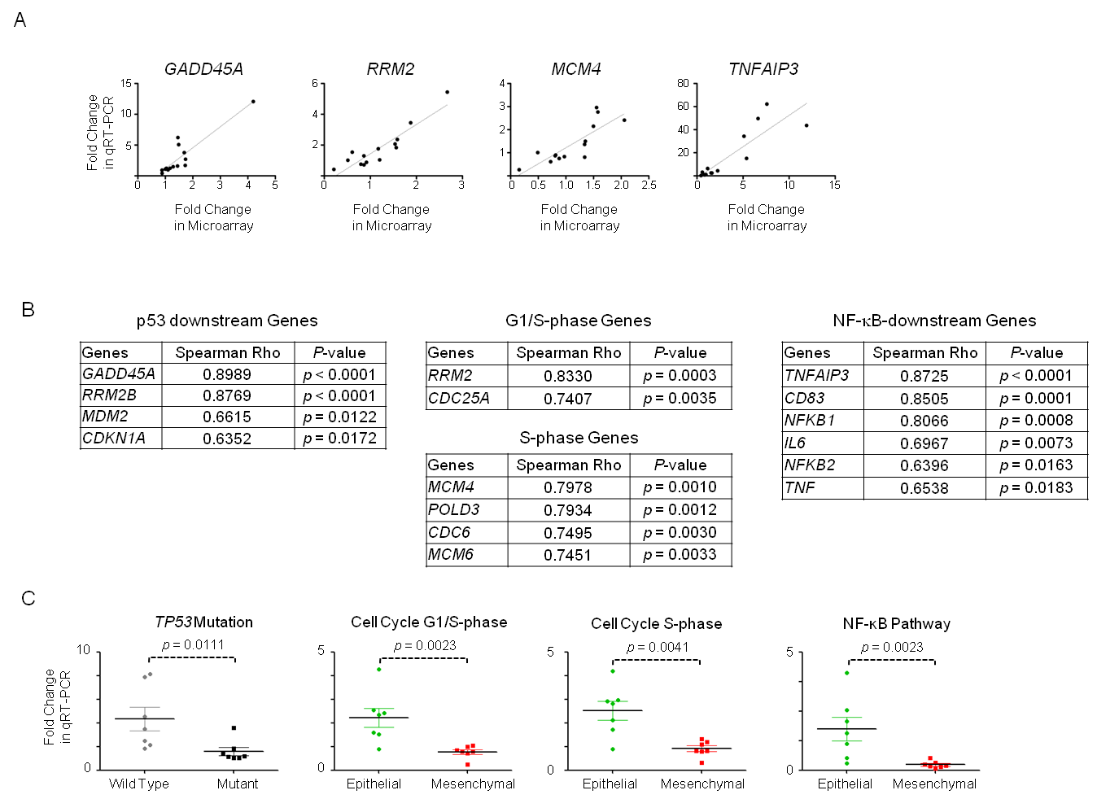

Suppl. Fig. 1. Quantitative RT-PCR validation of differential transcriptional responses following cisplatin treatment.
(A) Representative Spearman correlation plots showing concordance amongst cisplatin-induced expression changes as measured by quantitative RT-PCR (qRT-PCR; x-axis) and microarray (y-axis). (B) Tables listing Spearman rho and p-value for each selected gene of the p53 downstream genes (left panel), cell cycle phase genes (middle panel) and NF-ĸB downstream genes (right panel). For every gene examined, cisplatin-induced expression changes, as determined by qRT-PCR, were significantly correlated with those in the microarray analyses. (C) Differential responses induced by cisplatin in ovarian cancer cell lines as determined by qRT-PCR. We show the average expression changes of p53 downstream genes in cell lines with wild-type or mutant TP53, and also those of G1/S-phase genes, S-phase genes and NF-ĸB downstream genes in epithelial-like or mesenchymal-like cell lines. (grey = wild-type TP53; black = mutant TP53; green = epithelial-like; red = mesenchymal-like). Mann-Whitney U-test was used for statistical evaluation.
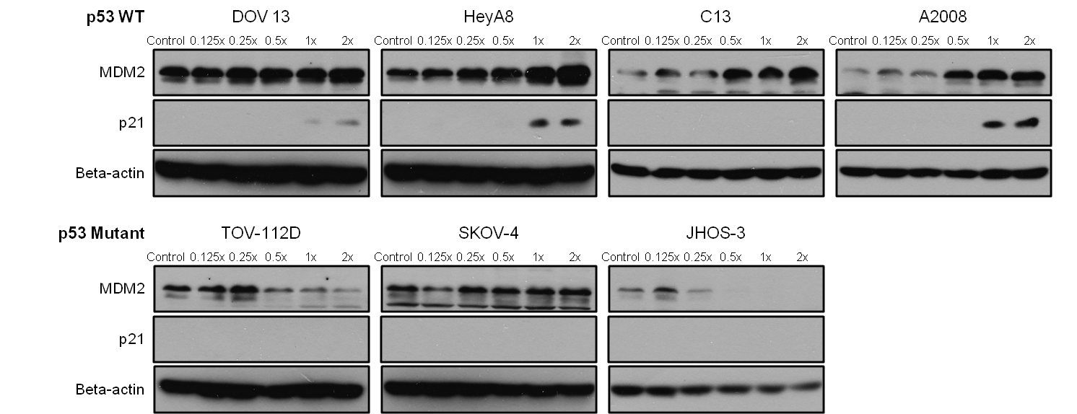

Suppl. Fig. 2. Selective transactivation of p53 downstream genes in ovarian cancer cell lines with wild-type TP53 at the protein level.
Detection of p53 downstream gene induction upon cisplatin treatment. Four cell lines with wild-type TP53 (upper panel) and three cell lines with mutant TP53 (lower panel) were treated with increasing concentrations of cisplatin for 48 h. Protein expression levels of p53 downstream genes were determined by immunoblotting for MDM2 and p21. Note that C13 (p53 wild-type) did not express any detectable p21 protein.

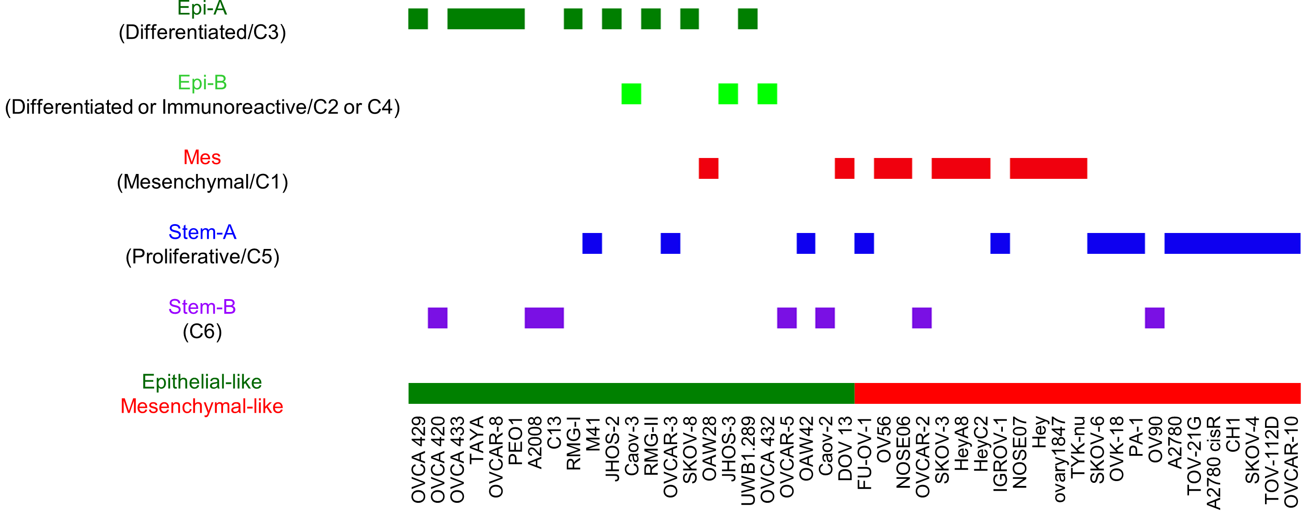

Suppl. Fig. 3. Relationship between EMT status and molecular subtyping in the cell line panel.
Forty-six ovarian cancer cell lines were classified according to the molecular subtype classification scheme from a previous study,¹³ and then compared with their EMT status. Colour code: Epi-A, dark green; Epi-B, light green; Mes, red; Stem-A, blue; Stem-B, purple. Corresponding molecular subtypes from two other molecular subtyping methods (TCGA and Tothill et al, 2008) are shown in parentheses. The bottom coloured bar indicates the EMT status of cell lines (epithelial-like, green; mesenchymal-like, red).

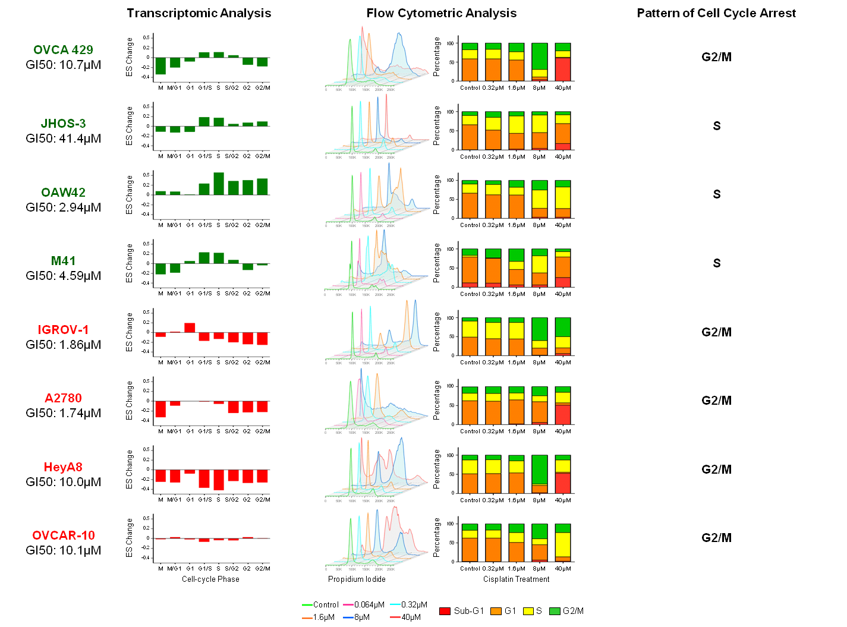

Suppl. Fig. 4. Cell cycle profiles of epithelial- and mesenchymal-like ovarian cancer cell lines following cisplatin treatment.
Left panels. Bar charts indicate changes in ss-GSEA enrichment scores (ESs) for gene sets of serial cell cycle phases in four epithelial-like and four mesenchymal-like cell lines after cisplatin treatment. The gene sets for this transcriptomic analysis was curated from Mizuno et al. (2009).¹⁵ (green = epithelial-like; red = mesenchymal-like). A value of cisplatin GI50 (μM) is indicated beneath the cell line name. Middle panels. Histograms and bar plots showing cell cycle profiles of ovarian cancer cell lines in response to cisplatin treatment. Ovarian cancer cell lines were treated with six different concentrations of cisplatin for 48 h and subjected to flow cytometric analyses. Right panels. Pattern of the cell cycle arrest determined through flow cytometric analysis of the cells treated with the approximate GI50 dosage. Each row represents the respective analyses for the same cell line.

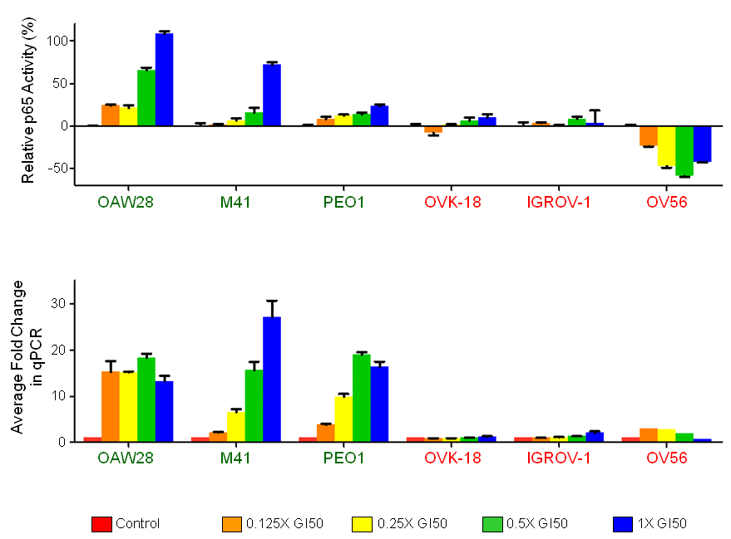

Suppl. Fig. 5. Differential changes in NF-κB activities in epithelial- or mesenchymal-like cells following cisplatin treatment.
Bar plots show the selective induction of NF-κB activities by cisplatin in epithelial- or mesenchymal-like ovarian cancer cell lines. Three epithelial-like and three mesenchymal-like ovarian cancer cell lines were treated with increasing concentrations of cisplatin for 48 h. NF-κB activities relative to control (cisplatin untreated) cells were then measured with an NF-κB p65 DNA binding activity ELISA kit and are shown as the relative p65 activity in percentage (upper panel). The mean fold-change in gene expression, as detected using qRT-PCR for all six NF-κB downstream genes (TNFAIP3, CD83, NFKB1, IL6, NFKB2 and TNF), is also shown (lower panel). Error bars indicate standard error of the mean (green = epithelial-like; red = mesenchymal-like).

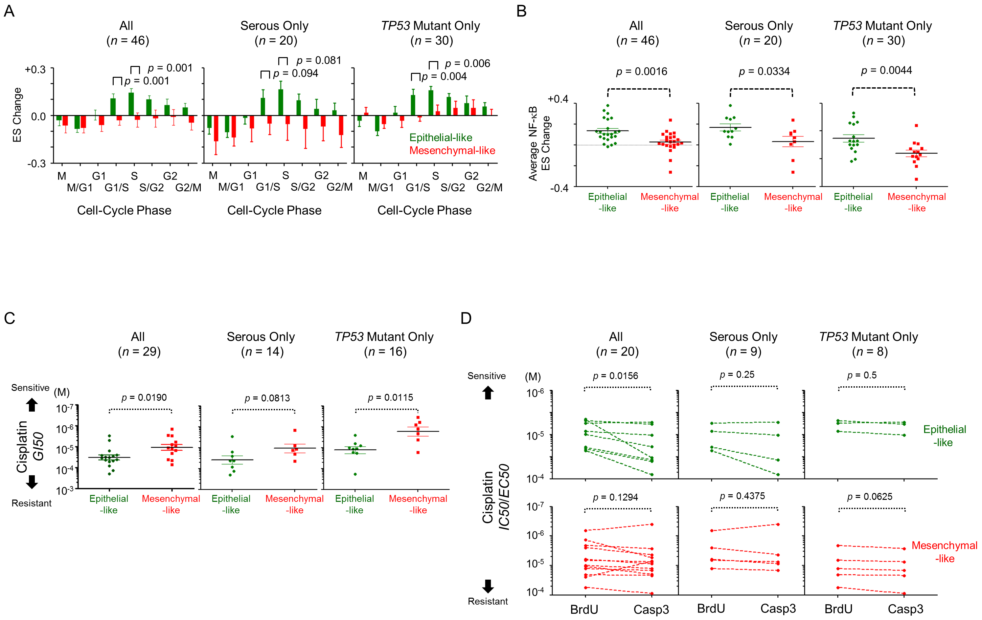

Suppl. Fig. 6. Differential cisplatin-induced responses in epithelial- and mesenchymal-like ovarian cancer cells with serous histology or mutant TP53.
(A-D) Comparisons of differential cisplatin-induced responses in epithelial- and mesenchymal-like cells analysed using all cell lines (left panel), cell lines derived from serous ovarian cancers (middle panel), and cell lines with mutant TP53 (right panel). Note that the results for “all” cell lines are reproduced here from Figures 2A, 2B, 3B and 3C in the main text for side-by-side comparison. (A) Bar graphs of the mean Enrichment Score (ES) changes for gene sets of serial cell cycle phases in response to cisplatin treatment. Error bars indicate standard error of the mean. The gene sets used here were curated from Mizuno et al.¹⁵ (B) Dot plots showing the average cisplatin-induced changes in the ESs of 14 NF-κB-related pathways obtained from Msigdb v3.0.¹⁶ (C) Cisplatin 50% growth inhibitory concentration (GI50; y-axis) of epithelial- and mesenchymal-like cell lines. (D) Cisplatin IC50 (inhibitory concentration of 50%) of BrdU incorporation and EC50 (effective concentration of 50%) of Caspase 3 activation (y-aixs) in epithelial- and mesenchymal-like cell lines. In (C) and (D), the y-axis shows the dosage (M) in log₁₀ scale. Mann-Whitney U-test and Wilcoxon paired tests were used to evaluate the statistical difference in (A-C) and (D), respectively. Colour code: epithelial-like, green; mesenchymal-like, red.

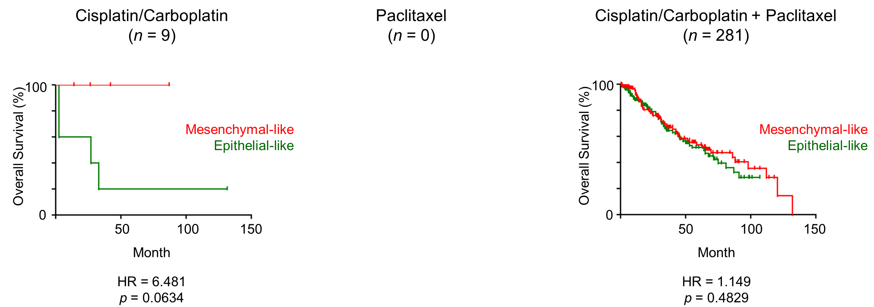

Suppl. Fig. 7. Overall survival of epithelial- or mesenchymal-like ovarian tumours following cisplatin/carboplatin single treatment, or cisplatin/carboplatin and paclitaxel combination treatment.
Kaplan-Meier analysis of overall survival in epithelial- (green) or mesenchymal-like (red) clinical samples compiled from GSE3149 and TCGA. Samples were subdivided into groups consisting of patients who had undergone cisplatin/carboplatin single treatment (left panel), paclitaxel single treatment (middle panel), or cisplatin/carboplatin and paclitaxel combination (right panel) treatment regimens. Note that there is no expression data with overall survival information for patient who had received the paclitaxel single treatment regimen. Classification of epithelial-like and mesenchymal-like tumours was based on the median of the EMT primary component analysis (PCA) in each cohort. The p-values were computed by log-rank test. Abbreviation: HR, hazard ratio.

References

1 Kastan MB, Onyekwere O, Sidransky D, Vogelstein B, Craig RW. Participation of p53 protein in the cellular response to DNA damage. Cancer Res 1991; 51: 6304-6311.

2 Bunz F, Dutriaux A, Lengauer C, Waldman T, Zhou S, Brown JP et al. Requirement for p53 and p21 to sustain G2 arrest after DNA damage. Science 1998; 282: 1497-1501.

3 Banin S, Moyal L, Shieh S, Taya Y, Anderson CW, Chessa L et al. Enhanced phosphorylation of p53 by ATM in response to DNA damage. Science 1998; 281: 1674-1677.

4 Fan S, el-Deiry WS, Bae I, Freeman J, Jondle D, Bhatia K et al. p53 gene mutations are associated with decreased sensitivity of human lymphoma cells to DNA damaging agents. Cancer Res 1994; 54: 5824-5830.

5 Eliopoulos AG, Kerr DJ, Herod J, Hodgkins L, Krajewski S, Reed JC et al. The control of apoptosis and drug resistance in ovarian cancer: influence of p53 and Bcl-2. Oncogene 1995; 11: 1217-1228.

6 Perego P, Giarola M, Righetti SC, Supino R, Caserini C, Delia D et al. Association between cisplatin resistance and mutation of p53 gene and reduced bax expression in ovarian carcinoma cell systems. Cancer Res 1996; 56: 556-562.

7 Goh AM, Coffill CR, Lane DP. The role of mutant p53 in human cancer. J Pathol 2011; 223: 116-126.

8 de Vries A, Flores ER, Miranda B, Hsieh HM, van Oostrom CT, Sage J et al. Targeted point mutations of p53 lead to dominant-negative inhibition of wild-type p53 function. Proc Natl Acad Sci U S A 2002; 99: 2948-2953.

9 Aurelio ON, Kong XT, Gupta S, Stanbridge EJ. p53 mutants have selective dominant-negative effects on apoptosis but not growth arrest in human cancer cell lines. Mol Cell Biol 2000; 20: 770-778.

10 Petitjean A, Mathe E, Kato S, Ishioka C, Tavtigian SV, Hainaut P et al. Impact of mutant p53 functional properties on TP53 mutation patterns and tumor phenotype: lessons from recent developments in the IARC TP53 database. Hum Mutat 2007; 28: 622-629.

11 Nakamura Y. Isolation of p53-target genes and their functional analysis. Cancer Sci 2004; 95: 7-11.

12 Cancer Genome Atlas Research N. Integrated genomic analyses of ovarian carcinoma. Nature 2011; 474: 609-615.

13 Tan TZ, Miow QH, Huang RY, Wong MK, Ye J, Lau JA et al. Functional genomics identifies five distinct molecular subtypes with clinical relevance and pathways for growth control in epithelial ovarian cancer. EMBO Mol Med 2013.

14 Tothill RW, Tinker AV, George J, Brown R, Fox SB, Lade S et al. Novel molecular subtypes of serous and endometrioid ovarian cancer linked to clinical outcome. Clin Cancer Res 2008; 14: 5198-5208.

15 Mizuno H, Nakanishi Y, Ishii N, Sarai A, Kitada K. A signature-based method for indexing cell cycle phase distribution from microarray profiles. BMC Genomics 2009; 10: 137.

16 Subramanian A, Tamayo P, Mootha VK, Mukherjee S, Ebert BL, Gillette MA et al. Gene set enrichment analysis: a knowledge-based approach for interpreting genome-wide expression profiles. Proc Natl Acad Sci U S A 2005; 102: 15545-15550.

17 Verhaak RG, Tamayo P, Yang JY, Hubbard D, Zhang H, Creighton CJ et al. Prognostically relevant gene signatures of high-grade serous ovarian carcinoma. J Clin Invest 2013; 123: 517-525.

18 Bild AH, Yao G, Chang JT, Wang Q, Potti A, Chasse D et al. Oncogenic pathway signatures in human cancers as a guide to targeted therapies. Nature 2006; 439: 353-357.

