#!?What’s the Title – to be decided?!

Introduction: Background and objectives of this study and output (Aging Cell 2013)

Methods

#The gene set comprises 166 genes that had been used for the

#Survival analysis using R

#Network models

Results

Gene clustering based on the phenotypic inferences to DR?

>Kaplan-Meler plots (AC13 paper) focuses on the survival function S(t) --- the probability that a subject survive longer than time t.

>The flexsurv package usually requires a life table

####Step1: Find out the distribution of genes from the AC13 set in the *S. cerevisiae* chromosomes; source --- NCBI.

**Table 1**. Distribution of gene numbers in the AC13 set

|  |  |  |  |  |  |  |  |  |  |  |  |  |  |  |  |  |  |
| --- | --- | --- | --- | --- | --- | --- | --- | --- | --- | --- | --- | --- | --- | --- | --- | --- | --- |
| Chr | 1 | 2 | 3 | 4 | 5 | 6 | 7 | 8 | 9 | 10 | 11 | 12 | 13 | 14 | 15 | 16 | MT |
| L1 | 0.23 | 0.81 | 0.32 | 1.53 | 0.58 | 0.27 | 1.09 | 0.56 | 0.44 | 0.75 | 0.67 | 1.08 | 0.92 | 0.78 | 1.09 | 0.95 | 0.09 |
| N2 | 0 | 10 | 1 | 24 | 9 | 3 | 21 | 6 | 7 | 5 | 12 | 17 | 18 | 10 | 12 | 11 | 0 |

1Chromosome lengths (in million bp’s); 2Gene numbers from the AC13 set.

Using the chromosome lengths (Table 1) the karyotype of the *S. cerevisiae* genome with 16 chromosomes (c1-c16) and the mitochondrion (mt) is shown in Figure 1.

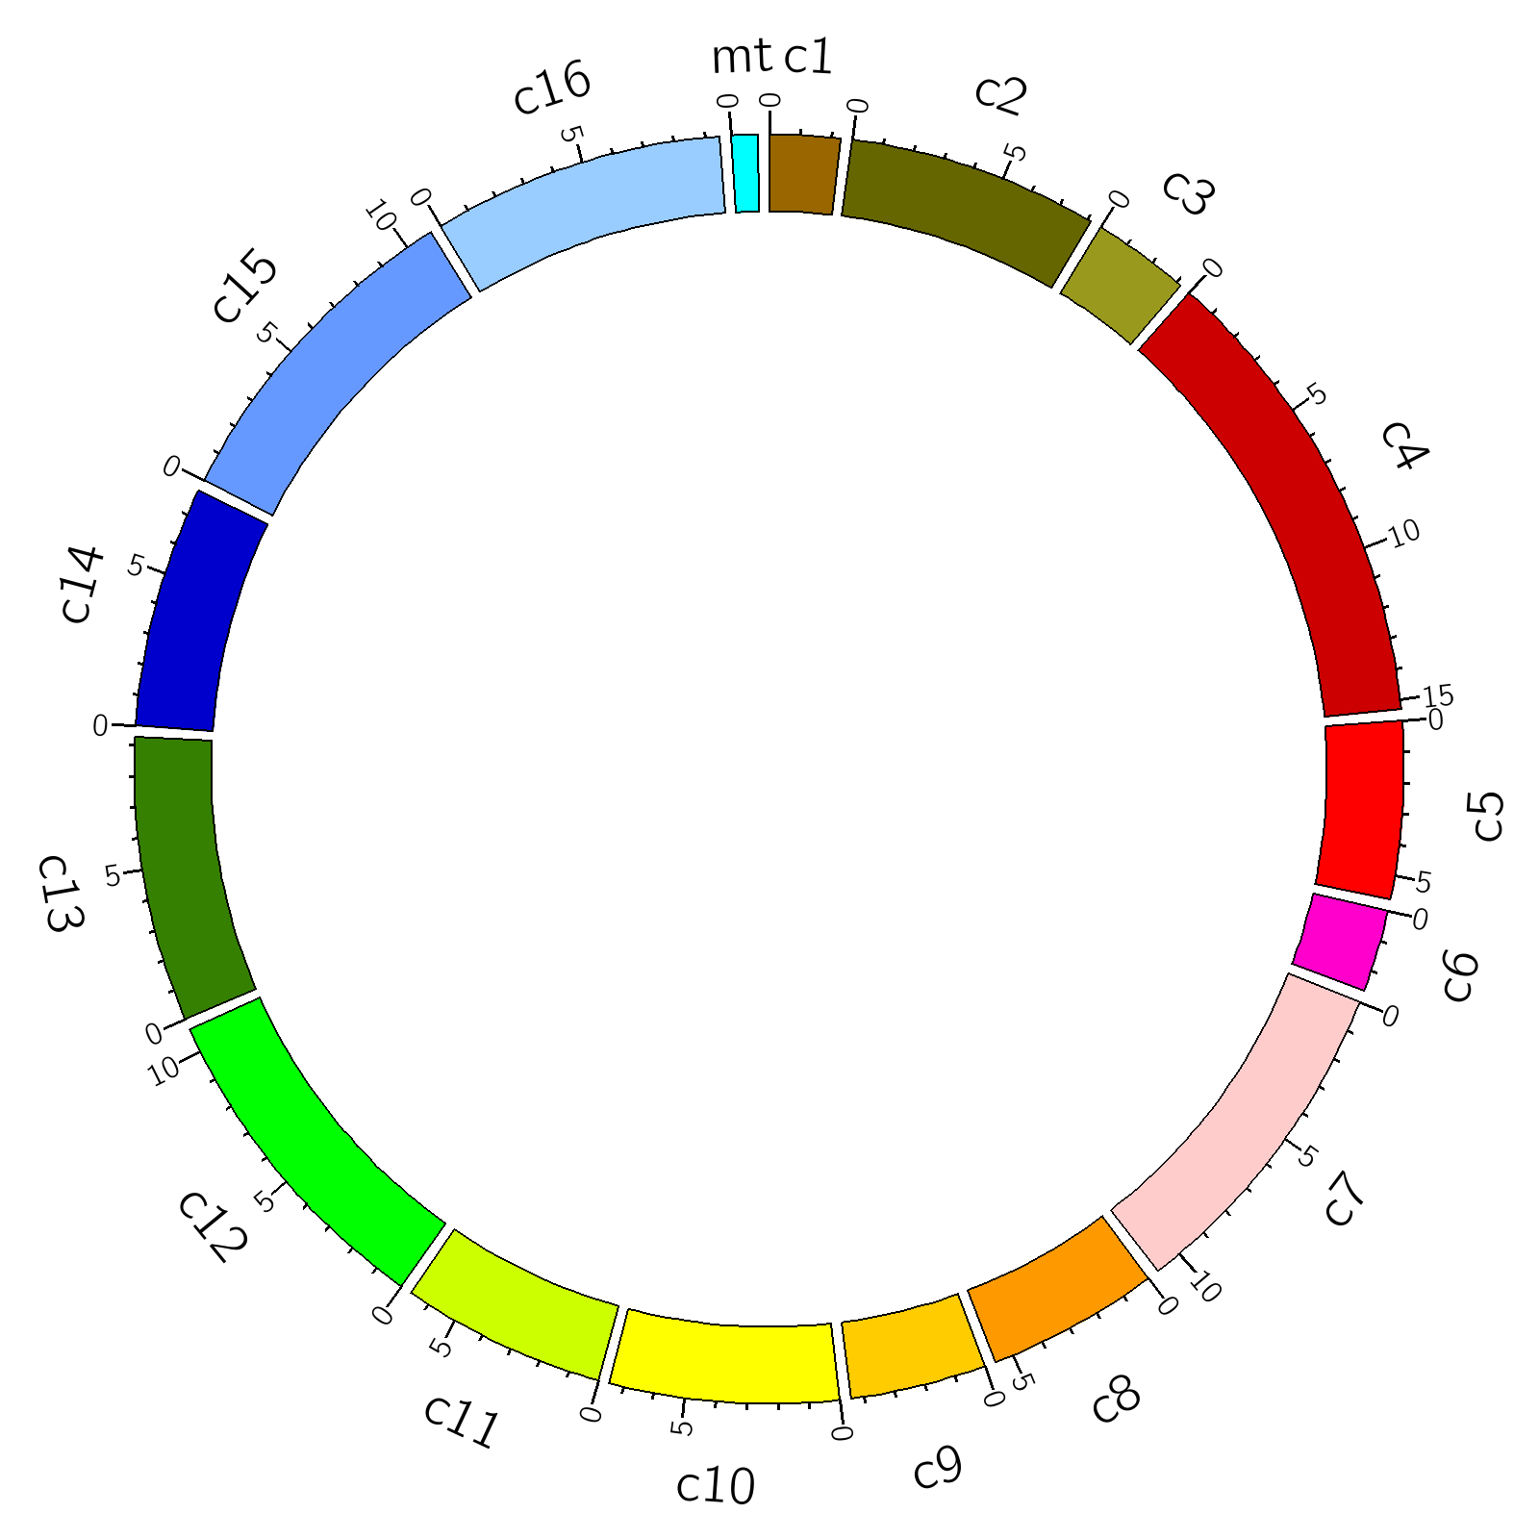

Figure 1. Karyotype of *S. cerevisiae*; length-labels in 0.1m bp’s, the letter c stands for chromosome and mt for mitochondrion.

####Step2: Create the network model for the AC13 set; source: the STRING database, UniProt.

All genes of the AC13 set are obtained from the original paper. However, the protein interaction network (PIN) of this gene set requires an external PIN database such as STRING, BioGrid, or many others. Here we used the STRING database which has collected comprehensive PIN’s for over 2k organisms. As one of the flagships of the STRING database, the *S. cerevisiae* PIN that contains over 2m interactions among 6,692 genes have been systematically collected integrating multiple contributions such as gene expression and fusion, homologous and experiments. The STRING database adopts the UniProt ID’s, which could be converted from the gene names from the UniProt-format *S. cerevisiae* proteome. For the AC13 gene set as summarized in Table 1, 2229 interactions among these 166 genes had been detected, as shown in Figure 2.

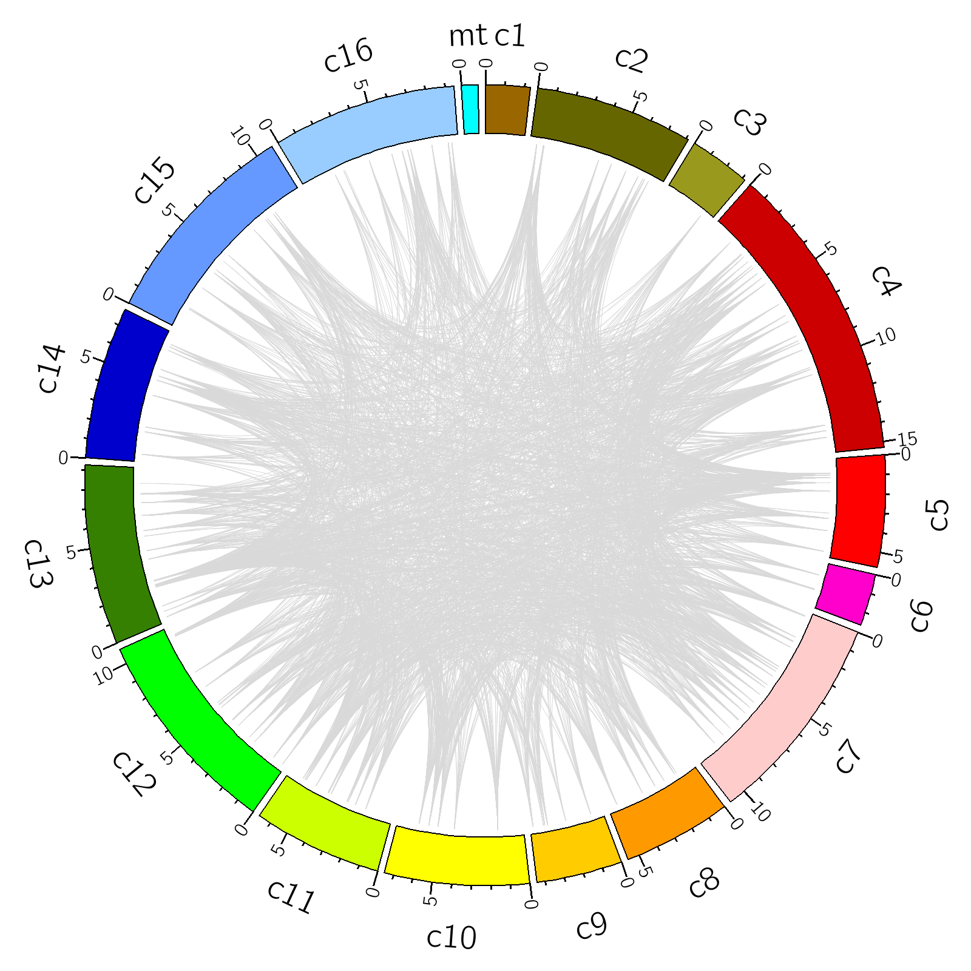

Figure 2. Protein-interaction network of the AC13 gene set. Each interaction is represented as a grey line. 2229 interactions among 166 genes have been detected.

####Step3: Considering the dietary restriction (DR) effects to the reproductive lifespan (RLS) in *S. cerevisiae*. For each gene of the AC13 set the RLS’s of the gene knockout mutant under both YPD (2% glucose) and DR (0.05% glucose) have been compared. Under DR, both WT cell lines (BY4742 and BY4741) have extended average RLS compared to the YPD strains, i.e., consistent with previous reports DR extends the lifespans of the WT yeast cells. However, it had been found that the effect of DR to the yeast RLS is dependent on the phenotype of the cell: it might be extending or shortening or neutral, depending on the gene that had been removed. For example, Figure 3 highlights six genes from the AC13 set with removing of 3 genes (MRPL4, FOB1 and SGF73, in red) significantly extended and 3 genes (SOD2, DLT1 and NDI1, in blue) significantly reduced the RLS under DR, respectively. Two criteria have been applied to this selection: 1. At least 30 cells have been tested in both YPD and DR strains for the mutants, 2. The average RLS is higher than 25 (time scale in generations), such that the data is comparable to the WT (27.3 and 26.2 for BY4741 and BY4742, respectively), and the top 3 genes have been selected for both extension and reduction categories.

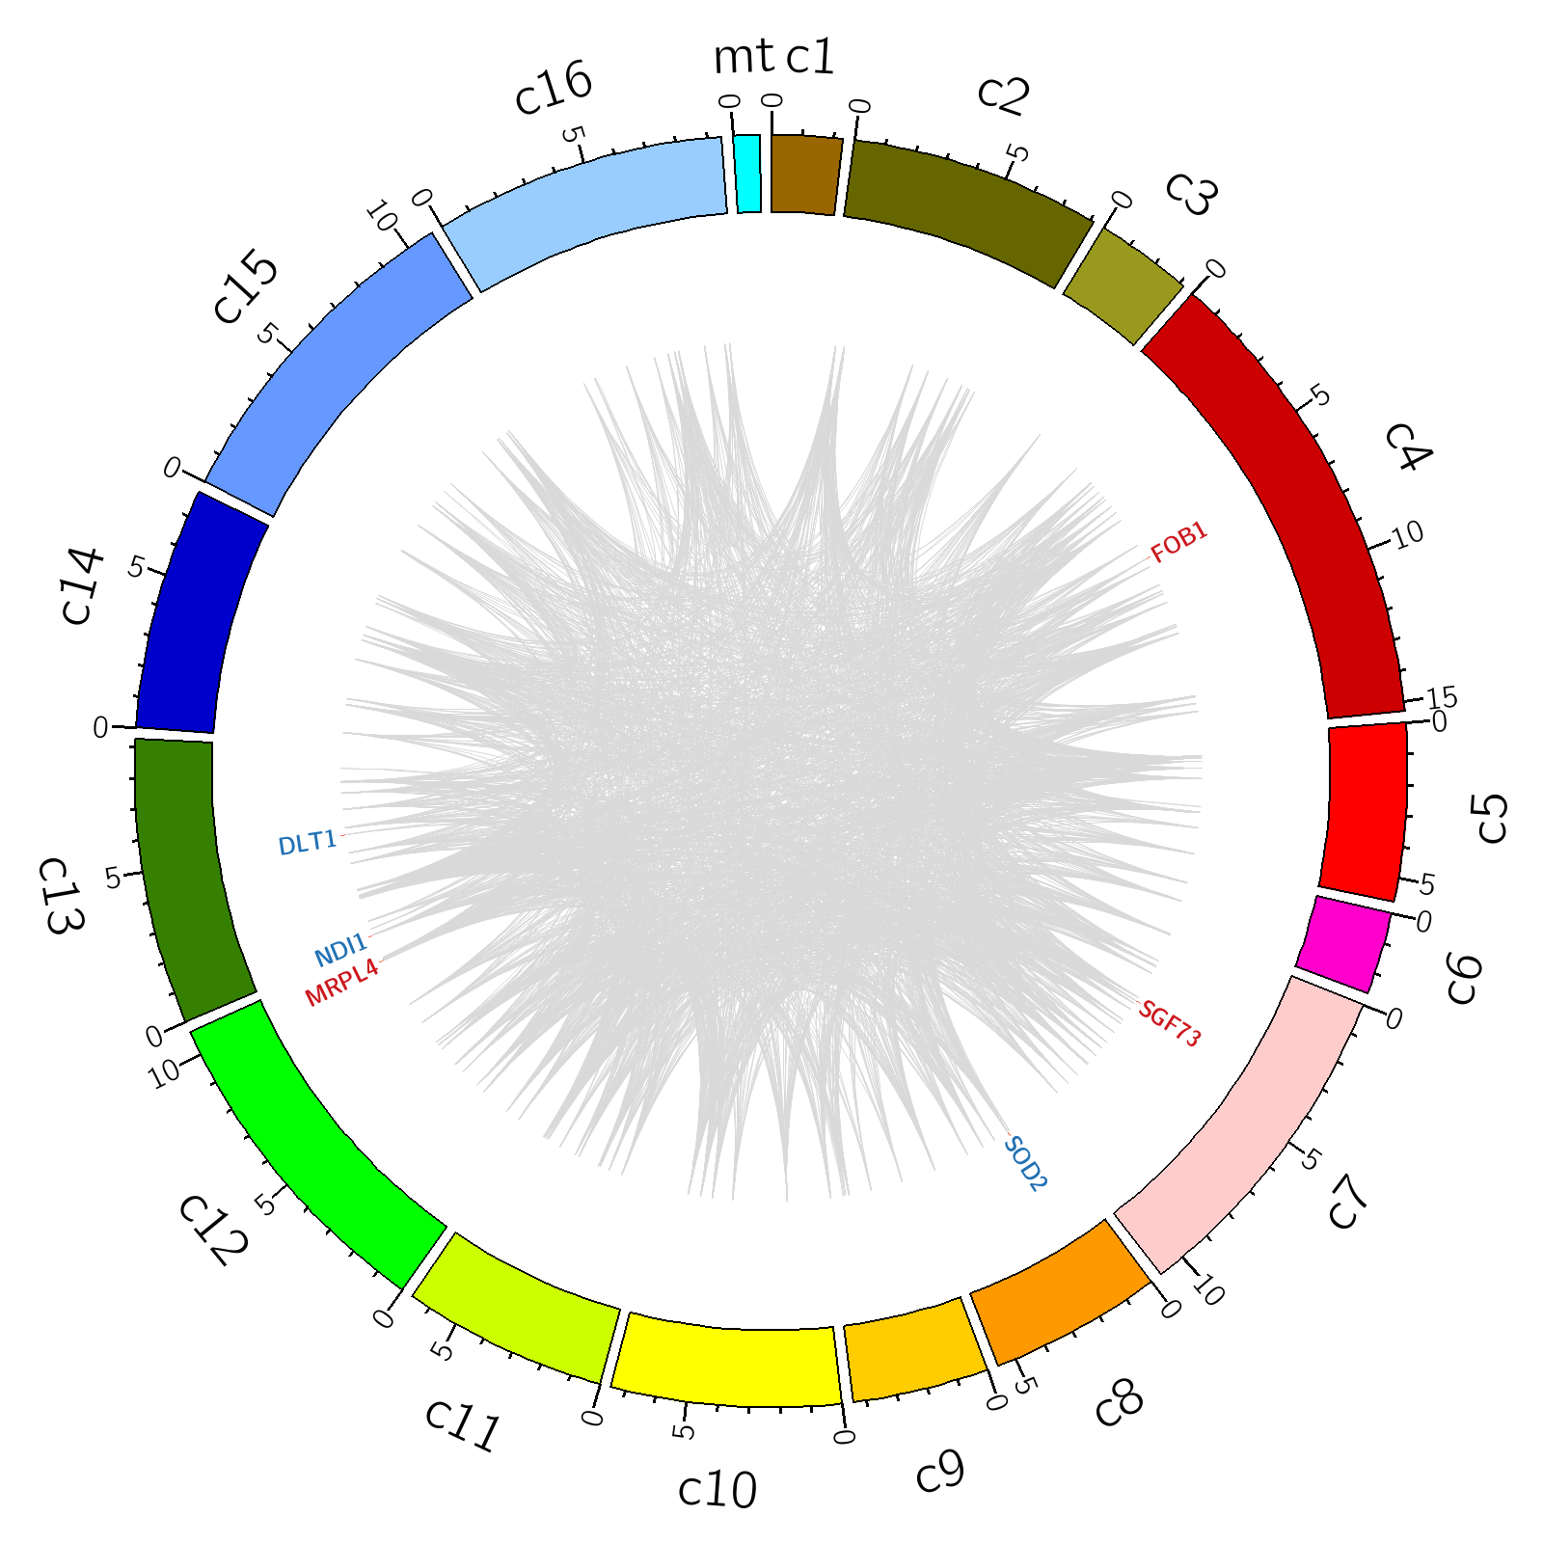

Figure 3. The PIN of the AC13 gene set; highlighted with genes whose knockouts significantly extend (red) or shorten (blue) RLS under DR.

####Step4: More genes could be added, labeled. And interactions with the highlighted genes can be simultaneously highlighted, as shown in Fig.4

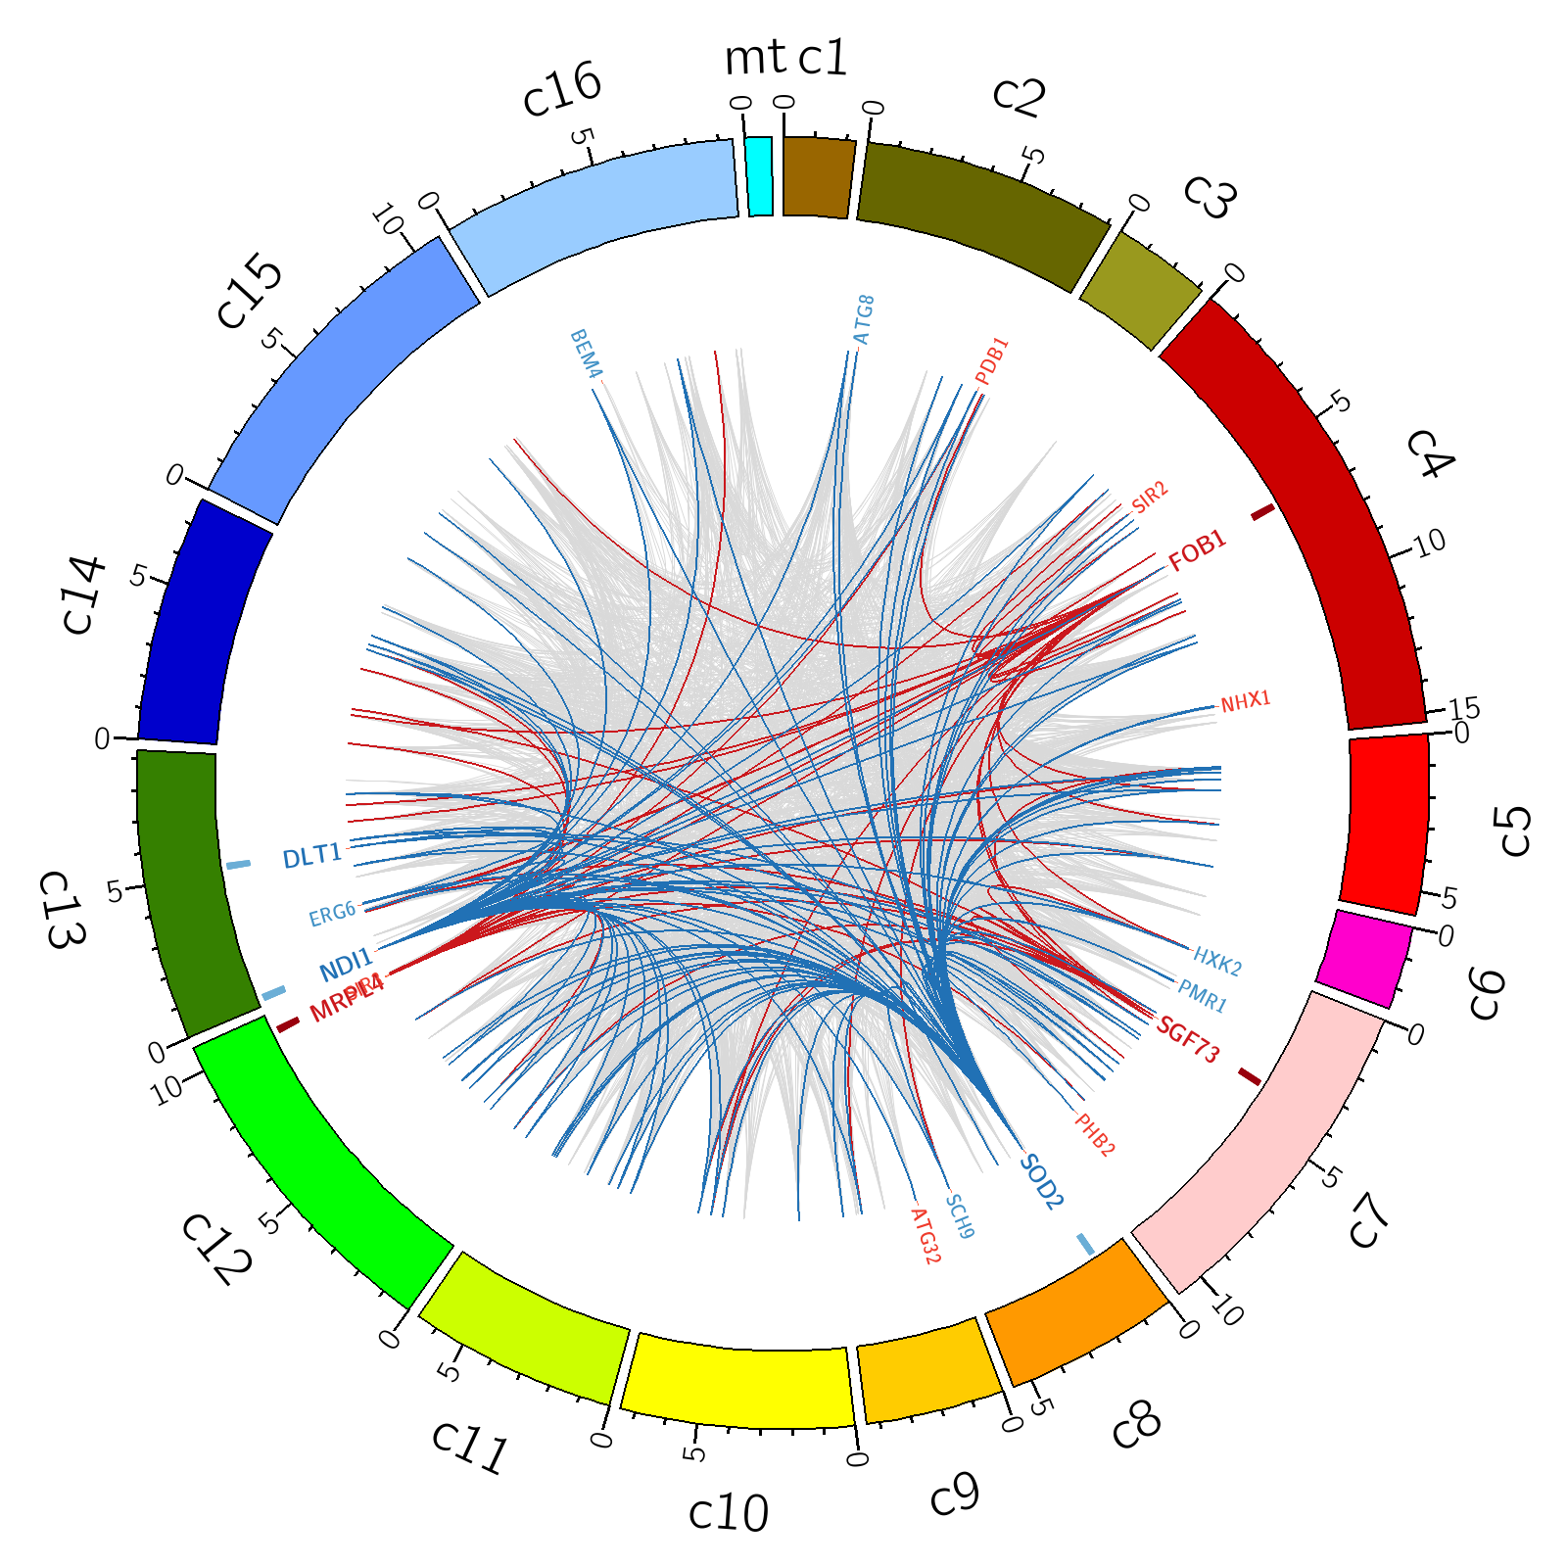

Figure 4. The PIN of the AC13 gene set; highlighted with genes whose knockouts significantly extend (red) or shorten (blue) RLS under DR. Protein-protein interactions with the top 3 genes in whose knockouts lead to either RLS extension (red) or reduction (blue) under DR have been highlighted.

####To-do. The STRING database gives normalized combined-scores (all 13 contributions) for all PPI’s ranging from 150 to 999. If only the strong interactions have been picked up, e.g., the combined scores ≥ 900, the PIN will be like that shown in Figure 5.

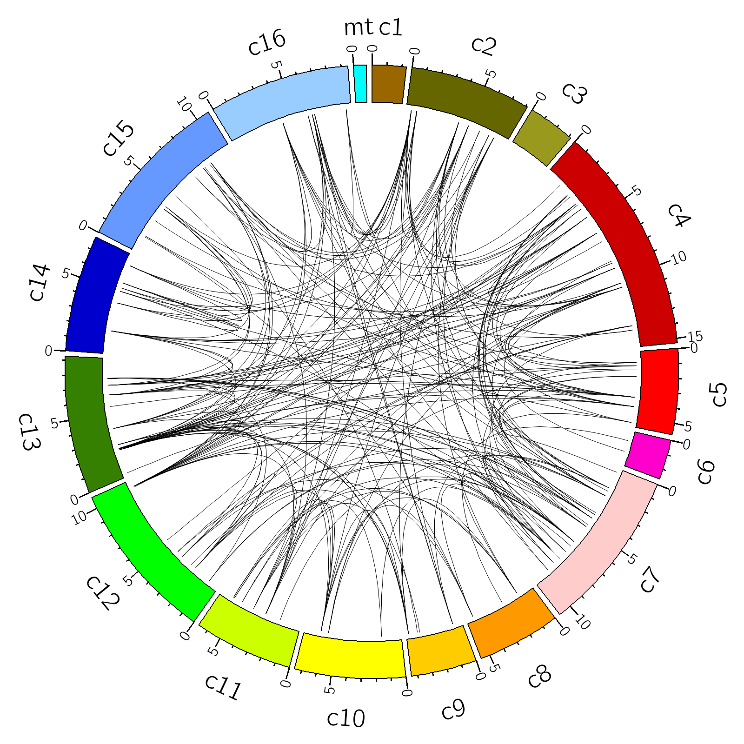

Figure 5. The PIN of the AC13 gene set; only the links with combined scores larger than or equal to 900 have been shown.

>P.S. After removing the cell lines < 30 tests both in YPD and DR conditions, a shortened list of cell lines (92 mutants and two WT strains) was left.

####To-do: If gene A and gene B have a considerably strong interaction, will they have the similar contributions to the DR effect on RLS? Might not be…

####To-do: for all Gompertz distributions, there is a negative correlation between G and R (Pearson’s CC -0.36) for all YPD strians, but it is not significant (Pearson’s CC -0.04) for all DR strains; why is this?

Discussion

Implications?

References