**R Tutorial Workshop, GAS 2014**

**Time: March 29, Sat, 10:30am, Location: Science Hall, W1002**

*Hong Qin, Biology Department, Spelman College*

1. 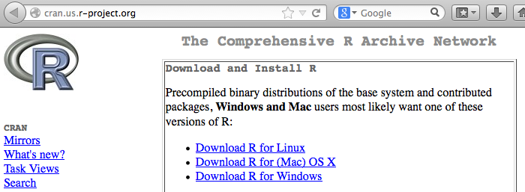Install R.

R is a computing language and programming platform that is an open source equivalent to SAS, SPSS, or MATLAB.

* 1. Go to [cran.us.r-project.org/](http://cran.us.r-project.org/) for the R project.
  2. Based on your computer system, choose Windows, Mac OS X or Linux version of R.
  3. Choose the ‘base’ version, and download the most-recently version (R 3.0.3).

1. 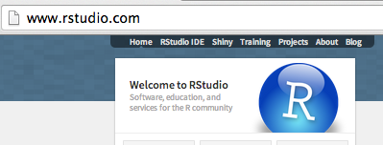Install RStudio

RStudio provides a MATLAB-like GUI to R.

* 1. Go to [www.rstudio.com/](https://www.rstudio.com/)‎,
  2. Click “download now”,
  3. Click “Download RStudio Desktop”,
  4. Choose the recommended version for your computer system.

1. Download the workshop materials from [github.com/hongqin/R-workshop-GAS14](https://github.com/hongqin/R-workshop-GAS14)

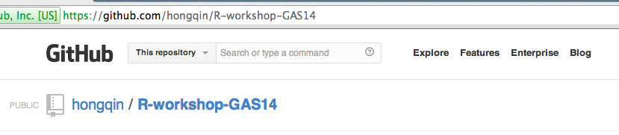

* 1. Choose “Download ZIP”.
  2. Then make sure to extract all files in the ZIP archive. It is often convenient to move the extracted folder to a place that can be easily found, such as the Desktop.
  3. The workshop will begin with “1.Introduction_to_R”. The rest of materials may be used for self-paced studies.