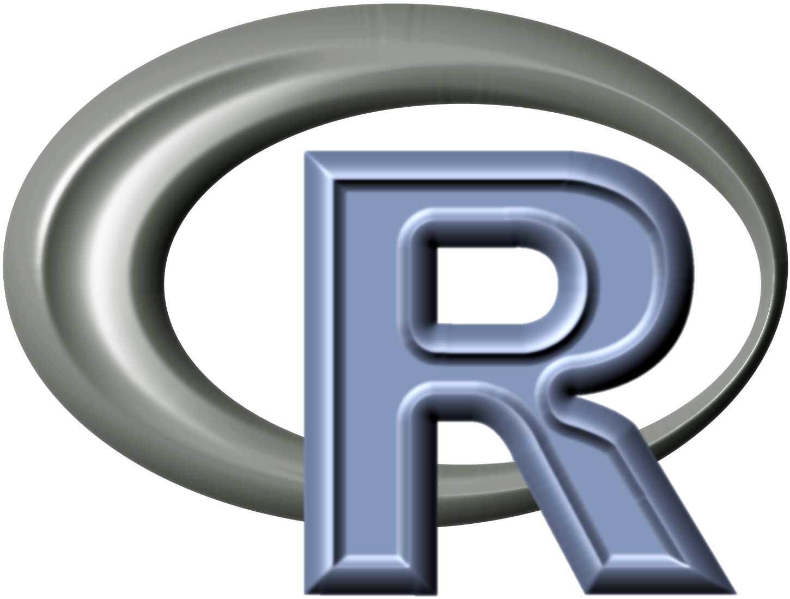

An R tutorial Workshop for Beginners

To be held at the 2014 Annual Meeting of the Georgia Academy of Science. Time and location will be announced soon.

R is a free programming language and environment with strength in computing and visualization. R is popular in both industries and academic research. This tutorial workshop aims to open the door of R programming to everyone interested.

The learning objectives of the workshop are:

Learn basic R programming using Rstudio;

Know how to manage working directories;

Know how to convert Excel files into csv format and load into R;

Know how to generate simple plots in R and export figures;

Know how to save and output results;

Know how to install R packages and where to get helps.

Advanced topics will be provided at <https://github.com/hongqin/R-workshop-GAS14> for practices after the workshop.

Examples of past tutorials are <http://youtu.be/v3k8WEOVSYw> and <http://youtu.be/u5tlUVbnrCg>.

Please bring a laptop for this hands-on workshop. Participants are encouraged to install R and RStudio before the workshop. Please feel free to contact the instructor Hong Qin, [hqin@spelman.edu](mailto:hqin@spelman.edu) for helps with installations and other course materials.