Designing Mutagenic Primers for Yeast MSH2

Overview
In a couple of weeks, you will use the Stratagene QuikChange® Kit to conduct site-directed mutagenesis of the yeast MSH2 gene in order to create an allele corresponding to the human mutation you have selected. The Stratagene QuikChange approach uses primer-directed PCR to replicate copies of the pMSH2 plasmid containing the change you desire. The desired nucleotide change is introduced by means of mutagenic primers which are used to prime the replication reaction. Examine the diagram below, illustrating the steps in QuikChange mutagenesis:

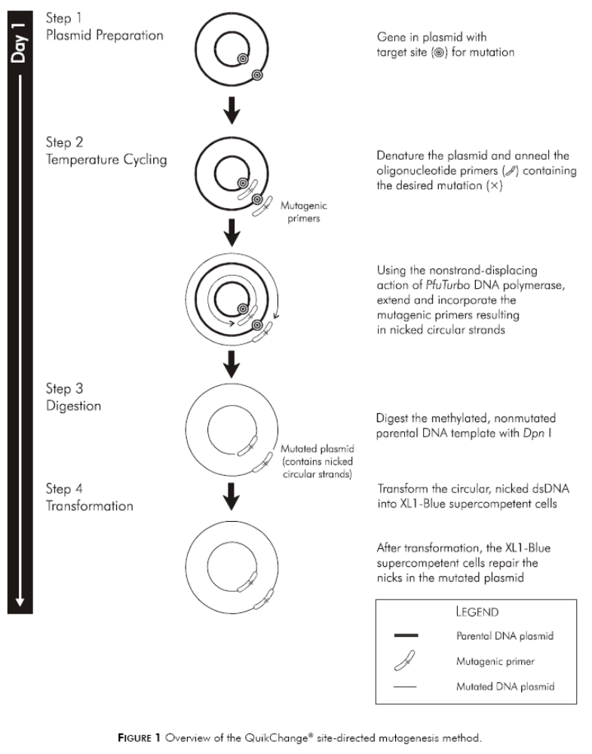

To begin, you will design a set of complementary primers, short single-stranded oligonucleotides that are specifically designed to hybridize to both DNA strands at the region surrounding the codon you want to change. This “oligo” pair will reflect a near-perfect complementary base sequence to each strand of the plasmid, so that they will anneal to the proper location. However, these primers will contain a nucleotide change from the WT sequence, and thus, when they are used to prime a plasmid replication reaction, they will introduce the codon change you desire. Thus, these oligos serve two purposes, first to prime the PCR reaction, and second, to mutagenize the resulting nascent strand sequence – thus, they are called “mutagenic” primers.
Designing Mutagenic Primers

Once the PCR mutagenesis is complete, it will be necessary to confirm that the expected nucleotide change has been incorporated into the gene. Ultimately, mutagenesis must be confirmed by DNA sequencing, but it is wise to incorporate a simpler test to determine if your desired change has been incorporated. In this project, you will make use of restriction analysis to confirm mutagenesis. That is, by coupling a codon change and a restriction site change into the same mutagenic primer, it will be easy to analyze the resulting allele by restriction analysis to determine if the reaction has been successful. If the restriction site has changed, then that must also mean that the desired codon change has also been incorporated into the sequence.

Therfore, to design a primer that will enable site-directed mutagenesis of your target codon, you will need to keep in mind two things:
- Primer must contain a nucleotide change that will alter the target codon so that it codes for the amino acid substitution you desire
- Primer must contain a nucleotide change that will alter the nucleotide sequence either to destroy a nearby restriction site, or to create a nearby restriction site
- These changes may or may not involve the same nucleotides.

- Before you can design your primer, you’ll need to become familiar with the region of the gene in which your desired codon change is located. You’ll need to pay attention to both coding information as well as the position of restriction sites in the vicinity of your target codon. Since the yeast MSH2 gene is quite large, it would be easiest to conduct your analysis on a fragment of the gene, stretching perhaps 100 nucleotides upstream and downstream from your codon. You can use WorkBench editing tools to generate you MSH2 fragment for further analysis.

- Once you’ve generated a shortened (or “truncated”) sequence to work with, you should conduct thorough restriction analysis on it to identify any restriction sites within 10 nucleotides of your target codon. You’ll need to select one of these restriction sites to alter as your diagnostic for mutagenesis.

- Now try your hand at creating a nucleotide sequence that meets the following parameters:
- 23 nucleotides in length
- Includes the nucleotide change(s) that will create the desired codon change
- Includes nucleotide change(s) that will destroy an existing restriction site or create a novel restriction site
- Total GC content should be ≥40%, and the oligo should contain Gs and Cs at the 3’ end.

- Once you have generated a mutagenic oligo that satisfies these parameters, generate its match, that is, a complementary oligo that will anneal to the same site on the opposite strand.
- Create a diagram showing how the oligo aligns with the target site on the MSH2 gene.

Example: Creating a mutagenic primers for site-directed mutagenesis in yeast VMA6

Here’s the nucleotide sequence of the yeast VMA6 gene:
1 ATGGAAGGCG TGTATTTCAA TATTGACAAT GGGTTTATTG AAGGTGTAGT GAGAGGCTAC
61 AGAAATGGGT TGTTATCTAA TAACCAATAC ATCAACTTAA CACAATGTGA CACGTTGGAA
121 GATCTAAAAT TACAATTATC ATCAACTGAT TATGGTAATT TTCTTTCCTC TGTTTCCTCA
181 GAGTCTTTGA CCACGTCATT GATTCAAGAA TATGCTTCTA GCAAGTTGTA CCACGAATTC
241 AACTACATAA GAGACCAATC CAGTGGATCC ACGAGAAAGT TCATGGACTA TATCACTTAT
301 GGTTACATGA TCGACAATGT AGCATTGATG ATTACAGGTA CTATTCATGA TCGTGATAAG
361 GGTGAAATTT TACAACGTTG TCATCCGCTA GGTTGGTTTG ATACTTTGCC TACGTTGAGT
421 GTTGCTACTG ATCTTGAATC CCTATACGAA ACCGTATTGG TGGATACCCC ACTGGCACCT
481 TACTTCAAAA ACTGTTTTGA CACGGCAGAG GAGCTAGACG ATATGAACAT TGAAATTATT
541 AGAAATAAGC TGTACAAGGC TTATTTAGAA GACTTTTACA ATTTTGTCAC TGAAGAAATT
601 CCGGAACCTG CTAAAGAATG TATGCAAACA TTACTAGGGT TTGAAGCTGA CAGAAGAAGT
661 ATCAATATTG CACTCAACTC TTTGCAAAGT TCAGATATTG ACCCAGATTT GAAAAGTGAC
721 TTGTTACCTA ACATAGGTAA GTTGTACCCT CTTGCAACGT TTCACTTGGC GCAAGCCCAA
781 GATTTCGAAG GAGTTAGAGC TGCTTTAGCT AACGTCTATG AGTATAGGGG ATTTTTGGAG
841 ACTGGTAACT TAGAAGATCA CTTTTACCAA TTGGAAATGG AACTATGTAG AGATGCTTTC
901 ACGCAACAAT TTGCCATCAG CACTGTTTGG GCCTGGATGA AATCCAAGGA ACAAGAAGTT
961 AGGAATATTA CCTGGATTGC AGAATGTATC GCACAAAACC AAAGAGAAAG AATCAACAAT
1021 TATATTTCCG TTTATTGA

Using SIXFRAME, the correct open reading frame (ORF 1) can be identified:
M E G V Y F N I D N G F I E G V V R G Y
1 atggaaggcgtgtatttcaatattgacaatgggtttattgaaggtgtagtgagaggctac 60
R N G L L S N N Q Y I N L T Q C D T L E
61 agaaatgggttgttatctaataaccaatacatcaacttaacacaatgtgacacgttggaa 120
D L K L Q L S S T D Y G N F L S S V S S
121 gatctaaaattacaattatcatcaactgattatggtaattttctttcctctgtttcctca 180
E S L T T S L I Q E Y A S S K L Y H E F
181 gagtctttgaccacgtcattgattcaagaatatgcttctagcaagttgtaccacgaattc 240
N Y I R D Q S S G S T R K F M D Y I T Y
241 aactacataagagaccaatccagtggatccacgagaaagttcatggactatatcacttat 300
G Y M I D N V A L M I T G T I H D R D K
301 ggttacatgatcgacaatgtagcattgatgattacaggtactattcatgatcgtgataag 360
G E I L Q R C H P L G W F D T L P T L S
361 ggtgaaattttacaacgttgtcatccgctaggttggtttgatactttgcctacgttgagt 420
V A T D L E S L Y E T V L V D T P L A P
421 gttgctactgatcttgaatccctatacgaaaccgtattggtggataccccactggcacct 480
Y F K N C F D T A E E L D D M N I E I I
481 tacttcaaaaactgttttgacacggcagaggagctagacgatatgaacattgaaattatt 540
R N K L Y K A Y L E D F Y N F V T E E I
541 agaaataagctgtacaaggcttatttagaagacttttacaattttgtcactgaagaaatt 600
P E P A K E C M Q T L L G F E A D R R S
601 ccggaacctgctaaagaatgtatgcaaacattactagggtttgaagctgacagaagaagt 660
I N I A L N S L Q S S D I D P D L K S D
661 atcaatattgcactcaactctttgcaaagttcagatattgacccagatttgaaaagtgac 720
L L P N I G K L Y P L A T F H L A Q A Q
721 ttgttacctaacataggtaagttgtaccctcttgcaacgtttcacttggcgcaagcccaa 780
D F E G V R A A L A N V Y E Y R G F L E
781 gatttcgaaggagttagagctgctttagctaacgtctatgagtataggggatttttggag 840
T G N L E D H F Y Q L E M E L C R D A F
841 actggtaacttagaagatcacttttaccaattggaaatggaactatgtagagatgctttc 900
T Q Q F A I S T V W A W M K S K E Q E V
901 acgcaacaatttgccatcagcactgtttgggcctggatgaaatccaaggaacaagaagtt 960
R N I T W I A E C I A Q N Q R E R I N N
961 aggaatattacctggattgcagaatgtatcgcacaaaaccaaagagaaagaatcaacaat 1020
Y I S V Y *
1021 tatatttccgtttattga 1038
To simplify the analysis, a shorter gene fragment can be generated using the nucleic editing tool:

L L P N I G K L Y P L A T F H L A Q A Q
1 ttgttacctaacataggtaagttgtaccctcttgcaacgtttcacttggcgcaagcccaa 60
D F E G V R A A L A N V Y E Y R G F L E
61 gatttcgaaggagttagagctgctttagctaacgtctatgagtataggggatttttggag 120
T G N L E D H F Y Q L E M E L C R D A F
121 actggtaacttagaagatcacttttaccaattggaaatggaactatgtagagatgctttc 180
T Q Q F A I S T V W A W M K S K E Q E V
181 acgcaacaatttgccatcagcactgtttgggcctggatgaaatccaaggaacaagaagtt 240
R N I T W I A E C I A Q N Q R E R I N N
241 aggaatattacctggattgcagaatgtatcgcacaaaaccaaagagaaagaatcaacaat 300
Y I S V Y *
301 tatatttccgtttattga 318

And this sequence can be analyzed with the TACG tool to identify restriction sites in the region of the codon to be targeted:
StyD4I
ScrFI
PspGI
HaeIII
Sau96I
BmgT120I
HpyCH4III StyI
BccI TspRI BstNI BsaJI TspDTI
Tsp509I TspRI AlfI CviKI-1 BtsCI FokI
\ \ \ \ \\ \\\ \ \ \ \ \
181 acgcaacaatttgccatcagcactgtttgggcctggatgaaatccaaggaacaagaagtt 240
tgcgttgttaaacggtagtcgtgacaaacccggacctactttaggttccttgttcttcaa
^ * ^ * ^ * ^ * ^ * ^ *
1 T Q Q F A I S T V W A W M K S K E Q E V

StyD4I
ScrFI
PspGI
BstNI TfiI TspGWI
SspI SetI HpyCH4V Hin4I HinfI Tsp509I
\ \ \\ \ \ \ \ \
241 aggaatattacctggattgcagaatgtatcgcacaaaaccaaagagaaagaatcaacaat 300
tccttataatggacctaacgtcttacatagcgtgttttggtttctctttcttagttgtta
^ * ^ * ^ * ^ * ^ * ^ *
1 R N I T W I A E C I A Q N Q R E R I N N

In the sequence above, the target codon is highlighted in yellow, and nearby restriction sites are highlighted in blue. To evaluate further, it is helpful to know what each restriction site is, and this information is conveniently provided for you in the TACG tool:

Enzyme Restriction Site
StyI C'CwwG_G
BsaJI C'CnnG_G
BtsCI GGATG_nn'
FokI GGATGnnnnnnnnn'nnnn_
TspDTI ATGAAnnnnnnnnn_nn'
SspI AAT'ATT
So, to illustrate the strategy for designing a set of mutagenic primers, this is the coding region we are interested in:

SspI
5’–atgaaatccaaggaacaagaagttaggaatattacctggattgcagaatgtatc-3’

M K S K E Q E V R N I T W I A E C I

To design a primer that 1) alters the glutamate codon (E) to code for lysine (K), and 2) destroys the SspI restriction site:

E SspI
Gene Sequence: 5’-ggaacaagaagttaggaatattacctgg-3’

Primer Sequence: 5’-gaacaaaaagttaggaatgttacc-3’
K SspI

Thus, by altering only 2 nucleotides in the entire sequence, both desired changes are accomplished. The resulting 24-mer can be used to prime a PCR reaction, and when incorporated, will introduce both a codon change and a restriction site change.

For the final step, it is important to design a second primer that will anneal to the complementary strand:

5’-gaacaaaaagttaggaatgttacc-3’ (referred to as the “forward” primer)

3’-cttgtttttcaatccttacaatgg-5’ (referred to as the “reverse” primer)

