Yeast Transformation

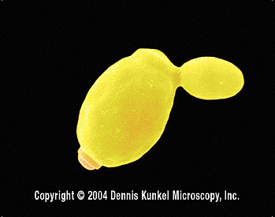
(Adapted from http://www.yeastgenome.org/VL-what_are_yeast.html) Yeasts are unicellular fungi of the phylum Ascomycetes, class Saccharomycetes (also called Hemiascomycetes). Yeasts multiply by budding (e.g. Saccharomyces) or direct division (fission, e.g. Schizosaccharomyces), or they may grow as simple irregular filaments (mycelium). In sexual reproduction most yeasts form asci, which contain up to eight haploid ascospores. These ascospores may fuse with adjoining nuclei and multiply through vegetative division or, as with certain yeasts, fuse with other ascospores.
Figure 1 - Saccharomyces mother cell with daughter bud.

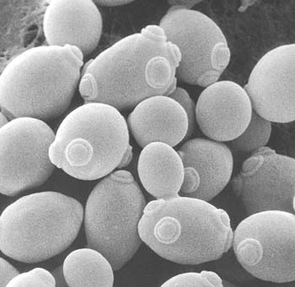
The most well-known and commercially significant yeasts are the related species and strains of Saccharomyces cerevisiae. For the past two decades S. cerevisiae has been the model system for much of molecular genetic research because the basic cellular mechanics of replication, recombination, cell division and metabolism are generally conserved between yeast and larger eukaryotes, including mammals. The well developed genetic system of yeast enables investigators to characterize any observable phenotype and correlate it with the corresponding genotype. Since the Saccharomyces genome has been sequenced in its entirety, it is also possible to identify the specific gene responsible, and examine cellular mechanisms and mutational effects at the genomic level.
Figure 2 – Yeast cells showing bud scars from multiple rounds of division.
Saccharomyces may exist stably in either diploid or haploid form. Often, haploid strains are utilized in the lab because they contain only one copy of each unique gene, facilitating the study of a gene of interest. Any gene may be selectively disrupted or deleted from its chromosomal locus resulting in a haploid “knock out” strain. The resulting mutant may then be studied to determine the cellular effects of that particular deletion. Alternatively, it is possible to introduce a gene of interest by transforming a yeast strain with a plasmid copy of the gene using an approach similar to bacterial transformation. The resulting strain may then be studied to determine the effect of that particular gene addition.
One powerful strategy in yeast is complementation testing. A mutant strain in which a single gene has been selectively deleted may subsequently be transformed with a plasmid carrying a wildtype “replacement” copy of the gene. The plasmid copy of the gene will “rescue” the phenotype resulting from the chromosomal deletion, and thus is said to “complement” the mutant allele.
Genetic Complementation in Yeast

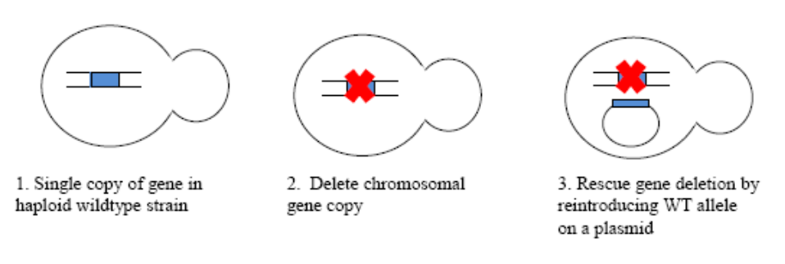

Transformation of the msh2 yeast reporter strain (from Gammie 2007)
In order to test the function of the missense mutations you have constructed by site-directed mutagenesis, you will test the function of the mutant allele for its ability to rescue or complement a strain in which the WT MSH2 gene has been selectively deleted. To do this, you will introduce your mutant into an msh2 yeast strain by transformation. In addition, as a positive control for complementation, you will transform the msh2 strain with a plasmid containing the WT MSH2 allele (pMSH2, the plasmid you started with at the beginning of this project); this plasmid should fully rescue the mutant phenotype. For a negative control, you will transform the msh2 strain with the original vector, pRS413, which does not contain MSH2.

In order to perform the functional assays, the plasmids must be introduced into an msh2 strain that will allow for the determination of the mutator phenotype associated with msh2 mutants. The full genotype of the strain that we will be transforming is very complicated, and includes several gene mutations in addition to msh2. The strain can be described as follows: MATa CAN1 ade2-1 trp1-1 ura3-1 leu2-3,112 his3-11,15 msh2::LEU2 [+ pSH44=TRP1 CEN ARS PLEU2-(GT)16.5-URA3]

The pSH44 is the reporter construct for microsatellite dinucleotide instability by the dinucleotide repeat assay (Henderson and Petes, 1992). pSH44 has a dinucleotide sequence, GT, repeated 16.5 times (GT_{16.5}) in frame with the URA3 gene. Expression of the fusion product is driven by the LEU2 promoter (P_{LEU2}), which is activated under conditions where leucine and threonine are limiting (–LEU –THR). The plasmid is selected for by growing trp1 defective strains harboring the plasmid in medium lacking tryptophan (–TRP). pSH44 has already been introduced into the msh2 strain. As the dinucleotide tracts expand or contract, the reading frame for the URA3 gene will be disrupted and the cell will no longer contain a functional gene product. There is a potent drug 5-fluoro-orotic acid, 5-FOA, that can select for the loss of URA3 function.

The background msh2 strain is also trp1 (see genotype above), or auxotrophic for tryptophan, so it can only grow in media supplemented with this essential amino acid. When this strain carries the pSH44 plasmid, however, the TRP1 gene on the plasmid complements the chromosomal deletion and the strain can grow in the absence of added trp.

The background msh2 strain is also his3 (see genotype above), or auxotrophic for histidine, so it requires histidine supplement to grow. When this strain is transformed with pRS413-derived plasmid containing the HIS3 gene, the plasmid HIS3 gene complements the auxotrophic phenotype. The HIS3 gene serves as a selectable marker for transformation with this the plasmid.

A schematic map of pSH44 ( P_{LEU2} GT_{16.5}-URA3 TRP1/ARS)
P_{LEU2}

TRP1/ARS
CEN11
ColE1 ori
β-lactamase
(GT)_{16.5}-URA3
pSH44

Transformation of msh2

PLATE solution is made of:
40% PEG3350 (w/v)
100 mM lithium acetate (LiAc)
10 mM Tris, pH 7.5
1mM mM EDTA

(adapted from Methods in Yeast Genetics: A Cold Spring Harbor Laboratory Course Manual. Copyright 2000 Cold Spring Harbor Laboratory Press and Cold Spring Harbor Laboratory, Plainview, N.Y. Edited by Burke, D., D. Dawson, T. Stearns.)

Before you start:
- Obtain fresh ice in your ice bucket
- Obtain an overnight culture of msh2 yeast
- Label three sterile 1.5 mL microfuge tubes: pMSH2, pRS413, and your mutant (e.g. M707I)
- Incubate the tube of Carrier DNA for 5 minutes in the boiling water bath, then chill on ice for at least 5 minutes

- Obtain a 10 mL culture tube of msh2 yeast, grown overnight at 30°C. Collect the cells by centrifuging for 5 minutes at 3000 rpm. You should observe a cell pellet at the bottom of the tube. Carefully decant the supernatant, and gently resuspend the pellet in 5 mL of sterile water. Centrifuge again.

- Remove the supernatant completely by pouring off and then by removing residual volume with a pipette. Carefully resuspend the cell pellet in 0.5 mL PLATE solution from the stock tube provided.

- To each of your three tubes, add the following transformation components:
0.5 mL msh2 yeast suspended in PLATE solution (what you just prepared)
20 uL 1M DTT (caution: this solution is stinky)
10 uL boiled Carrier DNA
10 uL plasmid DNA (pMSH2, pRS413, or your mutant plasmid)

- Mix the contents of each tube carefully by pipeting gently up and down with a blue tip. Incubate tubes for 30-45 minutes at 30°C.

- Heat shock the cells for 15 minutes at 42°C in the water bath provided.

- Centrifuge the transformation mixture for 10-15 seconds in a microfuge to collect the cells. Remove the supernatant and gently resuspend the cell pellet in 100 uL sterile water.

- Transfer the entire volume of cells to the surface of an SD-his-trp plate (to select for transformants) and spread evenly across the plate using sterile glass beads (as we did for the bacterial transformation).

- Incubate the transformation plates for 24-48 hours at 30°C in inverted position (upside down) in an incubator. Check for the presence of colonies after 24 hours; these represent transformants that have taken up the plasmid and are now able to grow in the absence of both tryptophan (due to the presence of the pSH44 plasmid) and histidine (due to the presence of the pRS413, pMSH2, or mutant plasmids).

