Testing Mismatch Repair Function in Yeast using the 5-FOA/URA3 Selection

Overview
To determine whether your mutants are able to complement the msh2 phenotype in the tester strain, you will grow them up on a plate containing 5-fluororotic acid (5FOA). Remember that your tester strain harbors the plasmid pSH44 which contains a URA3 allele with an in-frame microsatellite insertion. This modified URA3 will undergo frequent mutational damage in an mmr- background. Ura+ strains are sensitive to the presence of 5FOA in the growth medium because the substrate can be converted to 5-fluorouracil, a toxic metabolite. Thus, MMR+ strains that are able to repair microsatellite slippage mutations in URA3+ on pSH44 will be sensitive to 5FOA. In contrast, MMR- strains are unable to repair microsatellite slippage mutations and become ura- that are 5FOA resistant.

Calibrating the spectrophotometer:
- Turn on the instrument using the switch on the back panel and allow it to warm up for 5-10 minutes. Be sure that the Visible light source is ON. Set the absorbance reading to 600 nm using the toggle button on the top panel.
- To zero the instrument, make sure that the cuvette holder is empty. Set the output to Transmission (%T), and dial the value down to 0%T.
- To blank the instrument, insert a clean plastic cuvette filled with 1.0 mL sterile water into the chamber, and press the 0 ABS key. The value reported should be 100%T.
- Set the output to Absorbance by pushing the toggle 2x – the instrument should now read
“600 nm 0.000A”
- The instrument is now ready for use.

Measuring the absorbance of your overnight culture:
- Remove your overnight liquid cultures from the shaker incubator. To determine the growth, you’ll need to measure the turbidity or absorbance of the culture – the higher the absorbance, the greater the amount of cells in your culture.
- Carefully pipette 0.9 mL of sterile water into each of three (3) clean plastic cuvettes labeled MSH2, Vector, and Mutant. Add 100 uL of each of your overnight cultures and pipette up and down a couple of times to mix. You have thus diluted your culture 1:10 (100 μL in a total of 900+100= 1000 μL).
- Once you have calibrated the spectrophotometer, insert your sample cuvettes one by one and record the absorbance for each sample.
- To calculate the true absorbance of your culture, you’ll need to multiply the absorbance reading times 10 (since you prepared a 1:10 dilution).

- Note: Yeast cells OD600 ~ Concentration (x10^7 per ml)

OD600 | Cell x10^7
0.100 | 0.128 | 0.7 | 1.046 | 1.5 | 4.48
0.200 | 0.255 | 1.0 | 1.85 | 1.6 | 5.22
0.500 | 0.7 | 1.4 | 3.82

Because the 5FOA mutation rate in MSH2 is about 10^-6, we expect at least 50 mutants per 90ul, this means cell concentration = 10*10^6 * (1000/75) /ml = 13x10^7 per ml, which is about OD600>=?. Hence, we need to spin down OD=1.0 cells and re-suspend the cells in 1/10 of its volume to concentrate them.

Preparing dilutions of your overnight cultures:
- You need to prepare a dilution series of your overnight cultures that measure ~ 1.0, 0.1, and 0.01 Abs. To do this, you’ll first need to calculate the dilution for your overnights using the following formula:

Culture Abs/x = 1.0 Abs where x is the dilution factor

Then use the dilution factor to calculate the volume of culture you should add to water to make up 1.0 mL of total sample. Note that you’ll need to calculate a dilution factor for each of your three samples!

- Once you’ve created your dilutions, measure the absorbance of each one. The abs value should be approximately 1.0 +/- 0.1 (i.e. 0.9 – 1.1). If the values fall outside that range, check your calculations and redo the dilution.

- Now you are ready to make a serial dilution of each strain (see figure below). Pipette 0.9 mL sterile water in to each of 6 clean cuvettes. Label two of the cuvettes MSH2, two Vector, and two Mutant. Add 0.1 mL of each dilution from step 2 to a cuvette and pipette to mix. This is a 1:10 dilution, and should result in an absorbance reading of ~ 0.1.

- Now take 0.1 mL of the dilution from step 3 and add it to a cuvette to make another 1:10 dilution, resulting in an absorbance reading of ~0.01.

Testing strains on 5FOA plates:
- Obtain a fresh 5FOA plate and label it with your group name and date. Then label the plate as shown in the diagram below.
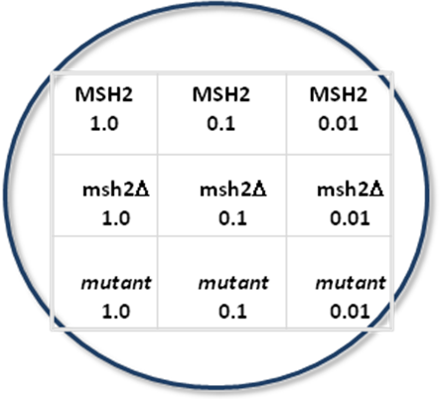

- Using a clean sterile yellow tip, carefully pipette 90 μL of each of your dilutions onto the surface of the 5FOA plate. The spots should spread out a bit to an approximate diameter of ~ 0.2-0.3 cm. It is important not to tip or bump the plate after you’ve transferred your dilutions onto the surface of the plate. You’ll need to wait 10-15 minutes for the spots to dry before inverting the plate and incubating them at 30°C for 24 hours. Check to make sure all spots are dry before you move the plates.

