**Restriction Enzymes Name:___________________________**

***WHY ARE RESTRICTION ENZYMES NECESSARY?***

1. Restriction enzymes are “molecular scissors” that ___________________________________________
2. Restriction enzymes are isolated from __________________ for use in biotechnology research.
   1. 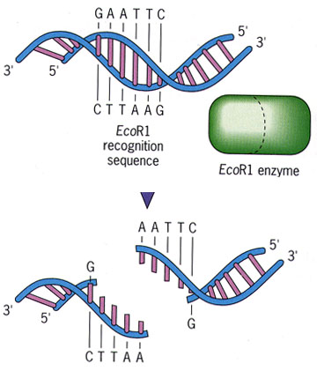The function of restriction enzymes in bacterial cells is to cut apart foreign DNA molecules (i.e. from ____________________________________)
   2. Restriction enzymes are named from the bacterium from which it was discovered. For example: __________________
      1. ______ – the first letter of the ___________ name of the bacteria (*Escherichia*)
      2. ______ – the first two letters of the ____________ name of the bacteria (*coli*)
      3. ______ – a particular _________________ of this bacteria (strain RY13)
      4. ______ – the particular ________________ among several produced by this strain
3. Restriction enzymes cut DNA in areas of specific base pair sequences, called ____________________
   1. In general, a restriction site is a 4- or 6-base-pair sequence that is a ______________________

|  |  |  |
| --- | --- | --- |
| **Restriction Enzyme** | **Restriction site** | **Sticky or Blunt** |
| EcoRI | 5’ GAATTC 3’  3’ CTTAAG 3’ |  |
| BamHI | 5’ GGATCC 3’  3’ CCTAGG 5’ |  |
| HindIII | 5’ AAGCTT 3’  3’ TTCGAA 5’ |  |
| AluI | 5’ AGCT 3’  3’ TCGA 5’ |  |
| SmaI | 5’ CCCGGG 3’  3’ GGGCCC 5’ |  |
| HhalI | 5’ GCGC 3’  3’ CGCG 5’ |  |

* + 1. A sequence in which the “top” strand read from 5’ to 3’ is the same as the bottom strand read from 5’ to 3’.
    2. Each different restriction enzyme (and there are hundreds) has its own restriction site. The ends of the DNA produced after being cut with a restriction enzyme can be either “blunt” or “sticky”

1. When scientists study a DNA molecule, one of the first things they do is figure out where many restriction sites are. They then create a “__________________”, showing the locations of cleavage sites for many different enzymes.
2. After the restriction enzyme cuts the DNA, the fragments are of different lengths and can be separated via ____________________________________

**Restriction Enzyme Name:___________________________**

**Exercises and Questions**

**Exercise 1: Modeling Restriction Enzyme Action**

1. Cut the DNA sequence strips (on the separate half sheet) along their borders. These strips represent double stranded DNA molecules. Each strip is labeled 1, 2, 3 or 4 in the upper left hand corner.
2. You will now simulate the activity of *Eco*RI. Scan along the DNA sequence of strip 1 until you find the *Eco*RI restriction site. You’ll have to look at your notes to see where on the DNA *Eco*RI cuts. Using scissors make a cut through the DNA to simulate the action of the EcoRI restriction enzyme. Separate the two pieces of DNA. Look at the new DNA ends produced by *Eco*RI. **Are they sticky or blunt?** Write *Eco*RI on the cut ends. Keep the cut fragments on your desk.
3. Repeat the procedure with strip 2, this time simulating the activity of *Sma*I. **Are the new ends sticky or blunt?** Label the new ends S*ma*I, and keep the DNA fragments on your desk.
4. Simulate the activity of *Hin*dIII with strip 3. **Are these ends sticky or blunt?** Label the new ends *Hin*dIII, and keep the fragments.
5. Repeat the procedure once more with strip 4 again simulating *Eco*RI. Pick up the 'front-end' DNA fragment from strip 4 (an *Eco*RI fragment) and the “back end” *Hin*dIII fragment from strip 3. Both fragments have single stranded tails of 4 bases. **Are the base sequences of the *Hin*dIII and *Eco*RI tails complementary?**
6. Put down the *Hin*dIII fragment, and pick up the back end DNA fragment from strip 1 (cut with *Eco*RI). Compare the single-stranded tails of the *Eco*RI fragment from strip 1 and the *Eco*RI fragment from strip 4. **Are they complementary?**
7. Imagine that you have cut a completely unknown DNA fragment with *Eco*RI. **Do you think that the single stranded tails of these fragments would be complementary to the single stranded tails of the fragments from strip 1 and strip 4? Why or why not?**
8. Tape or staple your restriction enzyme fragments for each DNA strand (labeled 1-4) onto the bottom of this sheet.

**Useful links:**

**Exercise 2: Identifying Restriction Sites**

1. Locate and label the restriction enzyme sites for EcoRI, HindIII, BamHI, and SmaI in the following sequence of DNA

Strip1



Strip 2



Strip 3



Strip 4



Strip 5



Strip 6



Strip 7



**Exercise 3: Reading Restriction Maps**

1. The following is a restriction map of a 4.8 kb (kilobases, means “thousand bases long”) piece of DNA. The first bases in the strand would be base #1 and the last would be base 4800. The map below shows that there is a restriction site for HindIII at base # 1400 (1.4kb), a restriction site for XbaI at base #3300 (3.3kb) and a restriction site for HpaII at base #4200 (4.2kb). What will be the lengths of the fragments produced by the following restriction enzymes?
   1. XbaI only



* 1. HindIII only
  2. HindIII and HpaII
  3. HindIII and XbaI

1. 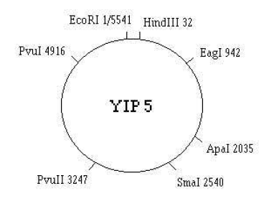A plasmid is a tiny piece of DNA that is separate from the main circular chromosome of a bacterium. Refer to the restriction map of the circular plasmid YIP5. This plasmid contains 5,541 base pairs. There is an *Eco*RI restriction site at base pair 1. The locations of other restriction sites are shown on the map. The numbers after the enzyme names tell at which base pair that enzyme cuts the DNA. If you exposed the Y1P5 plasmid to *Eco*RI, the restriction enzyme will cut the DNA, resulting in a linear piece of DNA that is 5,541 base pairs long.
   1. How many DNA fragments would be produced if the plasmid was exposed to the two enzymes EcoRI and EagI? How many base pairs long would each segment be?
   2. How many DNA segments would be produced if you took the products from question 11a and exposed them with PvuII? How many base pairs long would each segment be?
   3. How many DNA fragments would be produced if the original plasmid was exposed to the two enzymes HindIII and ApaI? How many base pairs long would each segment be?
   4. How many DNA fragments would be produced if the plasmid was exposed to the three enzymes HindIII, ApaI, and PvuI? How many base pairs long would each segment be?