**Cody Whitt**

**Analyze COVID-19 Data with R and Google CoLab. Thoughts/Notes**

**Note:** Comments written as I worked through the notebook, some comments were later addressed in subsequent sections. This was my first time using R.

**Warm up exercises**

**Simple calculator** - Could use a couple examples regarding assigning variables/using functions between the integer operations and function help/description. (Not sure on expected background knowledge of the audience).

**Vector, indexing, plots** - Could use a comment somewhere to point out indexing for vectors in R starts a 1 instead of 0. Had to look up what ~ meant/did.

**Dataframe, indexing** - Comment on line 37 is unclear (appears to be rows 5, 9 & 1).

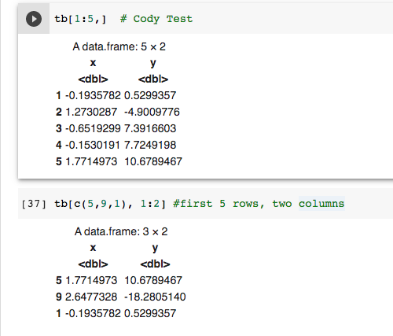

**Load libries** - Spelling error in title.

**Dataframe** - Lines 46 & 47 appear to be duplicates.

**Read a spead sheet** - could add a supporting image of the .csv data in Excel/Sheets to emphasize the relationship between a dataframe and same data in a spreadsheet. Dataset has extra/empty column values. Could add additional exercise/demo showing functions applied to vectors selected from the df ( mean(tb$Grade) etc).

**Looking for helps** - covered in earlier section, but good spot for reminder.

**Part 1**

**Load data into DataFrames** - Saw “tibble” in comment. Had to look up what those are (basically the same thing as DataFrame?).

**Pick rows, columns, and calls in DataFrames** - Comment on the index at 1 is there.

**Other sections** - Was able to follow along.

**Part 2**

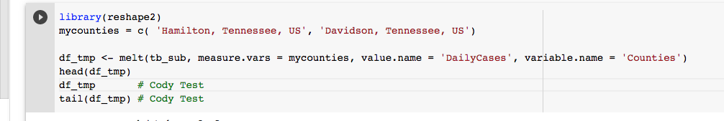

Could also call a tail() in this section to show the Davidson data is in there, head just shows Hamilton.

**Part 3**

**All sections** - Was able to follow along. Comment regarding what/why regarding scale might be useful.

**Part 4**

worldmet install took awhile

Pulaski, AR comment unclear in relation to Lovell Field.

Could use comment on the purpose all.y=FALSE here to emphasize importance:

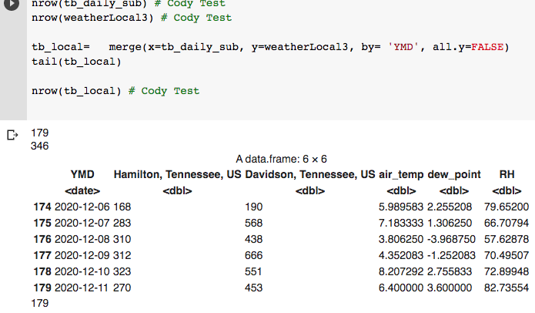

Warning being thrown here w/ timezone

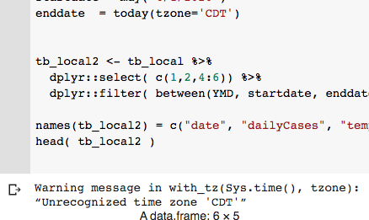

Cross correlation section throwing errors regarding reference to tb_HCTN2/tb_HCTN (I ran through them w/ tb_local_scaled).

**Part 5**

Was able to follow along. This was probably my favorite section. Covered a lot of things and the starting dataset was pretty simple.

**Part 6**

Was able to follow along. This section was probably the most complicated.

**Part 7**

No issues DLing/loading apple mobility csv. Could add a comment for users to make sure to correct the filename arg for their date (I tried to run it w/o changing 1st time). Reference errors thrown in section regarding merging w/ previous combined.

**Part X**

Very straightforward, would make a good earlier/introduction type section (with some of the apply() background from Part 5 shown before summing the cases).

**Part Y**

Similar to Part 6.

**Overall/Other thoughts:**

Other than a few invalid DataFrame references mentioned above, everything seemed to be running smoothly/correctly. Could use some more comments, but it seemed like the idea was that you would be working through this with the students, in which case additional comments wouldn’t be that necessary. Some additional stuff in the warm-up section would be nice as far as practice/getting comfortable goes. In particular merging dataframes and transposing. That stuff is covered later on, but definitely easier as a beginner to mess around with smaller datasets.