1.3
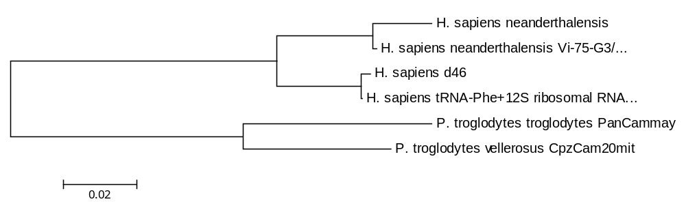
The length of this branch is 0.29. The distance was determined using Maximum Composite likelihood method and the units for distance was determined using the number of base substitutions per site.

2.2 N: nonsynonymous only

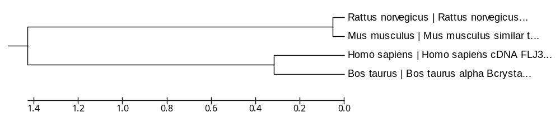

This tree has a branch length of 3.22. There were 194 positions. The distances were discovered using Nei-Gojobori method. The units for the distances are in nonsynonymous subsitityutions per nonsynonymous site.

2.3 S:synonymous only
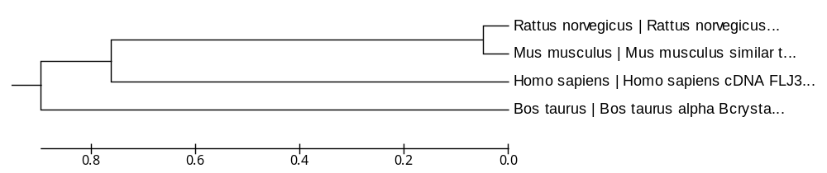
The length for this tree is 2.60. This is the same as the previous one except that the units for distances were synonymous substitutions per synonymous site.

2.4 Neighbour-join
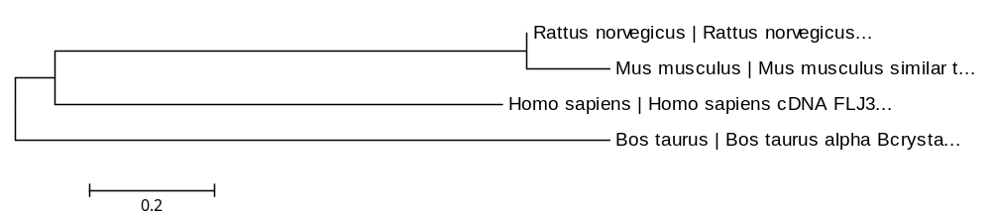
This tree had a branch length of 2.58, which is very similar to the branch length of the synonymous tree. This tree is extremely similar to the synonymous tree.

