Martha C. Washington
Bioinformatics Lab 9
November 5, 2007

1.3

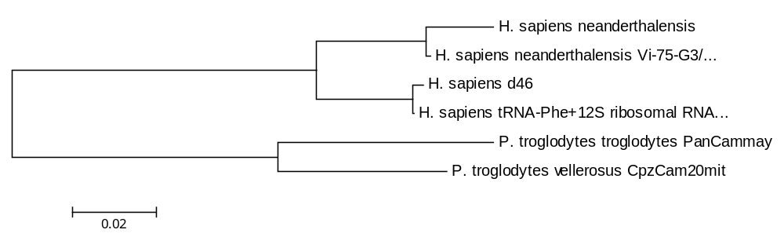
This tree was generated using neighbor join. In neighbor join the branches are uneven in length.

2.2

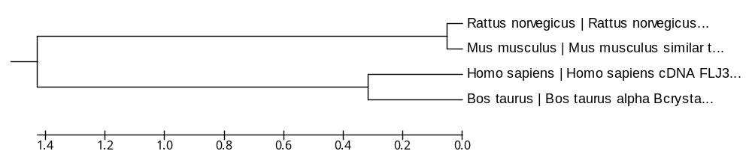
This tree was generated using UPGMA using nonsynonymous substitution. In UPGMA the different branches are the exact same length. There is a higher number in branch length also = 3.22089578.

2.3

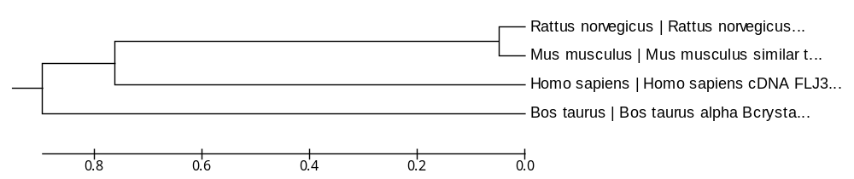
This tree was also generated using UPGMA but included synonymous. The branch length is the same distance but a lower number in branch length = 2.60084951.

Synonymous is the substitution of one base for another in an exon of a gene coding for a protein. Nonsynonymous amino acid replacement

