Lab. Display and analyze protein structures using Swiss PDB Viewer

Objectives:
1) Display 3D structure of a protein, identify secondary structures, individual residues, H-bonds, and ligands.
2) Export images of protein structures.

Exercise 1) It’s small but it has everything – 1IGD (1igd)

This peptide is only 61 amino acids in length, but it has an alpha helix and 4 beta strands. The instructor will demonstrate how to display the beta sheet with H-bonds. The students will then try to display the alpha-helix with H-bonds.
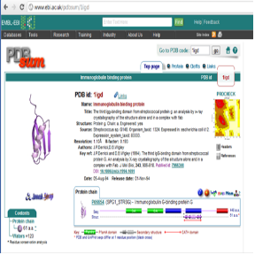
Fig 1. Red circle is “links”

1.1) Download the structure file.
Try google “PDBSUM 1igd”. This will leads to a entry in PDBsum website (see Fig 1). Click ‘PDBe’ on the “links” panel. This will leads to the entry of this structure in the EMBL PDBe server. Click the “Download PDB File”, and this will download the file “1IGD.ent” to your computer. You can move the file to the desktop for convenience.

1.2) Open file in SPDBV.
Start SPDV first. Then, choose “File” → “Open PDB file”.
Choose “Color”→”by secondary structure”. Now, we can see alpha-helix in red, and beta-sheet in yellow.

1.3 ) Use the control-panel
Click “Wind” → “Control Panel” (see Fig 2). You should be able to see the protein sequence in the “Control panel”. Try to click on some amino acid residues to “label” them. You can also choose “v” to show the volume of them, “col” to color them, “ribn” to show them in ribbon-model.
Now, use “Select” →”by secondary structure” and “show” column in the control panel to display only the beta strands. Remove side chains for clarity. Choose “color” →”
by CPK”.

1.4) Show H-bond in beta-sheet.
“Tools” →”Compute H-bonds”. We can also view distance of H-bonds by “Display” →”Show H-bonds distances”.
Try “Preference” →”3D rendering” to adjust the quality of the image.
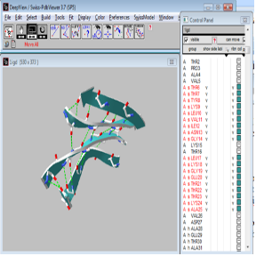
Fig 2. Beta-sheet of 1igd with control panel.

1.5) Save the image.
You can change the background color by “Preference”-> “Color”-> “Background”.
You can change the ribbon color in the control panel by “R”->”ribbon”, then click ‘ribn col’. An example can be seen in Fig 2.
To save image, choose ‘File’->’Save’->’Image’.

1.6) Show the alpha-helix in ribbon mode with H-bond
Work out this on your own. From the end of the helix, you can see that it looks like a tunnel. Verify that the helix is right-handed. Save the generated “layer” in a file and save the image in a file. This is part of your lab report.
Exercise 2) The classic – 1MBO (1mbo)

The first protein structure ever solved is myoglobin from sperm whale. It is used in many textbooks. This protein is also once the “molecule of the month” on PDBsum web site. There is a heme ligand in the myoglobin protein. In this exercise, we will learn to use “Layer” and color the ligand and protein differently.

2.1) Download pdb file of 1MBO. (There are multiple source to download the 1MBO pdf files. Try google and your will find alternative sites.)
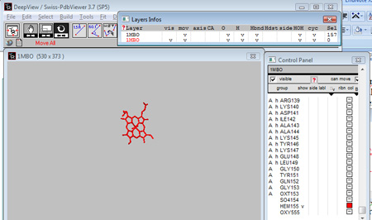
Fig 3. Heme group with ‘Layers’ and ‘Control panel’.

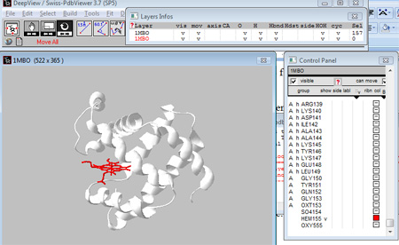
Fig 4. Merged layers.

2.2) Open the PDB file in spdbv. Show only the protein in ribbon mode.

2.3) Use “Layers”
Now, reopen the same file of 1MBO. Click “Window”→”Layers Info”. Choose “vis” to see which is the recent layers (see Fig 3). Hide the first layer.

Click the ID on the control panel to jump between layers.

2.4) Show only heme in the second layer (see Fig 3).

2.5) Merge the two images (see Fig 4).

2.6) Save the image.

Lab Report:

If you are doing on your own computer, you need to download SPDBV first. The software is available at http://expasy.org/spdbv/.
- Submit the alpha helix picture of 1IGD.
- Submit the final picture of 1MBO.
- Download PDB 1CHH from http://www.rcsb.org/pdb/explore.do?structureId=1chh
Use SPDBV to generate a picture of this protein in ribbon mode. Color the ligand and protein in different color. Use the picture on this site as a reference: http://www.ebi.ac.uk/pdbsum/1chh. The closer that your result resembles the picture on the PDBsum website, the better is your score of this assignment.

Your report must be written in WORD format that contains all of your generated images.

Useful SPDB tips:

Window: It’s best to have most of the windows open: Window/Tool Bar, Control Panel, and Layer Info.

The atoms in SPDBV are colored as:
C--> gray or white O --> red N --> blue S --> yellow
P --> orange H --> cyan other --> gray.

