**Palpasa Manandhar**

**Fall 2012**

**Mentor: Dr. Hong Qin**

**11/30/12**

**Effect of Network Configuration on the Aging Process in the Reliability Model of Cellular Aging**

Aging can be quantitatively defined as the increasing risk of dying over time. A key distinction between biological aging and non-biological aging is the dynamics of the aging process. Increasing rate of mortality over time follows exponential function in biological aging versus Weibull functions in non-biological aging. Cellular aging can be studied through the reliability framework based on gene networks. Here, we study the influence of network configurations on the dynamics of aging process. We compare three types of networks – networks with degree distributions of constants (lattice network), Poisson distribution and power-law distribution. We then evaluate the heterogeneity of the aging process using the coefficient of variation (CV). Preliminary results show that CV of the aging process in lattice networks with constant connecting degrees is higher than networks with Poisson distributed degrees, suggesting that Poisson networks are more robust for aging than lattice networks. This somewhat counter-intuitive finding suggests an important role of randomness in the emergence of aging from gene networks.

Reliability theory is a general theory about systems failure. It predicts that even those systems that are entirely composed of non-aging elements, with constant failure rate, will deteriorate with age, if these systems are redundant in irreplaceable elements. According to Gompertz Law, mortality rate increases exponentially with age. The objectives of the reliability theory is to find a general failure law applicable to all adult and extreme old ages and find out why relative differences in mortality rates of compared populations vanish with age.

Gompertz findings suggest that the force of mortality increases in geometrical progression with the age of adult humans. Human mortality rate doubles over about every 8 years of age. The Gompertz Law is the first mathematical model to explain the exponential increase in mortality rate with age. At advanced ages, mortality rates increase less rapidly than an exponential function (late-life mortality deceleration). Exponential increase in mortality rates is observed in different biological species like humans, rats, mice, fruit, flies, flour, etc.

The relevant questions that can be asked are:

* Why do most biological species deteriorate with age while some primitive organisms do not demonstrate such clear age dependence for motility increase?
* Why mortality rates increase exponentially with age in many adult species (Gompertz Law)? How should we handle cases when the Gopertzian Mortality Law is not applicable?
* Why does age-related increase in mortality rates vanish at older ages?
* How do we explain the so-called compensation law of mortality?

The high mortality rates in disadvantaged populations are compensated by low aging rate. As a result, the differences in mortality rates tend to decrease with age within a species. Evolutionary biology and genetics are used to explain aging and longevity. But late-life mortality plateaus cannot be explained using that because it requires highly specialized and unrealistic assumptions.

**Reliability Theory**

Reliability theory is a body of ideas, mathematical models and methods directed to predict, estimate, understand and optimize the lifespan distribution of systems and their components.

Described by the reliability function S(x)which is the probability that a system will carry out its mission through time x. The reliability function at time x is just the probability P that the failure time X is beyond time x. S(x) = P(X>x) = 1- P(X< equal to x) = 1- F(x), where F(x) is the standard cumulative distribution function. S(x) is a survival curve describing the proportion of those till alive by time x. Failure rate λ(x) : Relative rate for reliability function decline

λ(x) = -dS(x)/ S(X) = - d[logeS(x)]/dx]

**Cases for failure rates**

A constant failure rate explains a non-aging system that does not deteriorate with age. Reliability function for non-aging systems is λ(x)= λ = constant

S(x) = S0 exp (-λx) describes the “lifespan” distribution of atoms of radioactive elements. Iffailure rate increases with age, aging system deteriorates with age. System failure rates may contain both non-aging and aging terms in reality.

μ(x) = A + Rexp(αx), where A is the constant, non-aging component of failure rate due to extrinsic causes of death like accidents and acute infections. While the second term, Gompertz function (Re(αx)) is the aging component, due to deaths from age-related diseases like cancer & heart disease

**Compensation law of mortality**

The compensation law of mortality is given by: ln(R) = ln(M) –Bα

It is also called Strehler & Mildvan correlation. The relative differences in mortality rates of compared populations tend to decrease in many species. Weibull Law is used for technical devices & the Gompertz law is used more for biological systems.

**Destruction Stages**

In simple organisms, the damage of a vital organ can lead to its death. So they do not age, they just die when damaged. In complex organisms, every occurrence does not lead to death. As defects accumulate, redundancy in the number of elements disappears and this redundancy exhaustion causes degeneration of the organism.

**Diagram of past, present and future simulations** 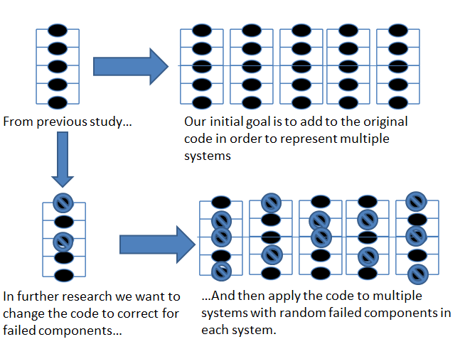

**Matlab program to find the difference between coefficients of variation:**

**For exponential distribution:**

%function [lifespan] = rnorm(x,mean, sd)

% function lifespan calculates the lifespan

%x=1000;

%mean=100;

%sd=10;

%ret = calculate.s.m.v2(lifespan)

Npop=100; % numOfSystems (individuals)

lifespan = 1:Npop

for nn = 1:Npop

m=15; % numOfBlocks in a system

n = 5 %fixed number of elements in each block

mymean = 0.1; % for expontial age of elements.

%mysds = 0.1;

ElementAges = randraw('exp', 0.1, m*n)

BlockAges = 1:m % buffer for temporary storage

for i=1:m

subElementAges = ElementAges((1+(i-1)*n):i*n)

BlockAges(i) = max(subElementAges)

end

IndividualSystemLifespan = min(BlockAges)

lifespan(nn) = IndividualSystemLifespan

end

hist(lifespan)

**For Poisson distribution**

%function [lifespan] = rnorm(x,mean, sd)

% function lifespan calculates the lifespan

%x=1000;

%mean=100;

%sd=10;

%ret = calculate.s.m.v2(lifespan)

Npop=100; % numOfSystems (individuals)

lifespan = 1:Npop

for nn = 1:Npop %loop over Nop individuals

m=15; % numOfBlocks in a system

n = randraw('Poisson', 5, m) %this can give zero-element block

n(n==0) = 1 %this is not Poisson anymore, but fixes the problem

mymean = 0.1; % for expontial age of elements.

%mysds = 0.1;

BlockAges = 1:m % buffer for temporary storage

for i=1:m

ElementAges = randraw('exp', 0.1, n(i))

BlockAges(i) = max(ElementAges)

end

IndividualSystemLifespan = min(BlockAges)

lifespan(nn) = IndividualSystemLifespan

end

hist(lifespan)