**Expression Plasticity under Oxidative Stress Linked to Cellular Aging and Various Networks Features in Yeast**

Jasmine Parker-McDuffie

BIO 386

Advisor: Dr. Hong Qin

12/11/12

**Abstract**

Aging is a fundamental part of an organism’s life. What makes the aging rate increase or decrease? By utilizing *Saccharomyces cerevisiae* as an organism model, an investigation on cellular aging was done. We found that expression plasticity under oxidative stress is linked to cellular aging and various networks features in yeast. This investigation focused on the genetic dataset of GSE12221 which was found on the GEO query. This genetic set is known for the destroying of *Saccharomyces cerevisiae* cells following oxidative stress and DNA damage. To examine the dataset several other networks such as fitness, interaction degree of protein network, positive genetic interaction degree, negative genetic interaction degree, and replicative life span. By using bioinformatics analysis of numerical data and figures were produced in a software called R-studio. Our study supported the link between cellular aging and oxidative stress. Observing a map of a real life situation, it showed that oxidative stress and DNA damage caused the increase in aging of a cell. The networks and oxidative stress factors influence the aging of cells in yeast.

**Introduction**

Aging is an important step in life for *Saccharomyces cerevisiae* or yeast. Why do *Saccharomyces cerevisiae* age? Aging is associated with a progressive imbalance between antioxidant defenses and intracellular concentrations of reactive oxygen species as exemplified by increases in products of lipid peroxidation, protein oxidation, and DNA oxidation (Dröge and Schipper 2007). Yeast is used as a model in order to analyze the cellular aging in other organisms. The life span of *Saccharomyces cerevisiae* can be measured in two ways which include replicative and chronological life spans. A replicative life span measures the average number of offsprings in a single cell and a chronological life span measures the cells in the stationary phase of growth**.** Bioinformatics is used to expand the research technics in the biology field. In this experiment through the method of using the software called R-studio. The investigation for the cellular aging of *Saccharomyces cerevisiae* was completed by the selection of a genetic set and comparing it against other networks.

In this project, we focus on the gene expression plasticity under oxidative stress, a dataset available at GEO (Shalem, et al 2008). The selection of the dataset GSE 12221 is used to analyze the aging of yeast. GSE12221 is known to decay profiles of *Sacchamyces cerevisiae* mRNAs with the oxidative stress and DNA damage ("GEO Accession Viewer"). The impact of stress can either speed or delay the aging process of a cell. This can convey a correlation on how it affects the aging rate of cells. With the examination of GSE12221 and other networks will be observed for its influence on the cellular aging of *Saccharomyces cerevisiae*.

**Aim**

To associate cellular aging of *Saccharomyces cerevisiae* with the oxidative stress and DNA damage as it relates to different networks.

**Methods and Materials**

The resources for this investigation were computer based. The upcoming field of bioinformatics was beneficial in the used of software to analyze various networks. An open source software called R-studio was used to interpret elements called R codes. The codes were placed in this software and the results of the data were given. The search for a significant dataset was done by conducting research on the GEO query site. The genetic set labeled GSE 12221 was found to be associated with oxidative stress which impacts cellular aging. The analysis of the influence on aging was done by comparing it to the several data networks. The following was the data: fitness, interaction degree of protein network, positive genetic interaction degree, negative genetic interaction degree, and replicative life span. These datasets were found by examining papers throughout the duration of the semester in a biology class. The relevance of the networks was considered by running codes on R-Studio and analyzing the results.

To analyze all of the networks and the selected genetic code, a working directory was set in R-studio with all of the data. With R-studio the working directory was set and the first set of codes were examined. The calculation of standard deviation, mean, and cell growth was completed from the group of networks. Then the data from fitness, interaction degree of protein, genetic networks, real life span and GSE12221 were placed together in the working directory. In addition this included the running of multiple regressions. To conclude the experiment, the data was permutated by the calculation of the different expression of the protein and genetic networks. Examples of these codes can be found in supplementary material which can be viewed in R-studio. The running of the codes yielded multiple graphs with p-values, means, and standard deviations from the figures in the results section. By observing these results the oxidative stress will be linked to the cellular aging process of *Saccharomyces cerevisiae*.

**Results**

The data below consist of several graphs and a concept map. The graphs were generated by running the code from the networks of data in R- studio. The diagrams were separated into three sections, which are labeled by the figure numbers. Figure one represents the calculations of standard deviation, mean, and cell growth that were completed from the assembly of networks. Then figure two displays the data from fitness, interaction degree of protein, genetic networks, real life span and GSE12221 and the analysis of multiple regressions. Figure three indicates the data which was permutated by the calculation of the different expression of the protein networks and genetic networks. The numerical data comprised of components such as mean, standard deviation, cell growth, p-value, and obstacles labeled in the graphs. The map that is placed in figure four is a real life example of how aging and stress is related to other organisms other than yeast. This organism can be related to human beings and how certain nutrimental values or enzymes influence stress and DNA damage through aging. Yeast can be examined for cellular aging by using other important networks and comparing it to another organism. Through the figures a conclusion on the aging of cells in yeast was made. The genetic set of GSE12221 and the oxidative stress on cells were found to be linked to the aging process by providing an increase.

|  |
| --- |
| **Figures In Three Sections from R- Studio**  **Figure 1- GSE12221** |
| **(A)**    *This histogram contains the data that is listed below:*  **Standard Deviation**  Min-0.01224  1st Qu- 0.03622  Median-0.05093  Mean-0.06122  3rd Qu-0.07366  Max-0.28834  **CV**  Min.- 0.003360  1st Qu.-0.009714  Median- 0.013776  Mean- 0.016811  3rd Qu.- 0.020289  Max. -0.079133  **Mean**  Min.- 3.271  1st Qu.-3.558  Median- 3.687  Mean - 3.690  3rd Qu.-3.824  Max. - 4.1 |
| **(B)**      *The important CV numbers from the histogram are 0.00785, 0.01638, 0.01574, 0.01826, and 0.00734. This graph is skewed to the left side.* |
| **(C)**    *The valuable standard deviation numbers from this histogram are 0.0285, 0.0639, 0.0583,0.0668,and 0.0282. This graph is skewed to the left side.* |
| **(D)**    *The important mean data from this histogram are 3.63,3.9,3.7, 3.66, and 3.85. This graph is equally averaged through the graph.* |
| **Figure 2-GSE12221** |
| **(A)**    *The results from this graph measures the replicative life span and cell growth is found in the following data:*  Residuals:  Min 1Q Median 3Q Max  -20.1202 -2.3201 0.1785 3.1752 13.0004  Coefficients:  Estimate Std. Error t value Pr(>|t|)  (Intercept) 24.1357 0.4309 56.014 <2e-16  RLS.tb2$myCV -1.1915 22.6039 -0.053 0.958  Residual standard error: 4.672 on 495 degrees of freedom  Multiple R-squared: 5.614e-06, Adjusted R-squared: -0.002015  F-statistic: 0.002779 on 1 and 495 DF, p-value: 0.958  *The p-value is very significant to the data from replicative life span and cell growth.* |
| **(B)**    *The results from this graph of the cell growth and fitness are listed below:*    Residuals:  Min 1Q Median 3Q Max  -0.90146 0.00624 0.03466 0.04965 0.13010  Coefficients:  Estimate Std. Error t value  (Intercept) 0.954162 0.004475 213.217  fitness.tb2$myCV 1.122002 0.237152 4.731  (Intercept) < 2e-16 ***  fitness.tb2$myCV 2.4e-06 ***  Residual standard error: 0.09908 on 1913 degrees of freedom  Multiple R-squared: 0.01157, Adjusted R-squared: 0.01105  F-statistic: 22.38 on 1 and 1913 DF, p-value: 2.396e-06 |
| **Figure 3-GSE12221** |
| **(A)**    *The p-value is 0.001 for this histogram with the cell growth data and is a signifcant value.* |
| **(B)**    *The obstacle on this graph measured at 0.0085691649582743, which correlated to the protein interaction network. This arrow is labeled far from the bar graphs.* |
| **(C)**    *The p-value for this graph is 0.22 for the histogram above.* |
| **(D)**    *The obstacle labeled in the graph is 0.00762428517538344 for the positive genetic interaction network. The red arrow is toward the middle of the bar graphs.* |
| **(E)**    *The p –value from this graph was 0 which is low for this histogram.* |
| **(F)**    *The obstacle for the protein interaction network is 0.00818713958574378. The red arrow is close to the bar graph areas.* |

**Figure 4**

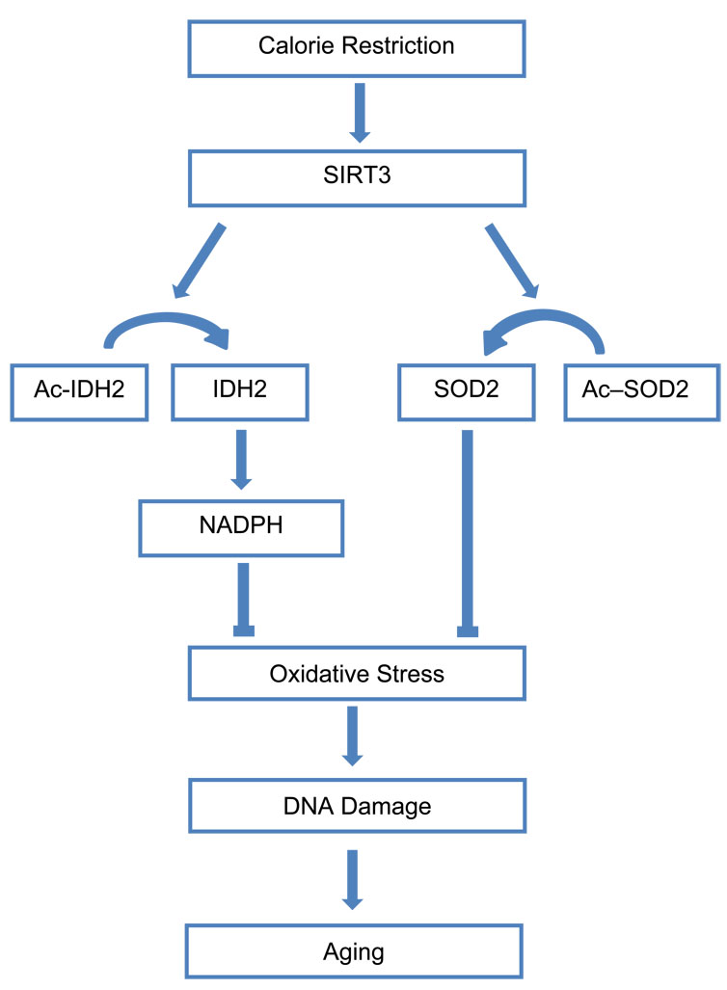

*This figure represents a possible route for the correlation of aging and oxidative stress. This map was specified by the resource Relief from Age-inducing Stress by Zhang, Liu, and Chen. The intake of certain particles such as NADPH can induce DNA damage and stress. This expressed how aging and stress related to other organisms.*

**Discussion**

The oxidative stress as it related to *Saccharomyces cerevisiae* increases the rate of aging of cells. This was concluded by the use of a genetic set which was GSE12221 and several other networks. The networks were fitness, interaction degree of protein network, positive genetic interaction degree, negative genetic interaction degree, and replicative life span. The GSE12221 dataset is responsible for decaying the profiles of Saccharomyces cerevisiae following oxidative stress and DNA damage ("GEO Accession Viewer"). From the results section several histograms and graphs were created. In figure one shows the analysis of GSE12221 by means of standard deviation, cell growth, and mean. The graphs show the distribution of the values and the significance of this dataset. Then for figure two the correlation between the data that had been used in the networks compared to the GSE12221. The p-values found from the graphs were 0.958 and 2.396e-06, which show the significant from the data. This the first sign that the oxidative stress is related to the aging of cells. In figure three the permutation was used to calculate the difference in expression of the data sets. The p -values for the protein network were small but the genetic network was higher and was more significant. Then in figure four the chart which influence of oxidative stress that induce the aging progression of cell. This could correlate with people with diseases which cause an increase of oxidative stress and cause the damage of the cells by increasing the development of the cell with aging.

In addition through observing a similar dataset of GSE7645, it was the exact opposite of GSE12221. By comparing the results of these two datasets, the blocking of the cells increases the aging of the cells. For farther investigation, these two datasets need to be compared in a detailed level, so a precise conclusion can be formulated. The oxidative stress of the cells destroys or damages the DNA which increases the life of the cell and causes the aging process. This shows that oxidative stress and aging of the cell are dependent on one other. The expression of oxidative stress increases the cellular aging of yeast through various networks.

**References**

Dröge, Wulf, and Hyman M. Schipper. "Oxidative Stress and Aberrant Signaling in Aging and

Cognitive Decline." *Wiley Online Library*. June 2007. Web. 5 Dec. 2012. <http://onlinelibrary.wiley.com/doi/10.1111/j.1474-9726.2007.00294.x/full>.

"GEO Accession Viewer". *GEO Accession Viewer*. Web. 28 Nov. 2012. <http://0-

www.ncbi.nlm.nih.gov.elis.tmu.edu.tw/geo/query/acc.cgi?acc=GSE12222>.

Shalem, O, O Dahan, M. Levo, Martinez M.R., Fuman I., Segal E., Pipel Y. Transient

transcriptional responses to stress are generated by opposing effects of mRNA production and degradation. Mol Syst Biol, 2008.

Zhang, Dan, Yufei Liu, and Danica Chen. "Open-Access Impact Journal on Aging." *SIRT-ain*

*Relief from Age-inducing Stress*. 8 Feb. 2011. Web. 05 Dec. 2012. <http://www.impactaging.com /papers/v3/n2/full/100283.html>.

**Bonus Points**

**1. Dataset- GSE9985**

**Figure 1**

**(A)**

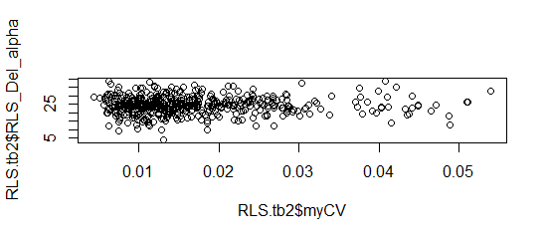

*The data from the graph are R-squared is 0.001432, adjusted R-squared is -0.0005854, and p-value is 0.3999.*

**(B)**

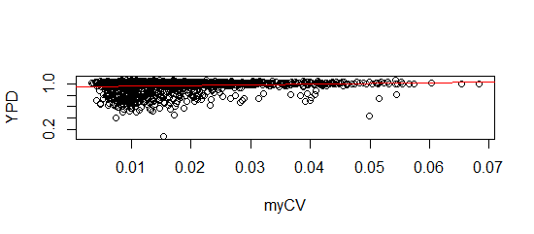

The data from the graph are *R-square is* 0.02214*, adjusted R-squared is* 0.02163*, and p-value is* 6.016e-11.

**Figure 2**

**(A)**

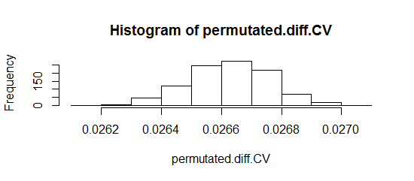

*The p-vale for this histogram is 0.001 and this is a significant p-value.*

**(B)**

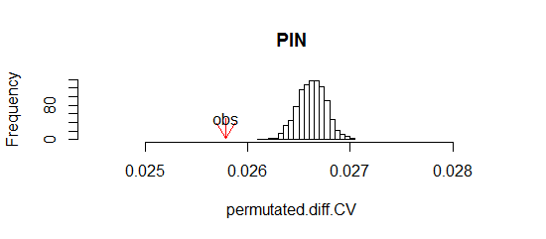

*The obstacle is labeled with the red arrow at 0.0257905021249966.*

**(C)**

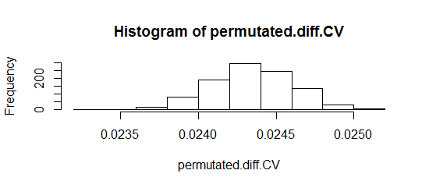

*The p-vale for this histogram is 0.697.*

**(D)**

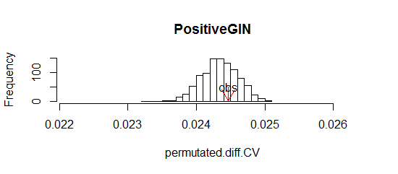

*The obstacle is labeled with the red arrow at 0.0244669231496863.*

**(E)**

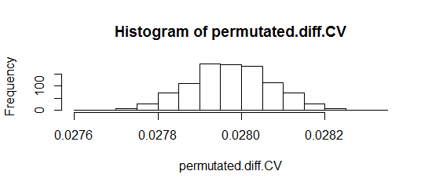

*The p-vale for this histogram is 0.24.*

**(F)**

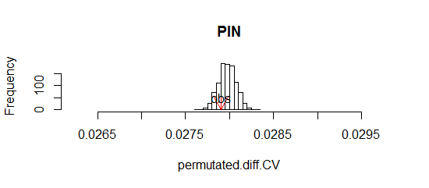

*The obstacle is labeled with the red arrow at 0.0279058263518703.*

**2. Dataset- GSE9840**

**Figure 1**

**( A)**

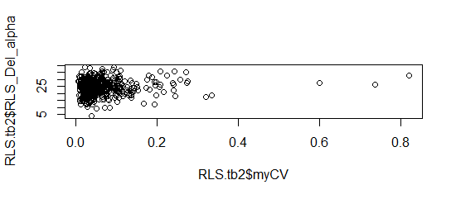

*The data from the graph are R-squared is 0.00365, adjusted R-squared is 0.001653 and p-value is 0.1778. This p value is very significant.*

**(B)**

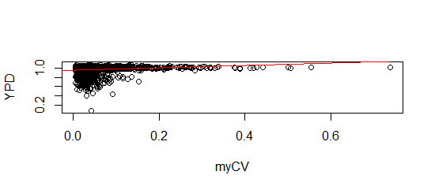

*The data from the graph are R-squared* is 0.02387, adjusted R-squared is 0.02336 *and p-value is 1.07e-11.*

**Figure 2**

**(A)**

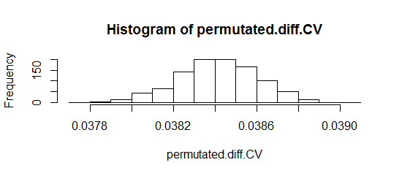

*The p-vale for this histogram is 0.001 which is significant.*

**(B)**

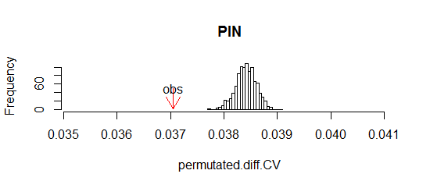

*The obstacle is labeled with the red arrow at 0.037517330918109.*

**(C)**

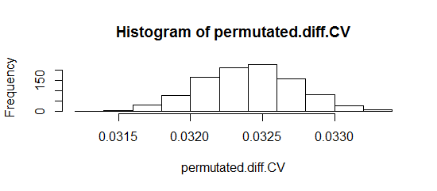

*The p-vale for this histogram is 0.011.*

**(D)**

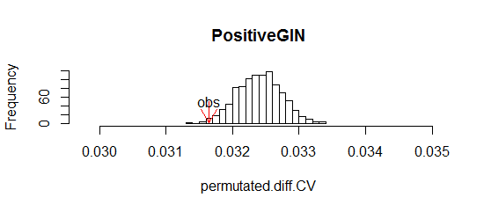

*The obstacle is labeled with the red arrow at 0.0316404228299721.*

**(E)**

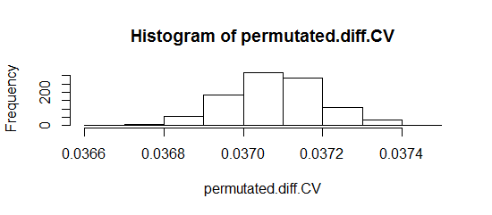

*The p-vale for this histogram is 0.239.*

**(F)**

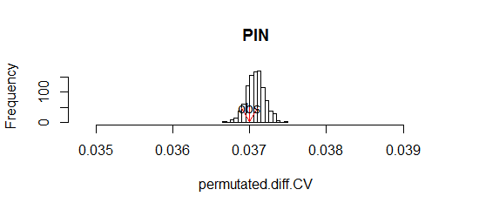

*The obstacle is labeled with the red arrow at 0.0369968157463132.*

**Discussion**

The graphs above from the datasets of GSE9985 and GSE9840 represented that there is a correlations between the networks. By using fitness, interaction degree of protein network, positive genetic interaction degree, negative genetic interaction degree, and replicative life span. The p-values from the graphs are significant. So GSE9985 and GSE9840 are important to the networks as it relates to the cellular aging of yeast.