

Course Project Report
Subject: SWD392

– Da Nang, April 2025 –

Table of Contents
Record of Changes 3
I. Overview 4
I.1 Project Information 4
I.2 Project Team 4
II. Requirement Specification 4
II.1 Problem description 4
II.2 Major Features 4
II.3 Context Diagram 4
II.4 Nonfunction Requirements 5
II.5 Functional requirements 5
II.5.1 Actors 5
II.5.2 Use Cases 5
II.5.2 .1 Diagram(s) 5
II.5.2.2 Use case descriptions 6
II.5.3 Activity diagram 8
III. Analysis models. 9
III.1 Interaction diagrams 9
III.2 State diagram 10
IV. Design specification 11
IV.1 Integrated Communication Diagrams 11
IV.2 System High-Level Design 11
IV.3 Component and Package Diagram 11
IV.4 Class diagram 12
IV.5 Database Design 12
V. Implementation 13
V.1 Map architecture to the structure of the project 13
V.2 Map Class Diagram and Interaction Diagram to Code 13
V. Applying Alternative Architecture Patterns 13
V.1 Applying the service-oriented architecture 13
V.2 Applying Service Discovery Pattern in the service-oriented architecture 13

Record of Changes
Date | A*  M, D | In charge | Change Description
*A - Added M - Modified D - Deleted

I. Overview

I.1 Project Information
- Project name: << Cafeteria Ordering System>>
- Project code: <<COS>>
- Group name: <<SWD392-G1>>
- Software type: <<Software Type: Web, Mobile App,..>>

I.2 Project Team
Full Name | Role | Email | Mobile
Phạm Hồng Quân | Leader
Hoàng Hải Quân | Member
Lê Quốc Hùng | Member

II. Requirement Specification

II.1 Problem description
In the context of a highly competitive labor market, a common paradox is that many candidates possess strong professional qualifications but still fail interviews due to poor communication skills and a lack of understanding of employer expectations. Candidates often struggle with rambling, unfocused answers, or become awkward when facing basic questions, resulting in an inability to demonstrate their true potential. The core problem lies in the lack of a realistic practice environment and professional feedback to correct mistakes, leaving candidates in a state where they are capable but simply do not know how to answer correctly.

II.2 Major Features
FE-01: Configure mock interview sessions by selecting specific industries, job positions, and experience levels (Beginner, Intermediate, Advanced) to match the user's career goals .
FE-02: Conduct interactive mock interviews with an AI-powered recruiter that adapts questions based on the user's role and responses, supporting both text-based input and voice interaction to simulate real-life pressure .
FE-03: Select interview duration modes (Short, Standard, Deep) to simulate different time-pressure environments and train the user in concise communication .
FE-04: Generate immediate, professional feedback reports that include scoring for individual answers, identification of strengths and weaknesses, and specific suggestions for better responses .
FE-05: Analyze and rate the user's "Career Fit" (High, Medium, Need Consideration) for a specific job role based on their interview performance, mindset, and problem-solving approach .
FE-06: Assign personalized "micro-tasks" (practical situational exercises or research tasks) to help users improve specific skill gaps identified during the interview .
FE-07: Track and visualize personal progress over time by allowing users to retry interviews and compare results across different attempts .

II.3 Context Diagram
[Context Diagram is the highest-level system analysis diagram, showing the system as a "black box" with:
External entities interacting with the system
Data flows into and out of the system]

II.4 Nonfunctional requirements

# | Feature | System Function | Description
1 | Performance | AI Feedback Generation | The system must generate and display the feedback report immediately after the session ends, with a processing latency of no more than 10 seconds to satisfy the "immediate feedback" value proposition.
2 | Usability | Interview Interface | The user interface must simulate a realistic video call environment to create psychological pressure similar to a real interview, ensuring the user feels "immersed" in the simulation.
3 | Reliability | Session Stability | The system must maintain stable connectivity and state for the entire duration of "Deep" interview sessions (up to 60 minutes) without data loss or session timeout.
4 | Security | Data Privacy | Personal user data, including voice recordings and interview transcripts used for AI analysis, must be stored securely and accessible only to the user to ensure privacy.
5 | Scalability | AI Request Handling | The backend architecture must be capable of handling concurrent AI requests from multiple users simultaneously without degrading the response speed during peak usage times .
6 | Compatibility | Voice Input | The voice recording feature must operate seamlessly on standard web browsers (Chrome, Edge, Firefox) without requiring the installation of additional plugins or specialized hardware.

II.5 Functional requirements

II.5.1 Actors

# | Actor | Description
1 | Candidate (User) | The primary user (student, fresh graduate, or job seeker) who role-plays as the interviewee to practice skills, receive feedback, and seek career guidance
2 | AI Recruiter (System) | The intelligent system agent that simulates the role of an employer, generates questions based on context, and analyzes the candidate's responses.
3 | Training Manager (B2B) | A potential user from training centers or enterprises who utilizes the platform for internal training or candidate assessment (identified as a target for future expansion)

II.5.2 Use Cases

II.5.2 .1 Diagram(s)
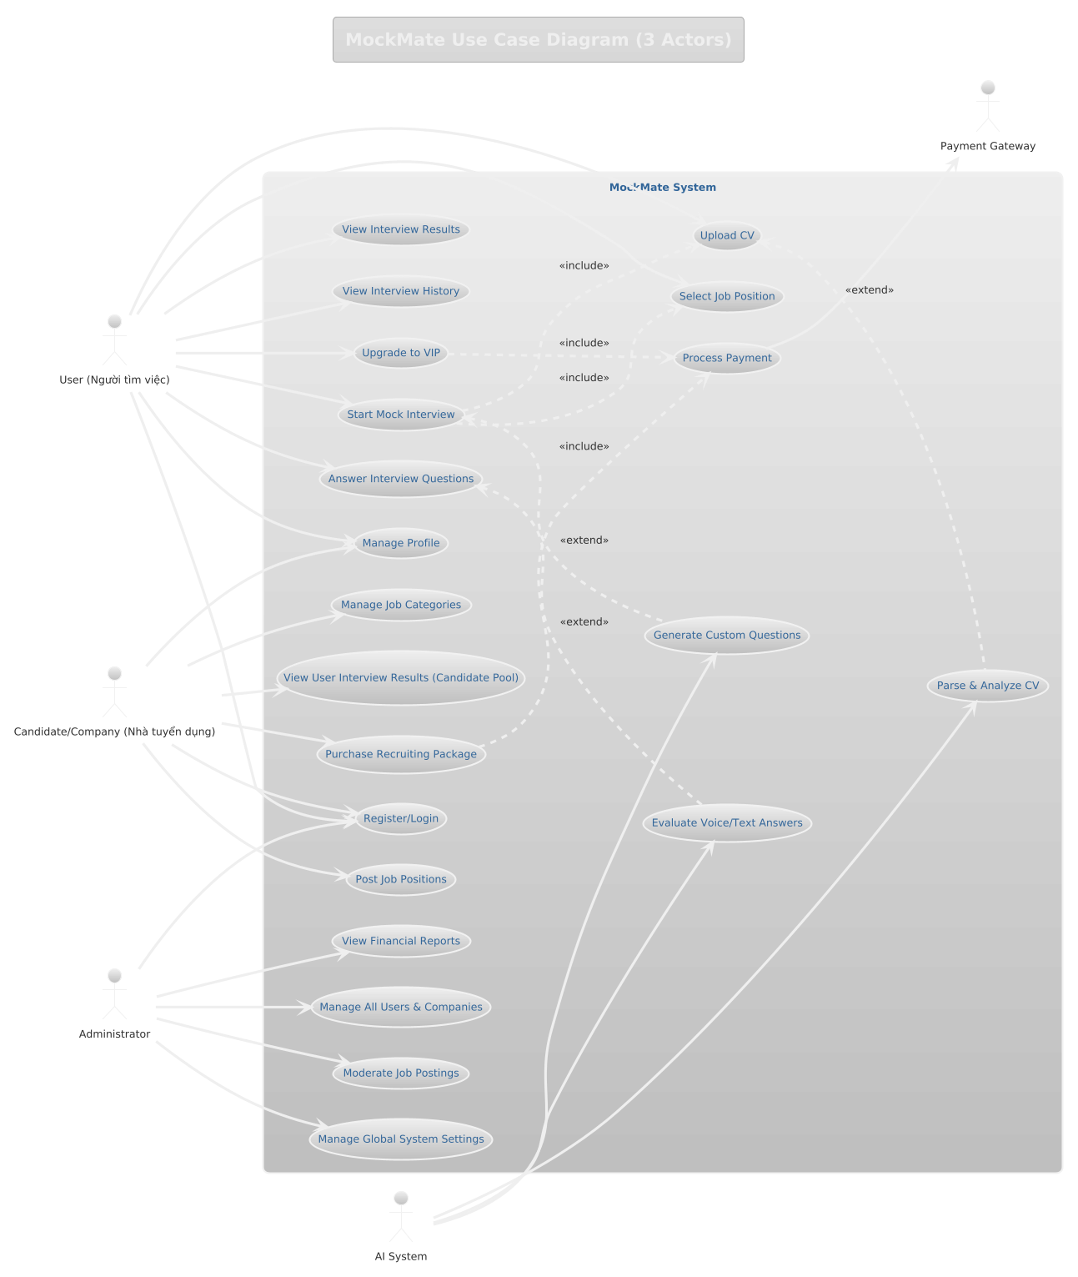

II.5.2.2 Use case descriptions

ID | Use Case | Actors | Use Case Description
01 | Withdraw Funds | ATM Customer
02 | Query Account | ATM Customer
03 | …

1 <<UseCaseCode_UC Name>>
Functional Description Template
UC ID and Name:
Created By: |  | Date Created:
Primary Actor: |  | Secondary Actors:
Trigger:
Description:
Preconditions:
Postconditions:
Normal Flow:
Alternative Flows:
Exceptions:
Priority: | High (Medium, Low), Must Have (Should Have, Could Have),..
Frequency of Use:
Business Rules:
Other Information:
Assumptions:

Functional Description Contents
Use Case ID and Name
Give each use case a unique integer sequence number identifier. State a concise name for the use case that indicates the value the use case would provide to some user. Begin with an action verb, followed by an object.
Author and Date Created
Enter the name of the person who initially wrote this use case and the date it was written.
Primary and Secondary Actors
An actor is a person or other entity external to the software system being specified who interacts with the system and performs use cases to accomplish tasks. Different actors often correspond to different user classes, or roles, identified from the customer community that will use the product. Name the primary actor that will be initiating this use case and any other secondary actors who will participate in completing execution of the use case.
Trigger
Identify the business event, system event, or user action that initiates the use case. This trigger alerts the system that it should begin testing the preconditions for the use case so it can judge whether to proceed with execution.
Description
Provide a brief description of the reason for and outcome of this use case, or a high-level description of the sequence of actions and the outcome of executing the use case.
Preconditions
List any activities that must take place, or any conditions that must be true, before the use case can be started. The system must be able to test each precondition. Number each precondition. Example: PRE-1: User’s identity has been authenticated.
Postconditions
Describe the state of the system at the successful conclusion of the use case execution. Label each postcondition in the form POST-X, where X is a sequence number. Example: POST-1: Price of item in the database has been updated with the new value.
Normal Flow
Provide a description of the user actions and corresponding system responses that will take place during execution of the use case under normal, expected conditions. This dialog sequence will ultimately lead to accomplishing the goal stated in the use case name and description. Show a numbered list of actions performed by the actor, alternating with responses provided by the system. The normal flow is numbered “X.0”, where “X” is the Use Case ID.
Alternative Flows
Document other successful usage scenarios that can take place within this use case. State the alternative flow, and describe any differences in the sequence of steps that take place. Number each alternative flow in the form “X.Y”, where “X” is the Use Case ID and Y is a sequence number for the alternative flow. For example, “5.3” would indicate the third alternative flow for use case number 5. Indicate where each alternative flow would branch off from the normal flow, and if pertinent, where it would rejoin the normal flow.
Exceptions
Describe any anticipated error conditions that could occur during execution of the use case and how the system is to respond to those conditions. Number each alternative flow in the form “X.Y.EZ”, where “X” is the Use Case ID, Y indicates the normal (0) or alternative (>0) flow during which this exception could take place, “E” indicates an exception, and “Z” is a sequence number for the exceptions. For example “5.0.E2” would indicate the second exception for the normal flow for use case number 5. Indicate where in the normal (or an alternative) flow each exception could occur.
Priority
Indicate the relative priority of implementing the functionality required to allow this use case to be executed. Use the same priority scheme as that used for the functional requirements.
Frequency of Use
Estimate the number of times this use case will be performed per some appropriate unit of time. This gives an early indicator of throughput, concurrent usage loads, and transaction capacity.
Business Rules
List any business rules that influence this use case. Don’t include the business rule text here, just its identifier so the reader can find it in another repository when needed.
Other Information
Identify any additional requirements, such as quality attributes, for the use case that may need to be addressed during design or implementation. Also list any associated functional requirements that aren’t a direct part of the use case flows but which a developer needs to know about. Describe what should happen if the use case execution fails for some unanticipated or systemic reason (e.g., loss of network connectivity, timeout). If the use case results in a durable state change in a database or the outside world, state whether the change is rolled back, completed correctly, partially completed with a known state, or left in an undetermined state as a result of the exception.
Assumptions
List any assumptions that were made regarding this use case or how it might execute.

b. Business Rules
Provide the business rules those are applied only to the use case
ID | Business Rule | Business Rule Description
FR1 | Password Encoding | User’s password must be encoded with MD5 hashing

II.5.3 Activity diagram
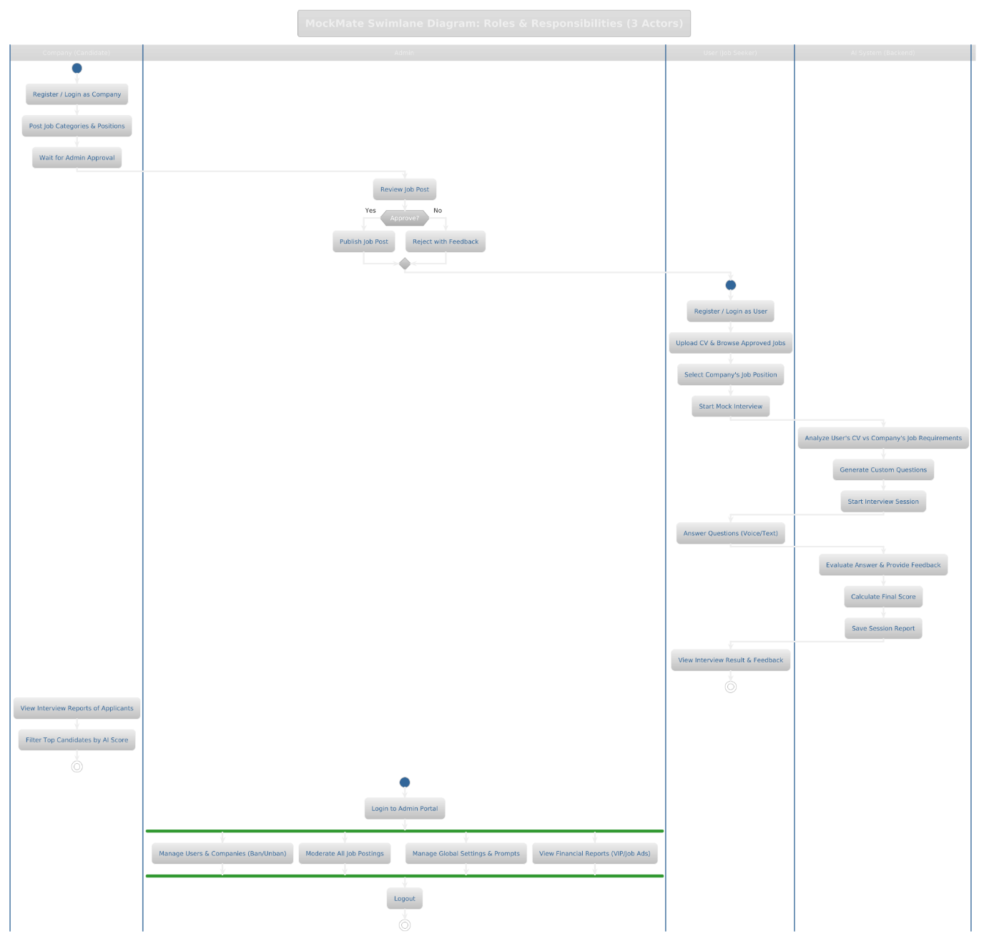

II.6 Entity Relationship Diagram
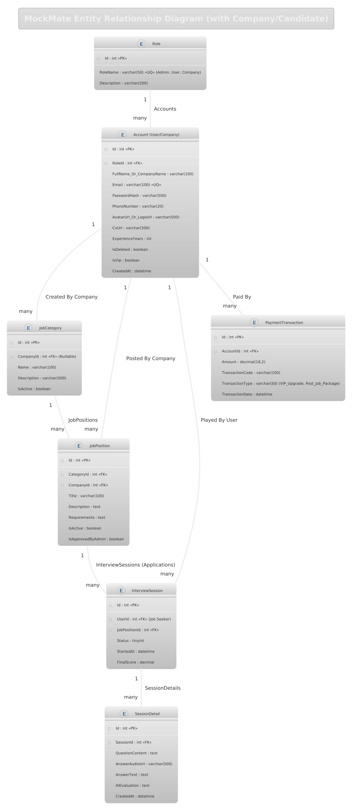

III. Analysis models.

III.1 Interaction diagrams
III.1.1.Sequence Diagram

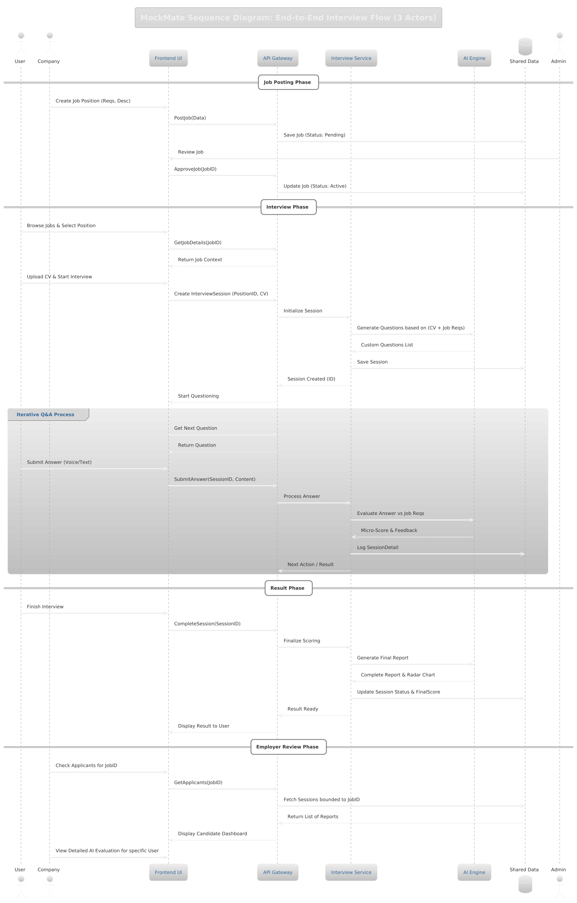

III.1.2. Communication Diagram
[Provide the Communication diagram(s) for the feature, see the sample below]

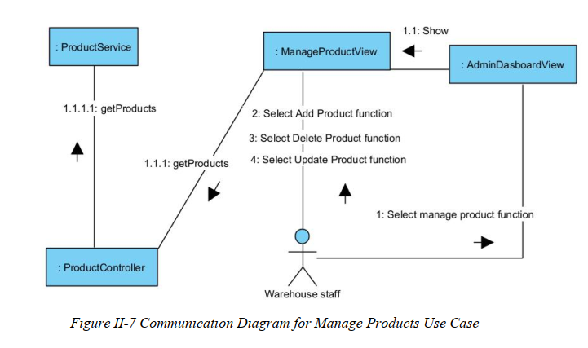

III.2 State diagram
[Provide the State diagram(s) for the feature, see the sample below]
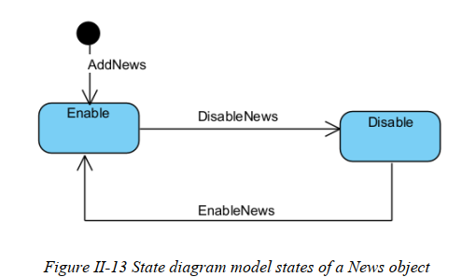

IV. Design specification

IV.1 Integrated Communication Diagrams
Sample
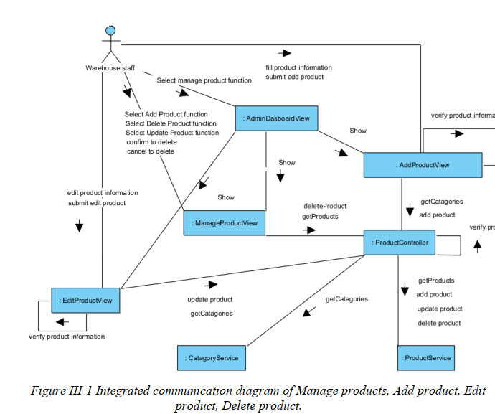

IV.2 System High-Level Design
Sample
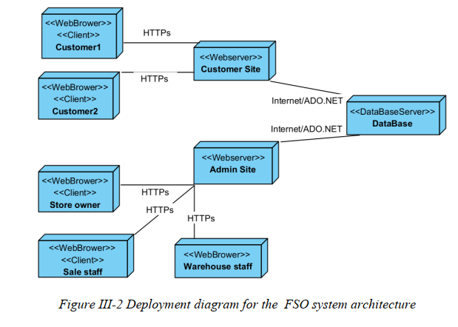

IV.3 Component and Package Diagram

IV.3.1 Component Diagram
Sample
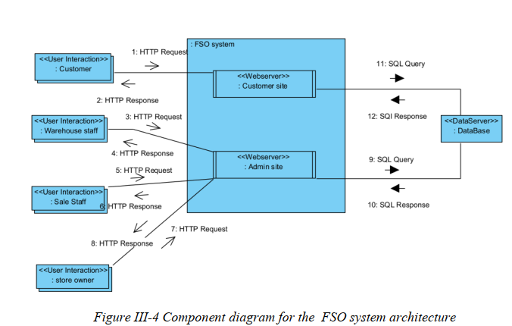

IV.3.1 . Package Diagram
[Provide the package diagram for each sub-system. The content of this section including the overall package diagram, the explanation, package and class naming conventions in each package. Please see the sample & description table format below (please note: package names don’t follow Java package naming convention yet)]
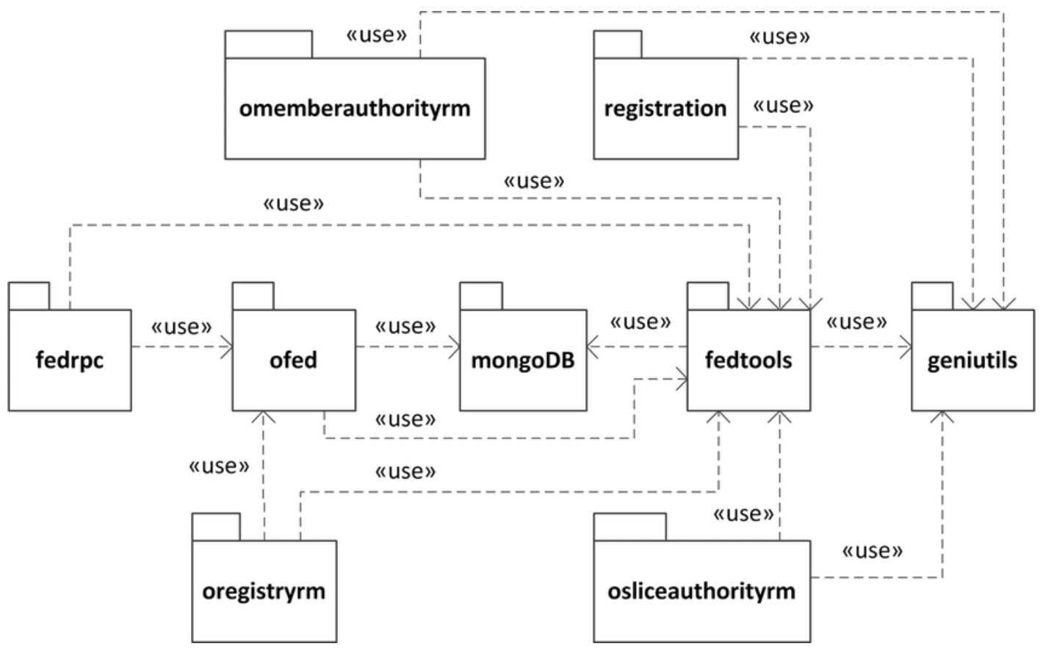
Package descriptions
No | Package | Description
01 | omemberauthorityrm | <Description of the package>
02 | registration | <Description of the package>
03 | fedrpc | <Description of the package>
04 | ofed | <Description of the package>
05 | mongoDB | <Description of the package>
06 | fedtools | <Description of the package>
07 | …

IV.4 Class diagram
[This part presents the class diagram for the relevant feature]
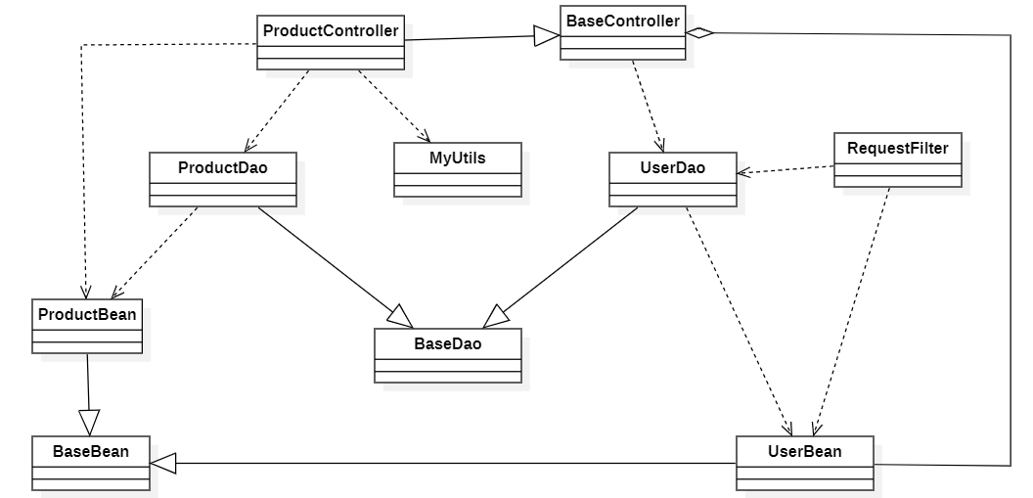

IV.5 Database Design
[Provide the tables relationship like example below – following MySQL database naming convention]

V. Implementation

V.1 Map architecture to the structure of the project
[Provide:
- Overview of the Chosen Architecture
Briefly describe the architectural style (e.g., Layered, MVC, Service-Oriented Architecture)
Explain why it was selected for this project (e.g., to meet non-functional requirements like maintainability, scalability, reusability)
- Mapping to Project Structure
Present the actual project folder/package structure
Map each layer/component in the architecture to concrete project modules]

V.2 Map Class Diagram and Interaction Diagram to Code
[Demo the implementation of several features using design patterns]

VI. Applying Alternative Architecture Patterns

VI.1 Applying the ………….. (ex: Service-Oriented Architecture (SOA)) architecture
[Redesign part of the system architecture using Service-Oriented Architecture (SOA) to improve reusability, scalability, and modularity.
Students must provide:
- Problem Identification
Briefly describe which non-functional requirement(s) are not fully supported by the current architecture (e.g., NF-05: Reusability)
- SOA-Based Solution
Reorganize system components into independent services
E.g., refactor FSOData into separate service modules
- Supporting Diagrams
Deployment Diagram
Updated Class Diagram
Component Diagram showing separate services]

VI.2 Applying Service Discovery Pattern in the service-oriented architecture
[Support dynamic service registration and discovery in SOA or microservice-based architecture for horizontal scalability and ease of expansion.
Students must provide:
- Problem & Requirement
Explain the relevant non-functional requirement (e.g., NF-06: Scalability)
Describe the need for service discovery in a growing system (e.g., multiple branches, independent modules)
- Service Discovery-Based Solution
Integrate a Service Discovery Pattern
Mention possible technologies: Consul, Eureka, Kubernetes DNS
- Supporting Diagrams
Deployment Diagram (with multiple instances and registry)
Updated Class/Component Diagram including a Discovery Service]

