Requirement Specification for Student Management System

Version: 0.1

Da Nang, 2025
Revision History
Date | Version | Author | Change Description
30/12/2025 | 0.1 | Quan

Table of Contents

1. Introduction 4
1.1 Purpose 4
1.2 Overview 4
1.3 Intended Audience and Reading Suggestions 5
1.4 Abbreviations 5
1.5 References 5
2. High Level Requirements 6
2.1 Entity Relationship Diagram 6
2.2 Workflow 8
2.2.1 Class Management 8
2.3 State Transition Diagram 10
2.3.1 Class Management 10
2.4 Use Case Diagram 11
2.4.1 Class Management 12
2.5 Permission Matrix 13
3. Use Case Specifications 0
3.1 General 0
3.1.1 UC1: Log in 0
3.1.2 UC 2: Logout 1
3.2 Common Business Rules 1
4. Mockups Screen 0
4.1 General 0
4.1.1 Log in 0
4.1.2 Landing Page 1
5. Other Requirements 3
6. Integration 3
7. Data Migration 0
7.1 Migration Scope 0
7.2 Data Mapping 0
8. Appendices 0
8.1 Messages List 0
8.2 Email Templates 1
8.2.1 ET 1: Sending email to Class Admin for assignment 1
8.2.2 ET 2: Sending email to Class Admin for change 1

Introduction

Purpose
This document provides a comprehensive description of the Student Management System (SMS). It defines the functional and non-functional requirements to ensure all stakeholders have a unified understanding of the system's capabilities.

Overview
The SMS is a web-based platform designed to digitize educational management, including student profiles, academic results, attendance, and AI-driven learning analytics to predict student performance.
Actors and Roles:
Actor | Roles
Admin | System administration, user management, permission assignment, and school year setup
Teacher | The homeroom/subject teacher manages the class, takes attendance, enters grades, and evaluates students.
Student | Students can view their grades, timetables, and track their individual progress.
Parent | Parents can monitor their children's results, attendance, and receive notifications.
Figure 1: Actors and Roles in system

Intended Audience and Reading Suggestions
This document is intended for:
• Developers and Testers.
• Project Managers and School Administrators.
• End-users (Teachers, Students, Parents).

Abbreviations
Acronym | Reference
UC | Use Case
BR | Business Rule
CBR | Common Business Rules
MSG | Message
Class | Class / Course

High Level Requirements
This section describes the general overview of the system functions or business processes which are depicted in different diagrams. It shows the types of users, their granted permissions to perform specific system functions and the sequence required to complete a business workflow (if any). As the section name implies, it is high-level which mean not detailed enough. For detailed requirement specification, please see section below.

Entity Relationship Diagram
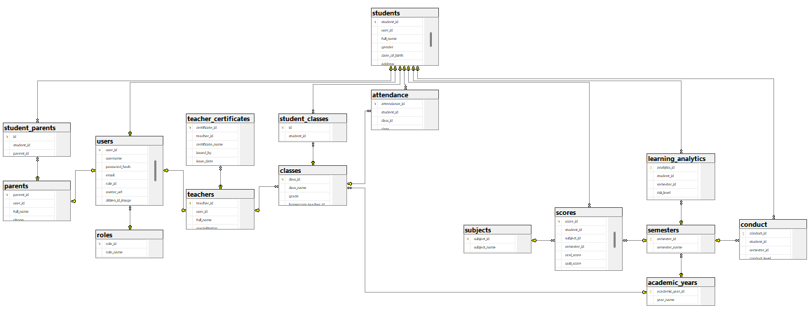
Figure 2: Entity Relationship Diagram of Fresher Academy

Workflow

Class Management
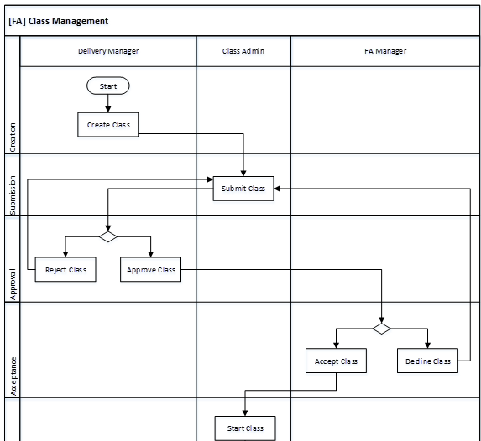
Figure 3: Workflow for Class Management Module

State Transition Diagram

Class Management
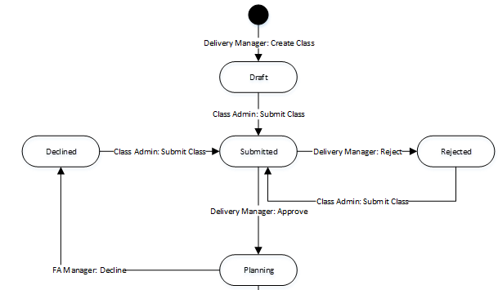
Figure 4: State Transition Diagram for Class Management Module

Use Case Diagram
The use case diagram here shows the specific goal and objective or how the user interacts with the system. The eclipse in the system boundary represents the system use case/functions while the stickman represents the actor/user of the system. The line connecting the actor and the use case shows that the actor can perform that function in the system to achieve a goal.

Class Management
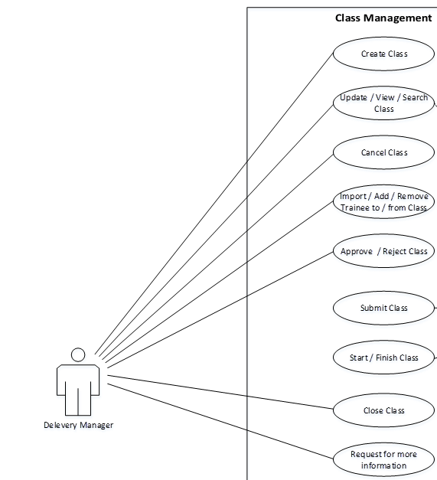
Figure 5: Use Case Diagram for Class Management Module
ID | Feature | Use Case | Use Case Description
01 | Common | Login | Login with email
02 | Common | Register | Sign up for a new account using your email address.
03 | Common | Forget password | Submit forgotten account's email to receive email and reset password
04 | Common | Log out | User can end login session and log out when no need to use the system
05 | Common | Change password | Provide old password and new expected password user can use the new password for login
06 | Guest | View homepage for guest | Guests can view the homepage for guests when they don’t have an account and can register a new account if they want.
07 | Students | View learning progress | View the curriculum
08 | Students | View student profile | View basic onduinfo of the student( name, age, address ..)
09 | Students | Check Attendance | View attendance of student and receive an announcement if the absent is >=4
10 | Students | View score | View score of the student
11 | Students | View timetable | View timetable on each week of the student
12 | Students | View conduct | View conduct of student
13 | Teachers | Manage Homeroom class | View, Update Homeroom class
14 | Teachers | View timetable | View the personal timetable
15 | Teachers | Request Change | Submit a request to change timetable/make up a class period.
16 | Teachers | Attendance | Teachers record the present/absent status for students during their lessons.
17 | Teachers | Grade Entry | Teachers enter the scores (Oral, 15-minute test, Midterm, Final) into the scores table. The system automatically calculates the average score.
18 | Teachers | Conduct student | The homeroom teacher will record the end-of-term conduct assessment for the students in their class on the conduct chart.
19 | Teachers | View Profile | Edit teacher’s profile (personal)
20 | Teachers | Manage Certificates | Teachers update their own qualifications and certificates.
21 | Parents | View your child's report card. | Look up the grades of the student whose parent account is linked.
22 | Parents | Attendance Tracking | Receive reports on which days your child is absent from school or arrives late.
23 | Parents | Receive Notifications/Alerts | Receive automatic notifications if your child is at "High Risk".
24 | Admin | School Year & Semester Management | Only the Admin has the authority to decide when the school year begins/ends and which semesters to activate.
25 | Admin | Class Structure Management | Admins can create new classes (e.g., 10A1, 10A2), delete classes, or merge classes. Teachers are not allowed to create classes independently.
26 | Admin | Teacher Assignment | Admin assigns homeroom teacher ID (homeroom teacher) to the classes table and assigns subject teachers.
27 | Admin | Course Management | Admin defines the list of courses and the number of credits.
28 | Admin | Schedule Management | The administrator arranges the school-wide class schedule to avoid overlapping classrooms/teachers.
29 | Admin | User Management | View, Update , Ban users
30 | Admin | Handle Teacher Request Change | Approve/Reject teacher request to change timetable/make up a class period.

Permission Matrix
Permission Matrix mapping functions and user roles for FA Management application is described as below:
Remarks:
X | User has permission to do this function with all records.
X* | User has permission to do this function with records pending for him/her or belonging to him/her only.

 | FA.  Manager | Delivery Manager | Class Admin | FA. Rec | Trainer | System Admin
Module1: Class Management
Create Class | X | X |  |  |  | X
Update Class | X | X |  |  |  | X
View Class | X | X | X | X | X | X
Search Class | X | X | X | X | X | X
Cancel Class | X | X |  |  |  | X

Use Case Specifications
This section covers the system’s functional requirements which details what the system must do in terms of input, behavior and the expected output. It elicits the interaction between the actor(s) and the system, the system’s behavior and the results of their interactions.

General

UC1: Log in
Objective: | This function allows user to login to system.
Actor: | All authenticated users.
Trigger: | User selects to login on Login screen.
Pre-condition: | User is not yet logged in to system.
Post-condition: | User is logged in to system successfully.
Activities Flows
Business Rules
Step | BR Code | Description
(1) |  | System display screen as Screen 1: Login screen.
(2) | BR 1 | Validation Rules:  System will check the following rules:  - If the value of [User Name] field or [Password] field does not match with any user data in the database, system will display MSG 1.  - If the value of [User Name] field is blank, system will display MSG 2.  If the value of [Password] field is blank, system will display MSG 3.
(3) | BR 2 | Screen Displaying Rules:  System will display corresponding screen as Screen 2: Landing Page.

UC 2: Logout
Objective: | This function allows user to logout from system.
Actor: | All authenticated users.
Trigger: | User selects to logout.
Pre-condition: | User is logged in successfully.
Post-condition: | User is logged out from system successfully.
Activities Flows
Business Rules
Step | BR Code | Description
(2) | BR 3 | Screen Displaying Rules:  System will display corresponding screen as Screen 1: Login screen.

Common Business Rules
This section defines business rules that are used across use cases and can be considered as common rules. Each common business rule below is applied only for use cases that have reference to it.
BR Code | Description
CBR 1 | - If the value of any mandatory fields is blank, system will display MSG 4.  - If the inputted value is wrong format, system will display MSG 5.  - If the inputted value is not number, system will display MSG 6.
CBR 2 | - If the value of any mandatory fields is blank, system will display MSG 4.  - If the inputted value is wrong format, system will display MSG 5.

Mockups Screen

General

Log in
This screen is for user to log in to System.
In order to access this screen, user has to access to the link https://insight.fsoft.com.vn/fhu/login.xhtml
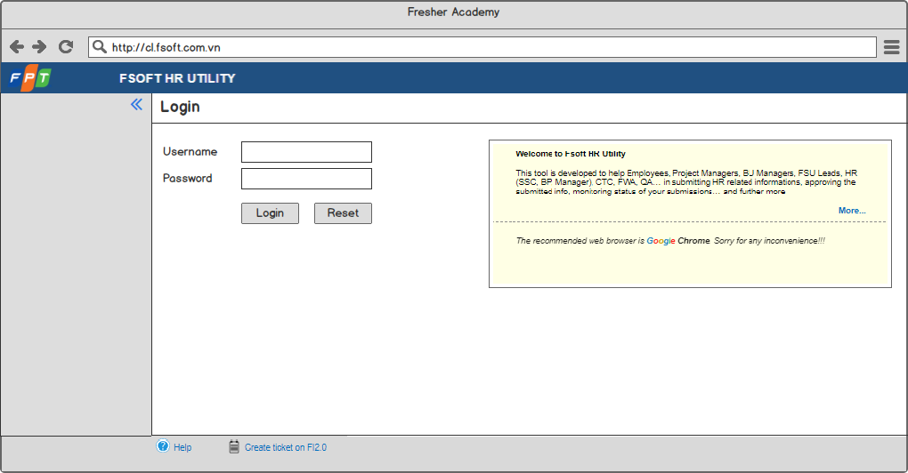
Screen 1: Login screen
# | Component | Comp. Type | Editable | Mandatory | Default Value | Description
1 | Screen Name | Label | No | N/A. | N/A. | This field displays text: “Login”.
2 | Username | Text Box | Yes | Yes | N/A. | - This field allows user to input username to log in to the system.  - This field gets all values of [Account] field in “User information” entity.
3 | Password | Text Box | Yes | Yes | N/A. | - This field allows user to input password to log in to the system.  - This field gets all values of [Password] field in “User information” entity.  - The inputted password is displayed as *****.
4 | Log in | Button | N/A. | N/A. | N/A. | - This button allows user to log in to the system.  - Refer to UC1: Log in for more details.
5 | Reset | Button | N/A. | N/A. | N/A. | - This button allows user to reboot log in screen forcibly.  - Once user clicks on this button, system will clear the inputted information and allow user to input information to log in to the system again.
6 | Introduction Corner | Text Area | N/A. | N/A. | N/A. | - This area displays introduction information of the system.  - The logic behind of this area is the same as current tool.

Landing Page
This is Landing Page.
In order to access this screen, user has to be logged in to the system successfully.

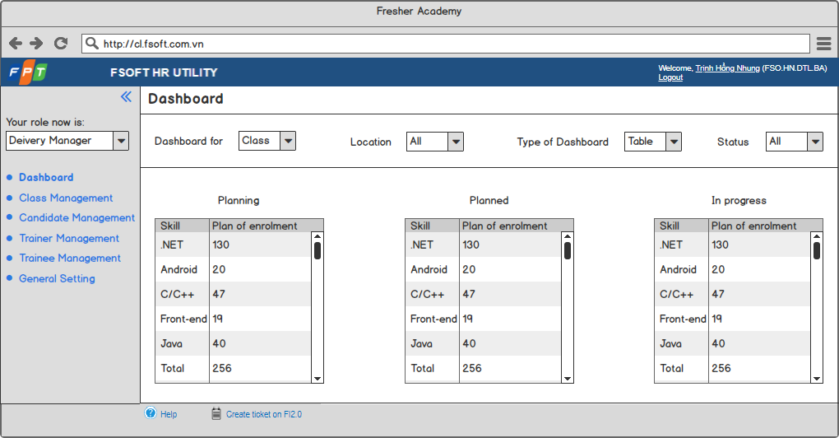
Screen 2: Landing Page
# | Component | Comp. Type | Editable | Mandatory | Default Value | Description
1 | Screen Name | Label | No | N/A. | N/A. | This field displays text: “Dashboard”.
2 | Dashboard for | Drop Down List | Yes | N/A. | Class | - This drop down list allows user to select object of dashboard displayed below.  - Value list:  - Class.  - Candidate.  - Trainee.  - Trainer.
3 | Location | Drop Down List | Yes | N/A. | All | - This drop down list allows user to select which location of object displayed in dashboard below.  - This field gets all values of [Location Name] field in “Location” entity and “All” value.
4 | Type of Dashboard | Drop Down List | Yes | N/A. | Table | - This drop down list allows user to select type of dashboard displayed.  - Value list:  - Table.  - Chart.
5 | Status | Drop Down List | Yes | N/A. | All | - This drop down list allows user to select which status of object displayed in dashboard below.  - This field gets all values of [Status] field of object selected in [Dashboard for] field and “All” value.
6 | Dashboard area | N/A | N/A | N/A. | N/A. | - This area displays corresponding dashboard basing on selected criteria.  - This area needs to be updated later on basing on detailed requirements.

Other Requirements
<Define any other requirements not covered elsewhere in the SRS. This might include database requirements, internationalization requirements, legal requirements, reuse objectives for the project, and so on. Add any new sections that are pertinent to the project.>

Integration
<Describe external system(s) which integrates with the system>

Data Migration
<Describe data migration scope and requirements.
In case SRS for data migration in a separated SRS, note down this point: e.g. detailed requirements for Data Migration part will be described on separated SRS. The data migration SRS and the functional SRS will be a couple of documents to fulfil the whole requirements for SSS migration.>

Migration Scope
This section is to define the scope of data migration. It contains the list of data objects or the specific condition to define the set of data which will be migrated.

Data Mapping
This section shows the mapping for migrated data. It contains the data properties on the old platform and the corresponding properties on the new platform. Data conversion and data patching rules are also described if any.

Appendices

Messages List
# | Message Code | Message | Description
 | MSG 1 | Sorry, your username or password is incorrect. Please try again! | - Type = Error Message  - Message displays as a warning message with red text above the form when user inputs wrong username or password.
 | MSG 2 | Username must be not empty! | - Type = Error Message  - Message displays as a warning message with red text above the form when user selects to log in without inputting username.
 | MSG 3 | Password must be not empty! | - Type = Error Message  - Message displays as a warning message with red text above the form when user selects to log in without inputting password.
 | MSG 4 | You must input all required fields! | - Type = Error Message  - Message displays as a warning message above the form and borders the inputted area with red line if any field marked with asterisk left blank when user does action such as Submit, etc.
 | MSG 5 | Wrong format. | - Type = Error Message  - Message displays as a warning message above the form and borders the inputted area with red line if the value of field having format is inputted with wrong format.

Email Templates

ET 1: Sending email to Class Admin for assignment
Send to | [Class Admin]
CC
Subject | [FA MANAGEMENT]: The Class [Class Code] is assigned to you.
Body | Dear [Class Admin]  The Class [Class Code] - [Class Name] has been assigned for you.  To view the Class details, please click here.  Sincerely,  Application Admin.  Note: This is an auto-generated email, please do not reply.

ET 2: Sending email to Class Admin for change
Send to | [Class Admin]
CC
Subject | [FA MANAGEMENT]: The Class [Class Code] is updated.
Body | Dear [Class Admin]  The Class [Class Code] - [Class Name] has been updated.  To view the Class details, please click here.  Sincerely,  Application Admin.  Note: This is an auto-generated email, please do not reply.

