eGit Plugin for Eclipse Installation
- Open Eclipse
- Click on Help Menu & choose ‘Eclipse Marketplace’
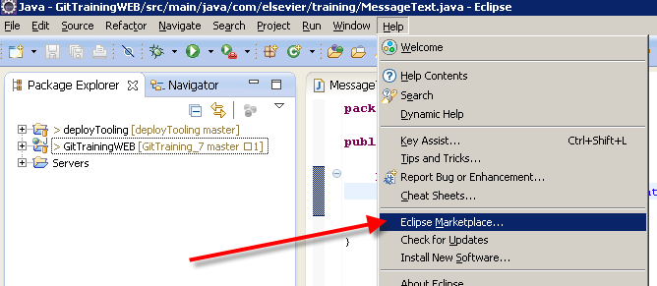
- In the Find with: field, enter ‘egit’ and click ‘Go.’
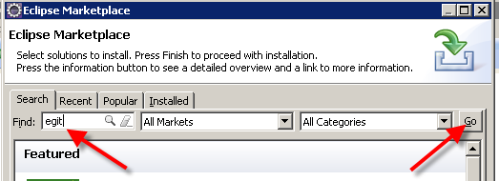
- Click ‘Install’ next to ‘EGit - Git Team Provider’
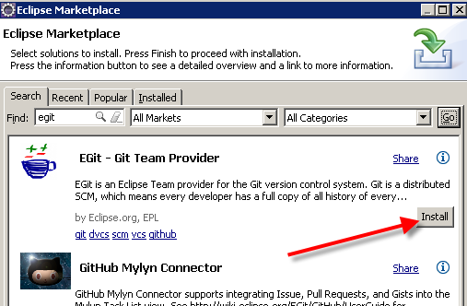
- When prompted for confirmation, click next (JGit & EGit will both be installed, which is what you want)
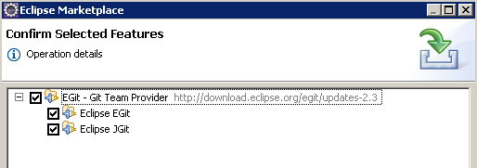
- When prompted, accept terms of license & click finish
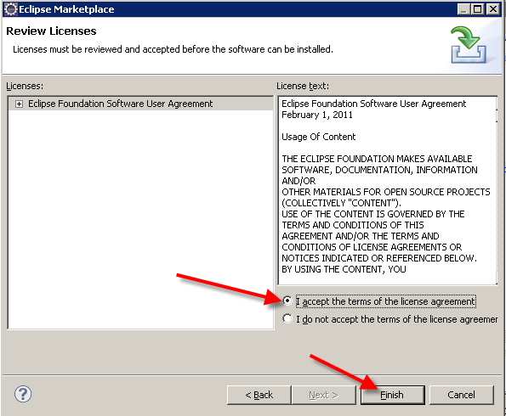

- After EGit installs, click Yes to have Eclipse restart
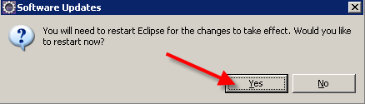
- After Eclipse restarts. Expand: Team | Git & click on Configuration. This is a graphical display of your .gitconfig file (stored in your HOME directory in Windows).
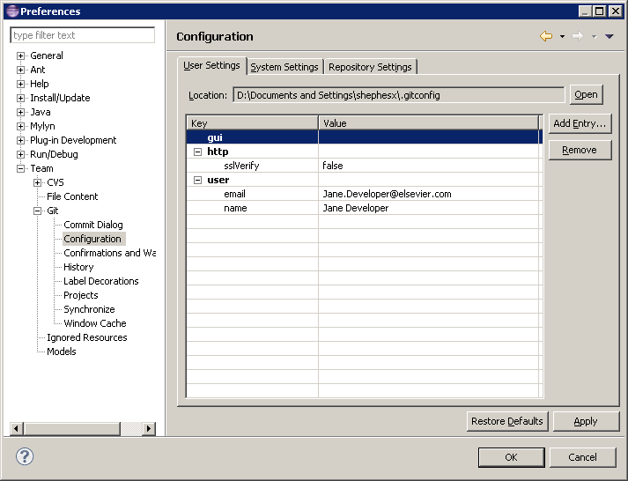
- If you do not have http.sslVerify set to false, click Add Entry button & add it
- If you don’t have user.email & user.name, click Add Entry button & add them

