Mermaid：
Img1
graph TD
A[User Interface] -->|Search Request| B[Web Application]
B -->|Verificaton| C[Kafka
Message Queue]

C --> D1[Work prcessor 1]
C --> D2[Work prcessor 2]
C --> D3[Work prcessor 3]
D1 -->|Read| E1[Redis Cache]
D2 -->|Read| E2[Redis Cache]
D3 -->|Read| E3[Redis Cache]
E1 -->|Miss| G["Response generator(LLM)"]
E2 -->|Miss| G
E3 -->|Miss| G
E1 -->|Hit| H
E2 -->|Hit| H
E3 -->|Hit| H
G --> H[Response]
H -->A[User Interface]

style A fill:#f9f,stroke:#333,stroke-width:2px
style B fill:#bbf,stroke:#333,stroke-width:2px
style C fill:#bfb,stroke:#333,stroke-width:2px
style D1 fill:#ff9,stroke:#333,stroke-width:2px
style D2 fill:#ff9,stroke:#333,stroke-width:2px
style D3 fill:#ff9,stroke:#333,stroke-width:2px
style E1 fill:#f99,stroke:#333,stroke-width:2px
style E2 fill:#f99,stroke:#333,stroke-width:2px
style E3 fill:#f99,stroke:#333,stroke-width:2px
style G fill:#ff9,stroke:#333,stroke-width:2px
style H fill:#f99,stroke:#333,stroke-width:2px

Img2：
graph TD
classDef classA fill:#f9c4d2,stroke:#333,stroke-width:2px;
classDef classB fill:#c4f9d2,stroke:#333,stroke-width:2px;
classDef classC fill:#d2c4f9,stroke:#333,stroke-width:2px;
classDef classD fill:#f9e0c4,stroke:#333,stroke-width:2px;
classDef classE fill:#c4d2f9,stroke:#333,stroke-width:2px;
classDef classF fill:#d2f9c4,stroke:#333,stroke-width:2px;
classDef classG fill:#e0c4f9,stroke:#333,stroke-width:2px;
classDef classH fill:#c4f9e0,stroke:#333,stroke-width:2px;
classDef classI fill:#f9c4e0,stroke:#333,stroke-width:2px;

A[User Queries] --> B[Load Balancer]
B --> C[Application Layer]
C --> D[MySQL Cluster]
D --> E1[Shard 1]
D --> E2[Shard 2]
D --> E3[Shard 3]
E1 --> F1[Replica]
E2 --> F2[Replica]
E3 --> F3[Replica]
F1 --> G1[Partition 1]
F2 --> G2[Partition 2]
F3 --> G3[Partition 3]
G1 --> H[Write-ahead log]
G2 --> H
G3 --> H
H --> I[Auto scaling]

E1 --> F4[Replica]
E2 --> F5[Replica]
E3 --> F6[Replica]
F4 --> G1
F5 --> G2
F6 --> G3

class A classA;
class B classB;
class C classC;
class D classD;
class E1 classE;
class E2 classF;
class E3 classG;
class F1 classH;
class F2 classI;
class F3 classA;
class G1 classB;
class G2 classC;
class G3 classD;
class H classE;
class I classF;
class C1 classG;
class C2 classH;
class C3 classI;
class F4 classA;
class F5 classB;
class F6 classC;
class G4 classD;
class G5 classE;
class G6 classF;

Img3
graph TD

A[Client] -->|User Request| B[API Gateway]
B --> C[Application Backend]

subgraph AWS
style AWS fill:#e0e0e0,stroke:#333,stroke-width:1px

C --> D[Redis Cache]
style D fill:#d1d1e0,stroke:#333,stroke-width:1px

D -->|Cache hit| E[Response]
style E fill:#b3d1e0,stroke:#333,stroke-width:1px

E -->|Update Cache| D[Redis Cache]

D -->|Cache miss| ElasticSearch

subgraph ElasticSearch
style ElasticSearch fill:#c2c2c2,stroke:#333,stroke-width:1px

F[Elastic Search] --> F1[Shard 1]
F[Elastic Search] --> F2[Shard 2]
F[Elastic Search] --> F3[Shard 3]

F1 & F2 & F3 -->|Search| G[Find Target Index]
style G fill:#e0b3d1,stroke:#333,stroke-width:1px
end

ElasticSearch -->|Target Index| MySQL

subgraph MySQL
style MySQL fill:#d9e0b3,stroke:#333,stroke-width:1px

H1[Table 1]
H2[Table 2]
H3[Table 3]
H4[Table 4]
H[MySQL Database] --- H1 & H2 & H3 & H4
end

MySQL -->|Data| E
end

style A fill:#d1e0d1,stroke:#333,stroke-width:1px
style B fill:#e0d1c2,stroke:#333,stroke-width:1px
style C fill:#e0d1b3,stroke:#333,stroke-width:1px

linkStyle default stroke:#333,stroke-width:1px

--------------------------------------------
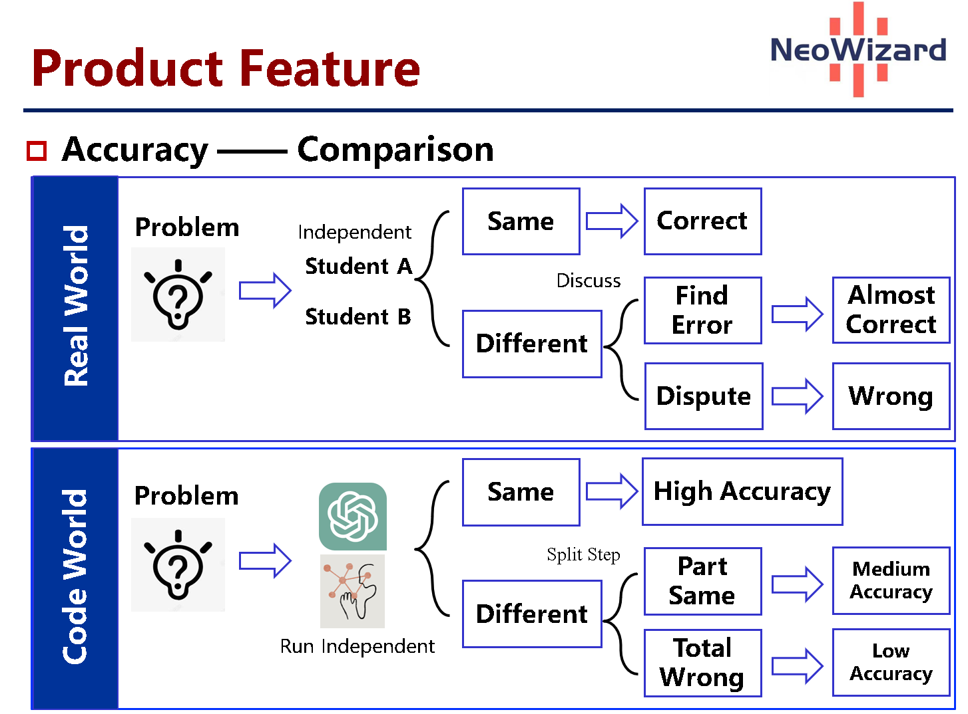
Other img:

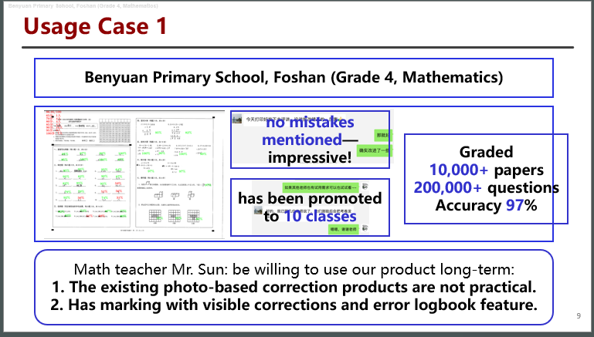

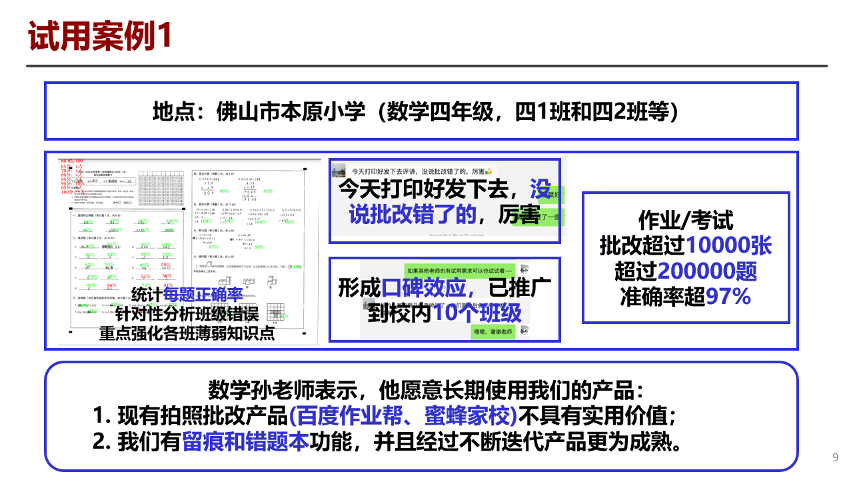

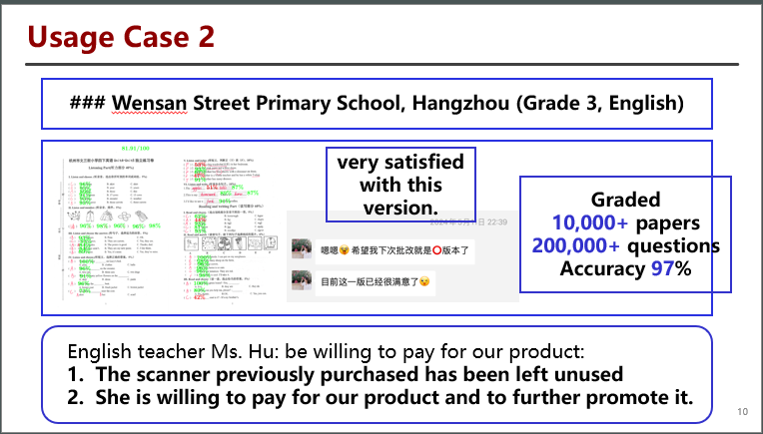

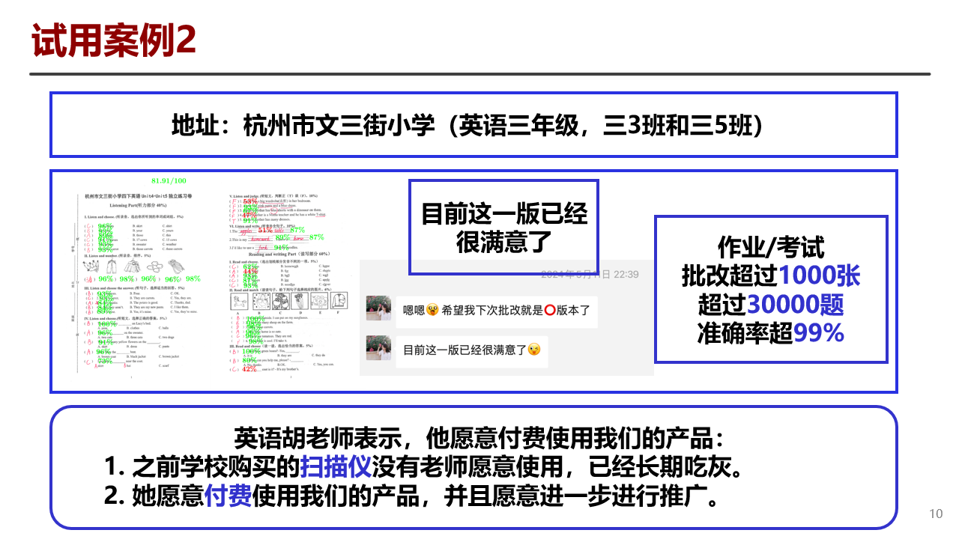

s

