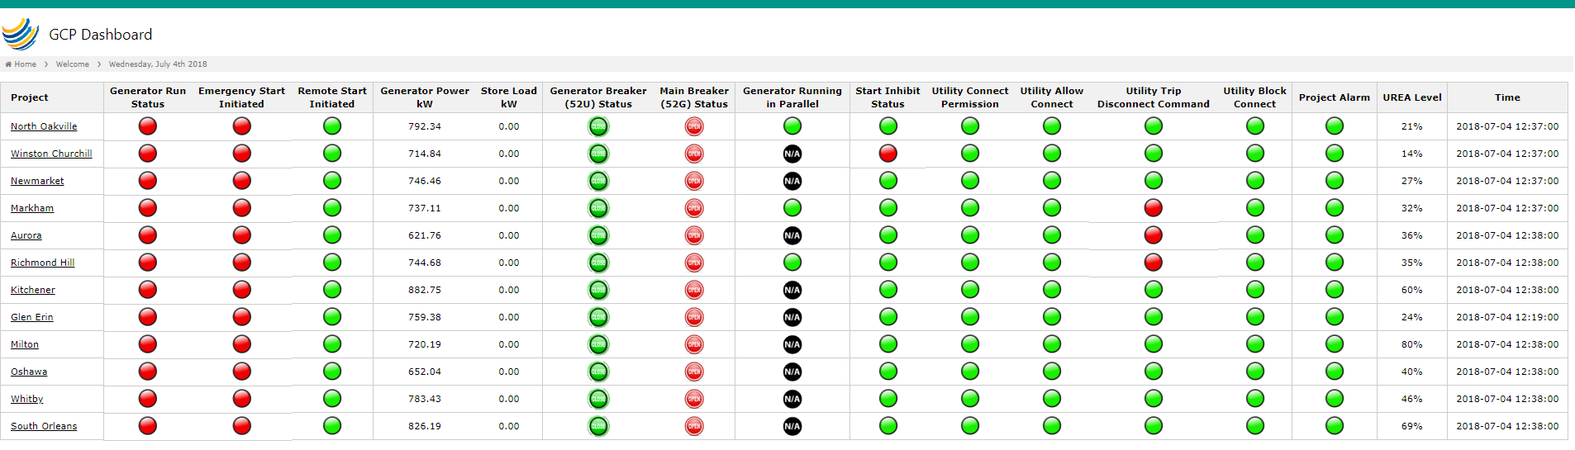

1. Delete Column (Generator Run Status)
2. Rename “Remote Start Initiated” to “Generator Status” -> also make “Generator Status” the first column
3. Rename: “Generator Breaker 52U Status” to “Generator Breaker (52G) Status”
4. Rename: “Main Breaker (52G) Status” to “Main Breaker (52U) Status” -> please note that this Modbus does not work (we will look for another Modbus Map for the Main Breaker).
5. Delete “Generator Running in Parallel” column
6. Delete Columns: “Start Inhibit Status”, “Utility Connect Permission”, “Utility Allow Connect”, “Utility Trip Disconnect Command”, “Utility Trip Disconnect Command”
   1. The Idea here is, we will make this one column and create a “Utility Alarm”. If one of these go Red, then we will have a “Utility Alarm”
7. Rename: Project Alarm to “P&C Alarm”
8. We will also add a column (later on if the Engine alarm works) called “Engine Status” (Engine Fault - > 20547)?