How to Write your ISOTT Paper
An easy guide
Eileen Harrison
Technical Subeditor, St Lorenzen, Italy
Abstract This document is written using the Springer T1-Book Template. In order to use it, make sure that this document is in the same folder as the Template. If you have opened it in a different folder, close the file and copy it to the correct folder. You will then be able to enable the macros when you re-open it. The paper will describe how to write your paper for the proceedings of ISOTT 2017 in Halle/Saale, Germany. It is written in the fonts and style that you should use to prepare your manuscript. You must refer to Springer’s instructions. These are to be found at: http://www.springer.com/authors/book+authors?SGWID=0-154102-12-417900-0.
1 Introduction
The publisher, Springer now provides a Template for you to use when writing your paper for publication in the Proceedings series. For regular contributors to the ISOTT Proceedings, you will note that the format for the manuscript is completely different from that used up until 2008. The new format was introduced for the Sapporo Proceedings and is relatively easy to produce using the Template. Springer has also provided Instructions for using the Author Template and anyone who is used to writing with Templates will have no problems. If, on the other hand, you have never used a Template before, here are some suggestions to make the process of getting started easier.
You can use the Template from the outset to write your paper or you can insert a document you have already written in another format into the Template and use either the toolbar or keystrokes to re-format each paragraph. Another alternative is to overwrite this document (but save it first for reference). Either way, the macro automatically sets the area within which your text and figures must appear and selects the correct font for whatever you are typing at the time. All you have to do is remember to mark what level of text the paragraph is to be. This can only be done by giving the correct command whilst the cursor is in a paragraph. You choose whether to use the toolbar or keystrokes to give the commands
2 Methods
In order to use the Template from the outset to write your paper, after downloading it from the website you will want to put it in the directory where you want to save your manuscript whilst working on it. To do this, follow the instructions on the first page of Springer’s Instructions for using the Author Template to open Word and set Macro Security. Then open My Computer or Windows Explorer and double click on the Template to create a new document. Word will open automatically. A warning may appear about macros: just click on “Activate Macros” or its equivalent. Note the warning: DO NOT OPEN THE TEMPLATE VIA FILE → OPEN. Now save the document you have just created as normal, naming it with the first author’s surname. Do not simply call it ISOTT 2010 or something similar – you may only have one paper but the editors may have 60 or more to deal with. If you have more than one paper by the same first author add a subject keyword (from the title, for example) to the file name to identify it or use the name of a second author. From now on you can open the file in Word.

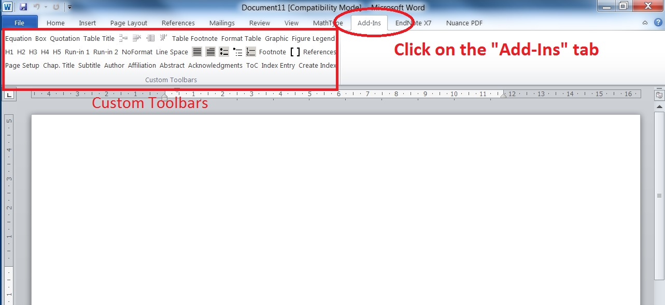

Fig.1 Click on “Add-Ins” tab on the menu bar to access the customized buttons
To access the customized buttons for style, click on the “Add-Ins” tab on the menu bar, as shown in Fig.1. To start writing, use the mouse to click on “Chap. Title” on the Toolbar at the top of the screen and type the title of your paper. It will automatically appear in the correct position and font. At the end of the title, press return. Before you start to enter the Subtitle (if you have one) click on “Subtitle” in the Toolbar. If you have no subtitle and want to enter the authors next, click on “Author” and type the names of the authors. Again, the correct spacing and font will be selected for you Press return and repeat the procedure by clicking on Abstract to enter the abstract. At the end of the abstract, press return and this time click on “H1” so you can type your first order heading “Introduction”. These headings are to be numbered: type the number followed only by a space before typing the heading. Press return and the macro switches to normal text. The first paragraph of every section after the heading is NOT indented, the following paragraphs ARE indented by 0.42cm and this should happen automatically. If it does not, simply use Format Paragraph to adjust the first line indent to 0.42cm. Now you can continue to write your paper as normal.
Once you have completed the Introduction, press return again and then click on H1 before writing your next first order heading. Again, pressing return will return you to normal text and you continue writing. If you want to use second (or even third) order headings, click on H2 or H3 to set the correct spacing and font (see in section 3 of this paper). However, be warned that this requires a great deal of space because of the prescribed spacing and will make restricting your paper to 6 pages more difficult.
The heading for the references is also a first order heading (H1) but without a number. After writing it and pressing return, click on References in the Toolbar and this will set the correct font.
3 Instructions to Authors
Please read the Instructions to Authors documents carefully. Manuscripts that do not comply will be returned for correction. The following should be noted in particular.
3.1 Length
The designated maximum length of 6 pages must include the abstract, all tables, figures and references and must not be exceeded. Do NOT include keywords in the manuscript: they should be supplied separately to the editors.
3.1.1 Sub-Headings
As mentioned above and as you will note from this section that the use of multiple sub-headings takes up a lot of space due to the prescribed spaces between the headings and text.
3.2 Figures
For vector graphics, the preferred format is EPS; for halftones, please use TIFF format. MS Office files are also acceptable. Each figure should be submitted as a separate file. Figures should NOT be included in the text, but placed at the end of the manuscript. Colour figures may charged for by Springer and all figures will be reproduced in grey scale. Authors wishing to use colour figures should contact Springer directly to arrange this.
Do not use text boxes. This makes any later editing that may be required (language editing or minor amendments undertaken by the editors) extremely complicated.
3.3 Tables
Tables should be prepared using the Table function in Word preferably using the Simple 1 format. Do not include tables as graphic files or pictures or in text boxes.
3.4 How to Cite References
References should be cited in the text in square brackets [1, 2] in the order they are cited in the text. The reference list should be similarly numbered in order of citation and the style used should be as in the References below. When listing publications with more than 3 authors, “et al” should be used after the name of 3rd author
4 Conclusions
If you use the above guidelines in conjunction with the two Springer documents, you should be able to prepare your manuscript easily and correctly.
Acknowledgments This document was prepared by the editors to help authors.
References
1. Sorensen LT, Jorgensen T, Kirkeby LT et al (1999) Smoking and alcohol abuse are major risk factors for anastomotic leakage in colorectal surgery. Br J Surg 86:927-931
2. Harrison DK, Hawthorn IE (2005) Amputation level viability in critical limb ischaemia: Setting new standards. Adv Exp Med Biol 566:325-332

