**NIRS cerebral evaluation of the hemodynamic and oxidative state of cytochrome-c-oxidase responses to +Gz acceleration in healthy volunteers**

**F. Langea**, G. Balea, R. Pollockb, A. Stevensonb and I. Tachtsidisa

*a*Department of Medical Physics and Biomedical Engineering, University College London, United Kingdom.

*b*Human Performance, QinetiQ PLC, United Kingdom.

*f.lange@ucl.ac.uk*

**Abstract:** We used a miniature broadband NIRS system to monitor changes in brain oxygenation and oxidative state of cytochrome-c-oxidase (oxCCO) during a high +Gz acceleration, induced by a human centrifuge, on 2 healthy experienced volunteers (2 male, 34 and 37 yrs). The NIRS probes were positioned and secured on the left forehead. We performed a sequence of nine +Gz exposures, ranging from +2.8 Gz to 6 +Gz. The concentration changes in [HbO2], [HHb], and [oxCCO] were recorded and the blood volume changes ([HbT]=[HbO2]+[HHb]) and oxygen delivery ([HbDiff]=[HbO2]-[HHb]) were calculated.

In Figure 1, we report the NIRS responses of the first +Gz event, which consisted of a gradual increase (0.1G.s-1) in +Gz until run termination at visual symptoms (loss of peripheral vision). The haemodynamic responses of subjects 1 and 2 are different. The response for subject 1 shows a significant decrease oxygen delivery (mean [HbDiff] = -2.97 ± 1.23 µMol) and in blood volume (mean [HbT] = -2.43 ± 0.73 µMol), coupled with a significant increase in [oxCCO] (mean [oxCCO] = 0.27 ± 0.12 µMol). The response for subject 2 shows a significant decrease in oxygen delivery (mean [HbDiff] = -2.37 ± 0.95 µMol) but no significant change in blood volume (mean [HbT] = 0.09 ± 0.23 µMol), but a significant increase in [oxCCO] (mean [oxCCO] = 0.18 ± 0.07 µMol).The increase in Gz is known to induce cerebral hypoxaemia and cerebral ischaemia [1]. In this case, subject 1 appears to be ischaemic but not hypoxic whereas subject 2 appears to be hypoxic. However, in both cases we can note an increase in [oxCCO] which is likely due to ischaemia limiting substrate delivery to the electron transport chain [2]. This result matches previous preclinical studies [3]. We have shown that human centrifuge studies can be used to investigate cerebral hypoxic-ischaemic events on healthy volunteers.

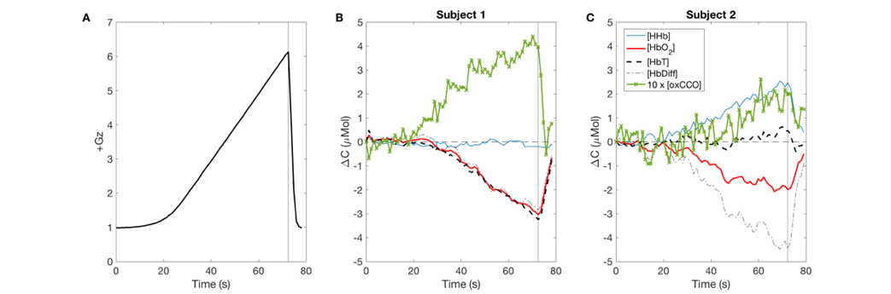

**Figure 1 :** A) +Gz value during the event. B) Concentration changes for [HHb], [HbO2], [HbT], [HbDiff], and [oxCCO] for subject 1. C) Concentration changes for [HHb], [HbO2], [HbT], [HbDiff] for subject 2. The black vertical line represents the time of the maximum Gz.

**References**

[1] C. C. Tran *et al*., 2003. Neurosci. Lett. 338, 67–71.

[2] M. Banaji, 2006. J. Theor. Biol. 243, 501–516.

[3] M. Tsuji *et al.*, 1995. Pediatr. Res. 37, 253–259.

I prefer:  