**Classification of Cognitive Tasks from multichannel fNIRS Signals using Convolutional Neural Networks**

**H. Lee**, M. Kim, G. Lee, M. Ji, J. Kim, M. Choi and H.-M. Bae

*School of Electrical Engineering, Korea Advanced Institute of Science and Technology, Republic of Korea*

*hmbae@kaist.ac.kr*

**Abstract:** Functional near-infrared spectroscopy (fNIRS) has been widely utilized for the non-invasive brain-computer interface (BCI) thanks to its portability and cost-effectiveness. Detecting and differentiating sophisticated cognitive states are the key technical requirements for the realization of BCI[1]. In recent years, convolutional neural network (CNN) has emerged as one of the most effective methods in the area of classification. In this study, we demonstrate a CNN-based classification scheme for the fNIRS signals acquired in the prefrontal region under different cognitive states.

**Method:** Hemodynamic response was monitored using NIRSIT (OBELAB Inc., Rep. of Korea), a multi-distance source-detector-paired near-infrared spectroscopy system containing 204 channels, over the prefrontal cortex. Nine healthy adult participants performed three cognitive tasks: arithmetic, N-back and verbal fluency tasks. For each task, the collected data were labeled with the name of corresponding task. The collected data were low-pass filtered for the noise reduction and then a modified Beer-Lambert law was applied to extract regional and temporal hemodynamic responses. The extracted hemodynamic responses were then converted into a 2D image (Fig. 1). A 3-layered CNN was implemented and trained with the 2D image data for classification. Four-fold cross-validation were performed and the accuracies from each fold were averaged for the evaluation. The effectiveness of the proposed scheme has been tested for both intra and inter subject classifications.

**Result:** The proposed classification scheme demonstrated 91.7% and 83.5% classification accuracies for the intra and inter-subject tests, respectively.

**References**

[1] Jonathan R Wolpaw, Niels Birbaumer, Dennis J McFarland, Gert Pfurtscheller, Theresa M Vaughan, Brain–computer interfaces for communication and control,

Clinical Neurophysiology, Volume 113, Issue 6, 2002, Pages 767-791, ISSN 1388-2457

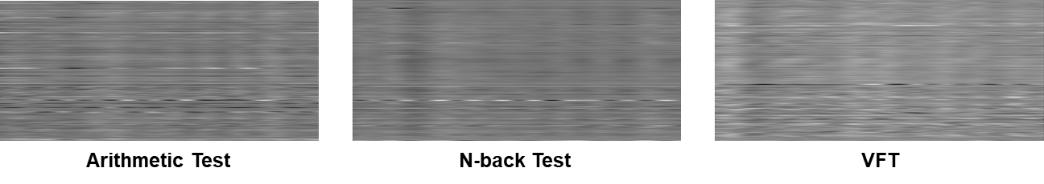

Figure 1 : 2D converted image of fNIRS signal

I prefer:

