**Abstract Submission Instructions for ISOTT 2018**

* Use the Microsoft Word template on the next page with the specified formatting for your abstract.
* Limit abstracts to a single A4 page (including if needed references and figures).
* Use Arial 12 point justified text with single line spacing and no empty lines before and after paragraphs.
* Set margins at 2.5cm on the Top, Left and Right and 2cm at the Bottom.
* Indicate at the end of the abstract (radio buttons) if you wish to be considered for an oral or poster presentation.

**Deadline for abstract submission: April 15st, 2018**.

**Investigating the relationship between hypothermia and cerebral metabolism following hypoxic-ischaemic injury**

**J. Russell-Bucklanda**, C. Bauera and I. Tachtsidisa

*a Dept Medical Physics and Biomedical Engineering, University College London, London, UK*

*Corresponding author e-mail address: j.russell-buckland.15@ucl.ac.uk*

**Abstract:**  Hypoxic ischemic encephalopathy (HIE) is a significant cause of death and neurological disability in newborn infants. Therapeutic hypothermia is one of the most common treatments and generally improves outcome, but 45-55% of injuries still result in fatalities or severe neurodevelopmental disability. We have adapted the existing BrainPiglet systems biology model1 of cerebral oxygen transport and metabolism to model the impact of hypothermia on the brain via inclusion of temperature.

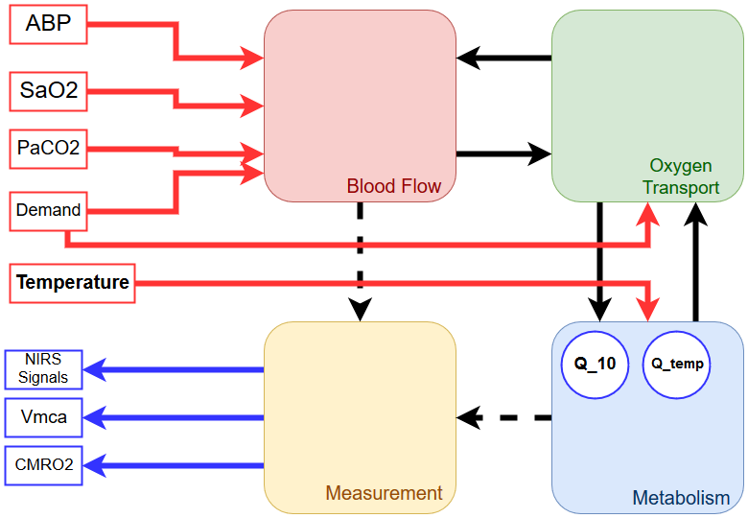

**Figure 1:** Shown is the general structure of the BrainPiglet hypothermia model, with inputs in red and outputs in blue and each of the 4 sub models shown, as well as the general relations between each.  
New additions are shown in bold. Temperature is added as an input to the model. Q_10,a measure of the change in reaction rate when increasing temperature by 10℃, is a new parameter. Q_temp, the factor by which a reaction rate is modified when changing temperature, as a new internal state variable local to the metabolism submodel.

Data collected using broadband near-infrared spectroscopy from piglets being treated with hypothermia following HIE shows differing responses to cooling in both cerebral oxygenation and metabolism between piglets. Preliminary results have identified a significant relationship between temperature and cerebral metabolism which is impacted by arterial blood pressure and oxygen saturation, with the relationship and additional impacts varying per piglet. Identifying the mechanisms behind this individual variation, through systems biology approaches, may provide insight into the variation in treatment success.

At the meeting we will present our new model, data collected during the piglet studies and use our model to predict differences in the effect of hypothermia on brain oxygenation and metabolism due to different level of brain injury.

**References:**

1. Caldwell M, Moroz T, Hapuarachchi T, Bainbridge A, Robertson NJ, Cooper CE, et al. (2015) Modelling Blood Flow and Metabolism in the Preclinical Neonatal Brain during and Following Hypoxic-Ischaemia. PLoS ONE 10(10): e0140171.

I prefer:  