**Quantification of the tumour oxygenation based on FMISO PET: influence of location and oxygen level of the well-oxygenated reference region**

**M. Lazzeronia**, I. Toma-Dasua, A. Urebaa, F. Schiavob, N. Wiedenmannc, H. Buneac, B. Thomannc, D. Baltas c and A. L. Grosuc

*a Department of Physics, Stockholm University, Stockholm, Sweden*

*b Department of bioengineering, PadovaUniversity, Padova, Italy*

*c Department of Radiation Oncology, Medical Center, Medical Faculty Freiburg, German Cancer Consortium (DKTK) Partner Site Freiburg, Freiburg, Germany*

*Corresponding author e-mail address: Marta.Lazzeroni@fysik.su.se*

**Abstract:** Tumor hypoxia is of the main determinants of cell radioresistance and is investigated as one of the leading causes of failure of tumor response to radiotherapy.

Given its potential pivotal role in treatment outcome determination, efforts are made in quantifying tumor oxygenation during treatment.

Positron Emission Tomography (PET) with hypoxia-specific agents offers not only a way to visualize hypoxic areas, but also to quantitatively characterize the microenvironment by conversion of radiotracer uptake into oxygenation maps. Conversion functions necessarily make use of well-oxygenated reference volume (WOV) for normalization purposes.

This study aims at assessing the sensitivity of quantifying the tumour oxygenation based on 18F-fluoromisonidazole (FMISO) PET with respect to the choice of the location and the oxygenation level of the WOV in head and neck cancer patients.

WOVs varying not only in shape and location but also with respect to the assigned pO2 level were considered. pO2 values other than the standard 60 mmHg were selected according to the specific tissue type encompassed by the volume, as reported in Ref. [1].

Specifically, three different strategies were analyzed: (1) a sphere located in the shoulder region (low density in Computer Tomography) with pO2 value equal to 60 mmHg (standard), (2) volume located in the neck muscle with two alternative levels of oxygenation equal to (a) 60 mmHg (standard), (b) 29 mmHg [1], respectively.

Figure 1 shows pO2 values within the Gross Tumor Volume (GTV) obtained for different combinations in location and pO2 level selection of WOV, together with the obtained hypoxic volume. Method (1) and (2b) show the largest degree of agreement in hypoxic patient classification (10 mmHg threshold).

Hypoxia mapping strategies are found highly sensitive to selection of the location of well-oxygenated region, but also on its assigned oxygenation level, which is crucial for hypoxia-guided adaptive dose escalation strategies.

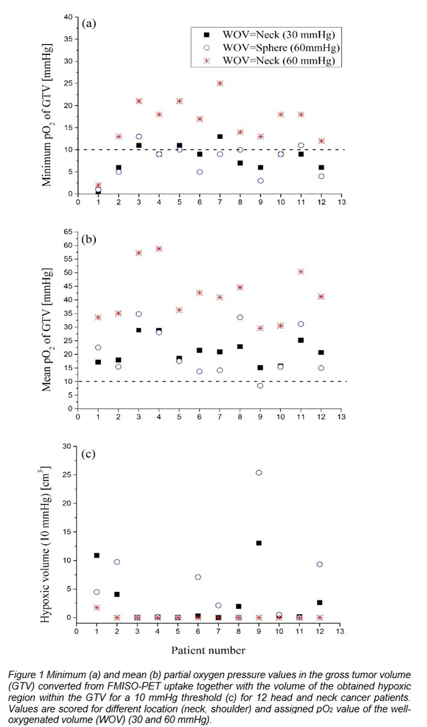

**References**

[1] Carreau, A., Hafny‐Rahbi, B. E., Matejuk, A., Grillon, C., & Kieda, C. (2011). Why is the partial oxygen pressure of human tissues a crucial parameter? Small molecules and hypoxia. *Journal of cellular and molecular medicine*, *15*(6), 1239-1253.

I prefer:  