**IoT monitoring system for healthcare: a preliminary study**

M Ishida a, Y Komuro a, Y Nagasawa a, S Ushioda a, L Hu a, K Sakatani a, b

*a NEWCAT Research Institute, Department of Electrical and Electronic Engineering, College of Engineering, bDepartment of Neurological Surgery, School of Medicine, Nihon University, Japan*

*sakatani.kaoru@nihon-u.ac.jp*

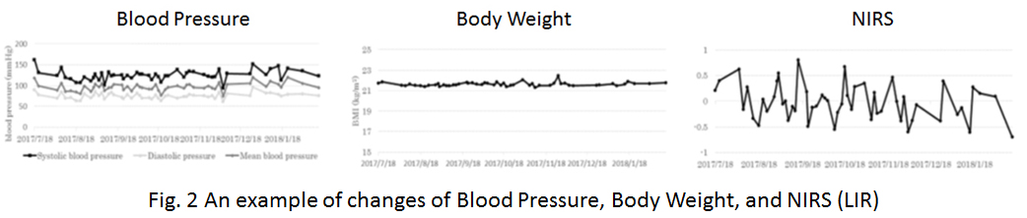**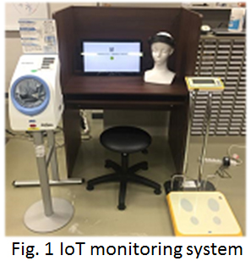Abstract:** Recently, patients with lifestyle diseases, dementia, and mental stress are increasing rapidly. Meanwhile, IoT technology have began to be introduced to home machines that are used everyday like home appliances, and various data in daily life have been collected as Big Data. In order to assess daily changes of physical and mental conditions, we have developed IoT monitoring system which allows long-term measurements of blood pressure, heart rate, and body weight. In addition, the system included NIRS for measurements of prefrontal cortex activity. The IoT monitoring system was set in the fitness gym (Kasuga Rehabilitation Hospital affiliated gym “Sakura”) for preliminary study (November 2017~March 2018). 39 subjects (62.0±8.6 years), selected from the members of the gym, participated the preliminary study. The IoT monitoring system was consisted with digital blood pressure monitor (TM-2657, A&D), electronic scale (AD-6209PBT-C, A&D), and 2 channel NIRS (HOT1000, Hitachi High-Technologies) (Fig. 1); we analyzed the laterality index at rest (LIR) which indicates degree of mental stress [1]. The data of the individual member was identified by a barcode, and sent to a PC via Bluetooth, and accumulated in the cloud system (Amazon Web Services) via the Internet. The subjects could measure their physiological data by themselves repeatedly when they visited the gym after brief introduction of measurements. Fig. 2 indicates an example of changes of blood pressure, body weight, and LIR during five months. Note that this subject showed a relatively high blood pressure (around 160/90 mm Hg) at the beginning, however, gradually normalized after repeating physical exercise. The fluctuation of LIR may indicate changes of mental stress. The preliminary results indicate that ordinary people can continuously monitor physiological functions such as brain function outside medical facilities such as fitness gym.

[1] W Ishikawa, et al. Correlation between asymmetry of spontaneous oscillation of hemodynamic changes in the prefrontal cortex and anxiety levels. J Biomed Opt. 2014

I prefer:  

