**The Usefulness of a New Device as the Monitor of Cerebral Blood Oxygenation using NIRS during CPR in Patients with Cardiac arrest**

**T. Yagi**abc, T. Kawamoritaad, E. Tachibanaa, K. Kuronumaa, W. Atsumia, N. Chibad,

K. Watanabebd, S. Kunimotoa, S. Tanib, N. Matsumotob, L. B. Beckerc, K. Sakatanie

*a Dept. of Cardiology, Kawaguchi Municipal Medical Center, Japan*

*b Dept. of Cardiology, Nihon University Hospital, Japan*

*c The Feinstein Institute for Medical Research, Northwell Health System, USA*

*d Dept. of Emergency and Critical Care Medicine, Nihon University Hospital, Japan*

*e NEWCAT Institute, Nihon University College of Engineering, Japan*

*Corresponding author email address;* [*tsuyagi-circ@umin.ac.jp*](mailto:ygt0108@gmail.com)

**Abstract:** Recent guidelines on cardiopulmonary resuscitation (CPR) have stressed the necessity for improving the quality of CPR. In previous studies, we reported the usefulness of monitoring of cerebral blood oxygenation (CBO) during CPR by near-infrared spectroscopy (NIRS) (NIRO-200NX, Hamamatsu Photonics, Japan). In the present study, we evaluated whether NIRO-CCR1, a new NIRS device (Hamamatsu Photonics, Japan) would be as useful in the clinical setting as NIRO-200NX. Table 1 shows a comparison of the characteristics between NIRO-200NX and NIRO-CCR1. We monitored CBO in 20 patients with cardiac arrest by NIRS (using NIRO-200NX in 19 patients and using NIRO-CCR1 in one patient). On arrival of the patient at the emergency department, the attending physician immediately assessed whether the patient was eligible for this study after conventional advanced life support, and if eligible, measured the CBO in the frontal lobe by NIRS. We found that the cerebral blood flow waveform was in synchrony with the chest compressions in all patients. Moreover, the tissue oxygenation index (TOI) and SnO2 (saturation of the waveform) increased following implementation of emergency cardiopulmonary bypass (ECPB) in the patients in whom ECPB was performed, including in the patient in whom the CBO was monitored using NIRO-CCR1. In addition, although NIRO-CCR1 could display the pulse rate (Tempo) in real time, the pulse rate was sometimes not detected despite detection of cerebral blood flow waveform. This suggested that the chest compressions may not have been effective, so that NIRO-CCR1 also appears to be useful to assess the quality of CPR. The present study suggested that NIRO-CCR1 could measure CBO during CPR in patients with cardiac arrest as well as NIRO-200NX, and may even be more useful, especially in prehospital fields, such as inside ambulances, as they are not only easy to use, but also easy to carry.

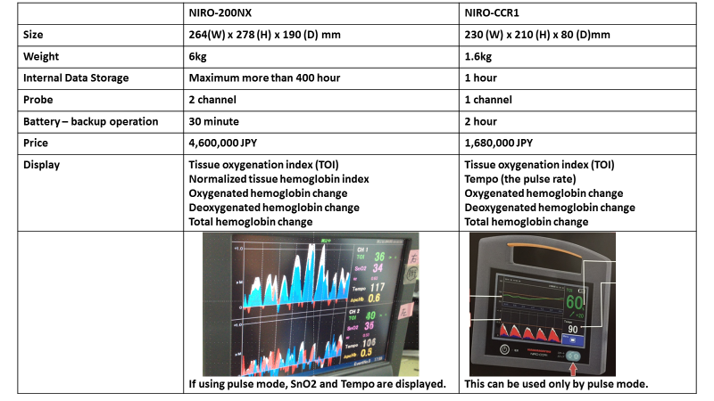Table 1

I prefer:  