**Relationship between cerebral blood oxygenation and electrical activity during mental stress tasks: Simultaneous measurements of NIRS and EEG**

Y Nagasawa a, M Ishida a, Y Komuro a, S Ushioda a, L Hu a, K Sakatani a, b

*a NEWCAT Research Institute, Department of Electrical and Electronic Engineering, College of Engineering, bDepartment of Neurological Surgery, School of Medicine, Nihon University, Japan*

*sakatani.kaoru@nihon-u.ac.jp*

**Abstract:** The incidence of stress-induced psychological and somatic diseases has been increasing rapidly, and it is important to clarify the neurophysiological mechanisms of stress response in order to establish effective stress management methods. We found that the prefrontal cortex (PFC) plays an important role in stress response [1-4]. In this study, we employed near-infrared spectroscopy (NIRS) and electroencephalography (EEG) to investigate the characteristics of PFC activity during mental arithmetic tasks.

**Methods**: We used a two-channel NIRS to measure haemoglobin (Hb) concentration changes in the bilateral PFC during a mental arithmetic task (2 min) in normal adults. We also measured the bilateral PFC activity during the task using EEG simultaneously. We evaluated concentration changes of oxy-Hb induced by the task, while analyze changes of α wave using power spectrum analysis.

**Results**: Fig. 1 shows a typical example of NIRS and EEG recordings. We observed that oxy-Hb in the bilateral PFC increased significantly during the task (p<0.05), while the power of α wave in the PFC decreased significantly during the task (p<0.01).

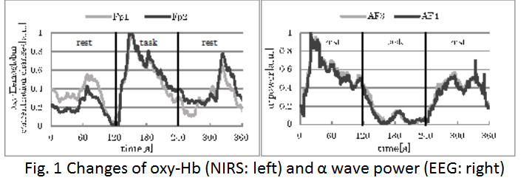

**Discussion**: The present results indicate that mental stress tasks caused activation of the bilateral PFC. Simultaneous measurements of NIRS and EEG are useful to evaluate neurophysiological mechanism of stress responses in the brain.

[1] RJ Davidson and W Irwin *Trends Cogn Sci.*, 1999;3: 11-21

[2] M Tanida, M. Katsuyama and K. Sakatani *Brain Research* 2007;1184: 210-216

I prefer:  