**Relation between cognitive dysfunction and systemic metabolic disorders in aged subjects: Dementia may be a systematic disease**

Y Komuro a, K Oyama c, L. Hu a, K Sakatani a, b

*a NEWCAT Research Institute, Department of Electrical and Electronic Engineering, College of Engineering, bDepartment of Neurological Surgery, School of Medicine,  CDepartment of Computer Science, Nihon University, Japan*

*sakatani.kaoru@nihon-u.ac.jp*

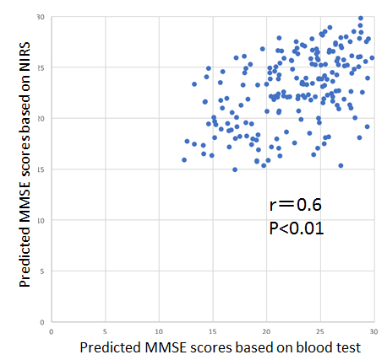**Abstract:** Recently, it has been propose that the Vascular Cognitive Impairment (VCI) plays an important role in dementia in elderly people. VCI refers to the contribution of vascular pathology to the entire spectrum of cognitive disorders ranging from mild cognitive impairment to severe dementia, and the pathological spectrum from “pure” Alzheimer disease through degrees of vascular comorbidity, so-called mixed disease, to “pure” Vascular Dementia [1]. In the present study, we investigated relation between cognitive dysfunction and systemic metabolic disorders employing deep learning (DL). We studied 202 patients (73.4 ± 13.0 years); 94.6% of the subjects were undergoing treatment for lifestyle diseases, and 68.8% of the subjects had a history of cerebrovascular disorder. We evaluated cognitive dysfunction by Mini Mental State Examination (MMSE): the mean MMSE scores were 25.3±4.0. We performed basic blood examination including Complete Blood Count and Basic Metabolic Panel, and measured cerebral blood oxygenation in the prefrontal cortex (PFC) employing a time-resolved near infrared spectroscopy (TNIRS) [2]. We, employing deep neural networks, assessed the MMSE scores of the subjects based on the TNIRS parameters and the blood examination data, independently. Then, we compared the predicted MMSE scores based on the TNIRS parameters and the blood examination data. There was a significant positive correlation between the TNIRS parameters and the blood examination data (r=0.6, p<0.01, Right Fig.). These observations suggest that the cognitive dysfunction in most of aged people may be caused by combination of the systemic metabolic disorders such as energy and oxygen metabolisms and the cerebral circulatory disturbance due to arteriosclerosis based on lifestyle-related diseases.

References

[1] Vascular Contributions to Cognitive Impairment and Dementia *Stroke* 2011; 42: 2672-2713

[2] Prediction of MMSE score using time-resolved near-infrared spectroscopy *ISOTT2017*

I prefer:  