**The effects of post-stroke on cerebral hemodynamic responses to posture change evaluated by NIRS**

**M Moriya a ,** K Sakatani ｂ

*a Department of Rehabilitation, Nihon University Itabashi Hospital, Japan*

*b NEWCAT Research Institute, Department of Electrical and Electronic Engineering,*

*College of Engineering, Nihon University, Japan*

[*sakatani.kaoru@nihon-u.ac.jp*](mailto:sakatani.kaoru@nihon-u.ac.jp)

**Abstract:** Recently, we employed near infrared spectroscopy (NIRS) to evalaute the relationship between the left-right asymmetry of the prefrontal cortex (PFC) activity at rest and the autonomic nervous system (ANS) function in the post-stroke patients who suffered consciousness disorder (ISOTT2017). NIRS demonstrated fluictuation of oxygenated hemoglobin (oxy-Hb) concentrations in the PFC at rest, indicating that the PFC was functioning at rest. Interestingly, although these patients exhibited orthostatic hypotension, NIRS demonstrated an increase of oxy-Hb in the PFC during standing load, suggesting a paradoxical increase of the regional cerebral blood flow (rCBF) in the post-stroke patients. In this study, in order to clarify the mechanism of the paradoxical increase of rCBF during standing load in the post-stroke patients, we compared NIRS responses in the PFC during standing load between the post-stroke patients and normal adults. We studied 12 post-patients and 8 healthy adults. Employing NIRS, we measured oxy-Hb changes in the bilateral PFC at rest for 10 min. Then, the standing load was applied step by step; 30, 45 and 60 degrees every 5 min. In order to analyze left/right asymmetry of PFC activity at rest, we calculated the laterality index at rest (LIR) as follows [1]:

LIR= $\frac{Σt \{(ΔoxyRt - ΔoxyRmin) - (ΔoxyLt - ΔoxyLmin)\}}{Σt \{(ΔoxyRt - ΔoxyRmin) + (ΔoxyLt - ΔoxyLmin)\}}$

LIR>0 indicates right dominant activity, while LIR<0 indicates left dominant activity.

We observed a significant positive correlation between LIR before standing test and oxy-Hb changes during standing test (Figure below). Interestingly, post-stroke patients exhibited positive LIR associated with an increase oxy-Hb, while normal adult exhibited negative LIR associated with a decrease oxy-Hb. The present results suggest that the paradoxical increase of oxy-Hb during standing load is specific to post-stroke patient, and right-dominant PFC activity play a role in the paradoxical increase.

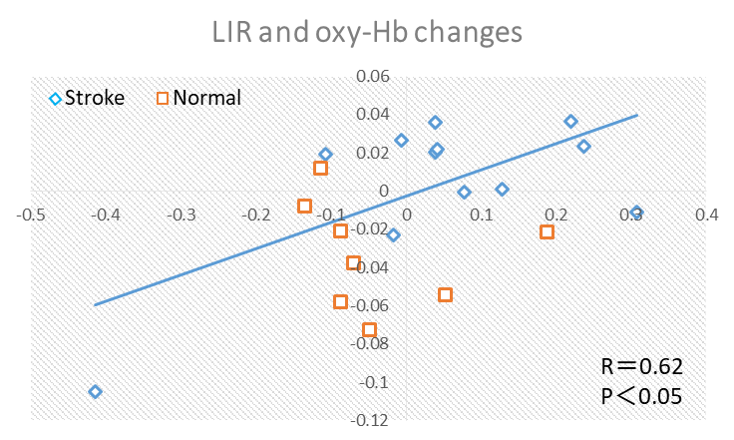

References

[1] Ishikawa W, et al. J Biomed Opt. 2014 Feb;19 (2):027005.

I prefer:  