**Development of cuff-less blood pressure monitoring system**

S Ushioda a, Y Nagasawaa, M Isidaa, Y Komuroa, L. Hu a , Sakatani a, b

*a NEWCAT Research Institute, Department of Electrical and Electronic Engineering, College of Engineering, bDepartment of Neurological Surgery, School of Medicine, Nihon University, Japan*

*sakatani.kaoru@nihon-u.ac.jp*

**Abstract:** In contrast to conventional sphygmomanometer, a cuff-less sphygmomanometer has advantages of being able to measure blood pressure easily and continuously without catheterization. In this study, we developed a cuff-less sphygmomanometer which uses optical pulse measurement and electrocardiogram, and evaluated measurement accuracy with conventional sphygmomanometer. The cuff-less sphygmomanometer consists of an ECG and a reflection type photoelectric pulse wave sensor (PPG), and it can calculate blood pressure by measuring the ECG waveform and pulse wave waveform respectively [1]. Systolic blood pressure (SBP) was calculated by equation (1) and diastolic blood pressure (DBP) was calculated from equation (2):

$SBP={SBP}_{0}-\frac{2}{γ{PTT}_{0}}(PTT-{PTT}_{0})$ (1) $DBP=SBP-\left({SBP}_{0}-{DBP}_{0}\right){\left(\frac{{PTT}_{0}}{PTT}\right)}^{2}$ (2)

(PTT: Pulse Transmit Time)

We evaluate accuracy of the cuff-less blood pressure monitoring system comparing with a conventional sphygmomanometer. Figure (below) shows the Bland-Altman plot of SBP and DBP. In SBP, 94% of the measured value was within the allowable error range (standard deviation × 1.96), while the mean square error (RMSE) was calculated to be 9.6 mmHg. In DBP, 90% of the measured value was within the allowable error range, while the RMSE was calculated to be 7.5 mmHg. Blood pressure measurement by cuff-less sphygmomanometer was highly accurate and suggested that it could be used as an alternative to cuff sphygmomanometer.

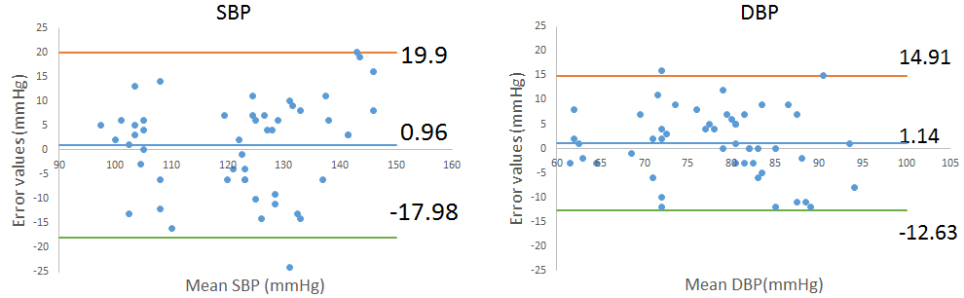

References

[1] Tang Z, Tamura T, Sekine M et al (2017) IEEE J Biomed Health Inform. 21:1194-1205.

I prefer:  