**动物乐园**

**任务描述：**

* + **以面向对象思想设计动物乐园系统** 
    - * + **动物乐园包括的成员：猫、鸭子， ，……**
    - **属性：名称、腿**
    - **方法：叫**
  + **设计类图** 
    - * + **使用多态、接口优化设计**

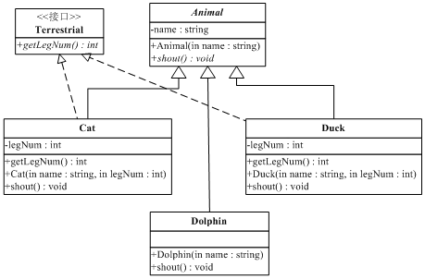

* + **编码实现**

**分别创建Cat、Duck、Dolphin对象并放到一个数组中，对数组进行遍历输出各种动物如何叫，各种动物腿的条数。instanceof判断动物种类 。**

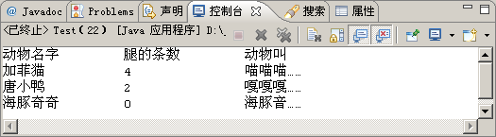

package day10.homeWork;

class Animal{

String name;

public Animal(String name) {

this.name = name;

}

public void shout() {

System.out.println("叫！");

}

}

interface Terrestrial{

public abstract int getLegNum();

}

class Cat extends Animal implements Terrestrial {

private int legNum;

public Cat(String name,int legNum) {

super(name);

this.legNum = legNum;

}

public void shout() {

System.out.println(name+"\t"+legNum+"\t旺旺旺");

}

@Override

public int getLegNum() {

return legNum;

}

}

class Duck extends Animal implements Terrestrial {

private int legNum;

public Duck(String name,int legNum) {

super(name);

this.legNum = legNum;

}

public void shout() {

System.out.println(name+"\t"+legNum+"\t嘎嘎嘎");

}

@Override

public int getLegNum() {

return legNum;

}

}

class Dolphin extends Animal{

public Dolphin(String name) {

super(name);

// TODO Auto-generated constructor stub

}

public void shout() {

System.out.println(name+"\t0\t海疼音");

}

}

public class Disney {

public static void main(String[] args) {

Animal[] animals = new Animal[3];

Animal cat = new Cat("汤姆猫",4);

Animal duck = new Duck("唐老鸭",2);

Animal dolphin = new Dolphin("海豚奇奇");

animals[0] = cat;

animals[1] = duck;

animals[2] = dolphin;

System.out.println("动物名字\t腿的条数\t动物叫");

for (Animal animal : animals) {

animal.shout();

}

}

}