**Desktop:**

**Layout**

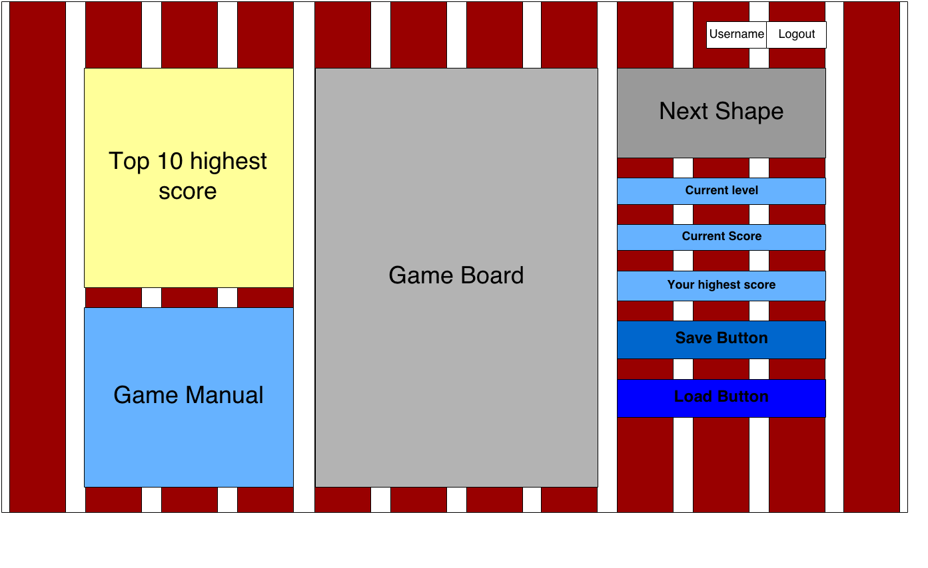

3 columns

Offset 1 col

3 columns

4 columns

* Save + Load: Bootstrap button, size = bootstrap button large.
* Username + Logout button: Bootstrap button group, size = boostrap button default.
* Top 10 highest score: bootstrap panel.
* Game manual + current leve + current score + Your highest scrore: bootstrap well.
* Game board + Next Shape: html5 canvas.

**Design**

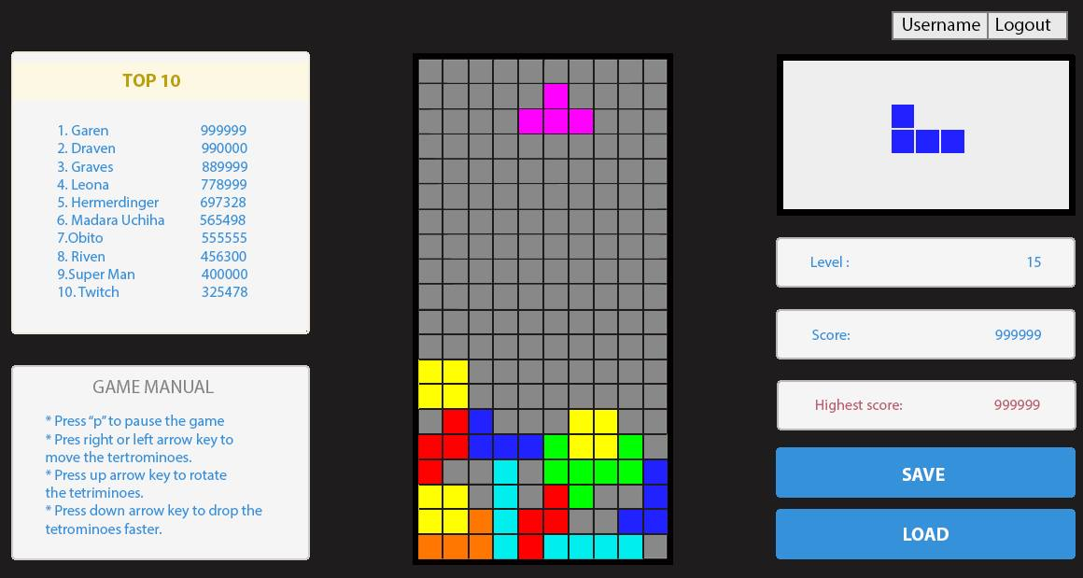

**Phone**

8 columns

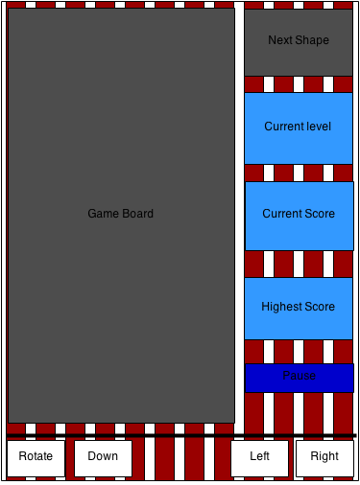

Row 1

Row separate

4 columns

Row 2

* Pause button: Bootstrap button, size = bootstrap default.
* Rotate +Down + Left + Right: Bootstrap button group, button size = bootstrap button large.
* Rotate + Down button: pull left, Left + Right button: pull right.
* Game board + Next Shape: html5 canvas.
* Current level, current score, highest score: bootstrap well.

**Design**

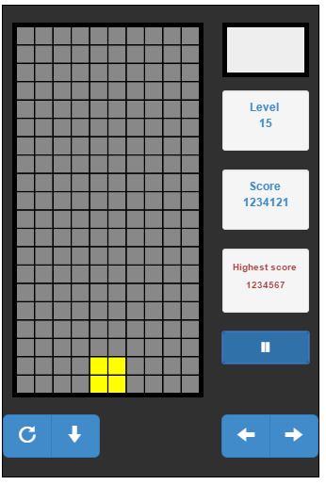

Pause button click -> toggle new windows (bootstrap modal): Use **bootstrap** **pill** class to make “Guide” and “Top 10” tab.

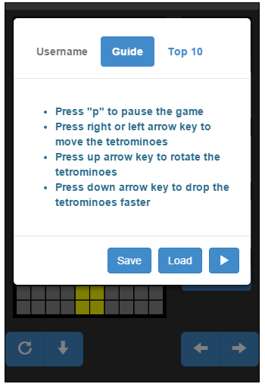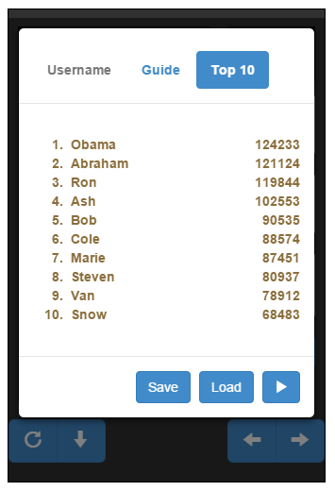

Save, Load, “Continue”: bootstrap button, size = default.

Shape design:

