Bai 1:
- Lenh touch dung de tao file
- lenh cat de hien thi noi dung ra man hinh hoac noi cac tap tin voi nhau va chuyen sang mot tap tin khac
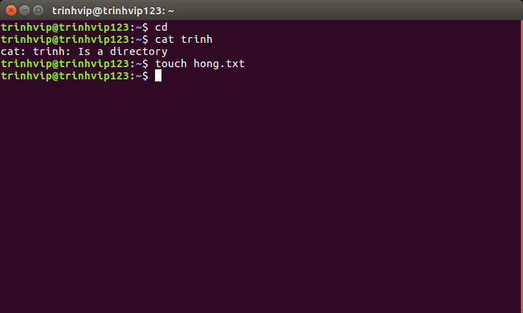

- Cac vi du lenh more va lenh less :
+ Lenh more cho phep nguoi dung chuyen qua cac trang tiep theo cua van ban
vd: more trinh/file.txt
+ lenh less viet noi dung cua file len man hinh tai mot thoi diem
vd: less trinh/file.txt
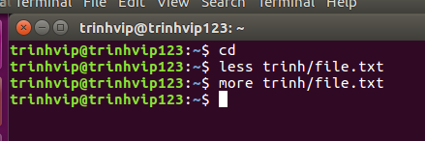

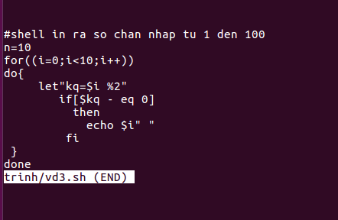

bai2:
- Hien thi so luong cac tu trong 1 file:
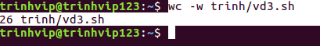

- Hien thi so dong trong 1 file:
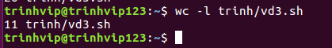

- Hien thi so ky tu trong 1 file:
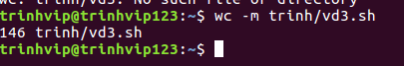

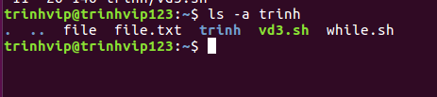
- Hien thi danh sach cac file trong thu muc :

- Sap xep ket qua tra lai theo ket qua giam dan:
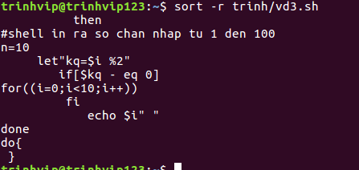

- Sap xep ket qua tra lai theo ket qua tang dan:
