- 表xcms_front_credit
verfication_id->verification_id

- 表xcms_front_credit
添加字段file_type，
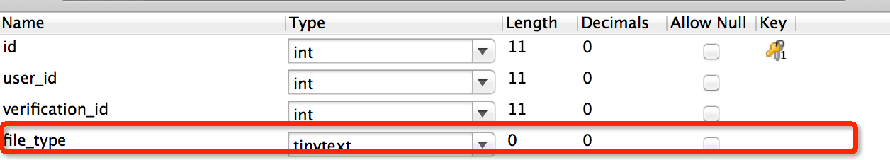

- 表xcms_front_credit
主键添加自动递增

