**How to deploy Radiology Central Project to other server**

1. In visual studio, open project.
2. Get the latest version of the project.
3. Right click Project name of RadiologyCentralReport, select publish option
4. On publish web screen, select profile name of ‘CCHMCRadiology’, then click Publish

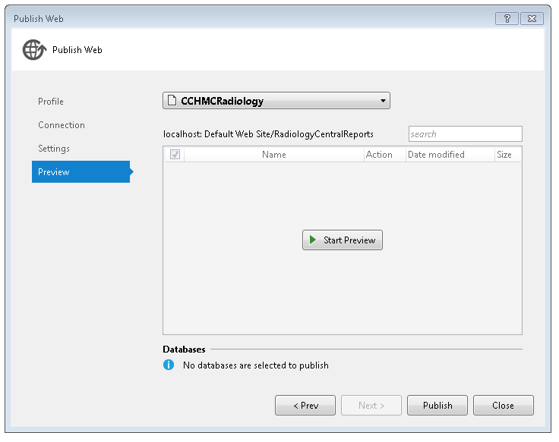

1. After the publish done, in the Output window, you will see below. Publish: 1 succeeded, 0 failed, 0 skipped.
2. 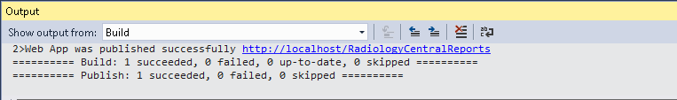
3. Go to the directory of C:\inetpub\wwwroot on the computer
4. Remote to the target server
5. Copy RadiologyCentralReports to C:\inetpub\wwwroot on the target server

Notes: If this Application never was deployed to the server, you need to config it at IIS Server on your deployment server.

**Steps to configure on IIS server**

1. Open the IIS server
2. Navigate to your server name/Sites/Default Web Site.
3. Right click RadiologyCentralReports directory, select Convert to Application option
4. 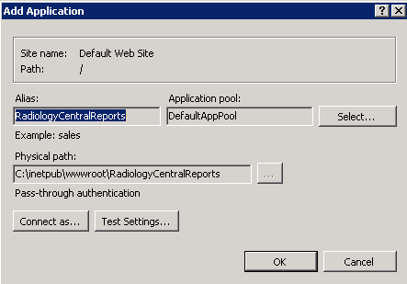
5. On the Add Appliction screen, change Application pool selection to ASP.NET V4.0 pool, then save it.
6. 